Environmental and Social Management Plan (ESMP) Checklist

for Niksar Municipality 960 kWp/1,137.96 kWe Solar Power Plant of
Niksar Municipality

Date of Issue: December 2025

Document History

Revision | Submitted to | Issue Date | Revision Details
V1 | ILBANK | 24 July 2025 | Draft
V2 | ILBANK | 03 Nov 2025 | Draft
V3 | ILBANK | 30 Dec 2025 | Draft

This document has been prepared by ÇA Engineering Company.

Environmental and Social Management Plan (ESMP) Checklist

Part 1: General Subproject and Site Information
1.a) General
Associated ILBANK Project | Türkiye Public and Municipal Renewable Energy Project (PUMREP)
International Financial Institution (IFI) Financing the Project | The World Bank
Project’s E&S Risk Classification according to WB ESF (2018) | Moderate
Subproject Title | Niksar Municipality 1,137.96 kWp/ 960 kWe Solar (Photovoltaic) Power Plant (SPP)
Sub-borrower Name | Niksar Municipality
Responsible ILBANK Regional Directorate (RD) | Sivas Regional Directorate
Subproject’s E&S Risk Classification according to ILBANK ESMS (2023) | Moderate
Subproject Location | Province: Tokat  District: Niksar  Neighborhood: Dönekse  Parcel/Block no: 980/1
Scope of Subproject and Activity  (in case of any changes of the subproject please fill Appendix-12 and submit to ILBANK) | Technology (e.g. Photovoltaic, monocrystalline, polycrystalline, thin film, bi-facial, tracking system, etc.): monocrystalline  Installed power: 1,137.96 kWp  Connection power: 960 kWe  Annual electricity generation: 1,618 MWh/ year  Construction Duration: 1,5 months  Operation Duration (Economic life of the Plant): 25 years  Number of Construction Workers (at peak, including contractors and subcontractors): 10  Number of Operations Workers (at peak): 4  Planned accommodation: Off-site (Rented houses in nearby settlements.)
Energy Transmission Line (ETL) | Grid connection: will be established by linking to the Yolkonak transformer station.  Status of transformer station: Built  Energy transmission line (ETL):  An ETL will be constructed. The technical information on the ETL is provided below:  Transformer station: Yolkonak  Length of the route: 1.5 km  Voltage level: 20 (kV)  The energy transmission line is planned to be constructed underground.  The Niksar Municipality Solar Power Plant (SPP) will be established on a 13,440 m² plot located in Dönekse Neighborhood, Niksar District, Tokat Province, on Lot 1 of Block 980.  As part of the project, an ETL approximately 1,500 meters in length will be constructed. The ETL will extend from the project site (Block 980, Lot 1) and will pass only through cadastral roads and forest land.  The forest land in question is limited to lot 1 of block 101(Yolkonak Neighborhood) and lot 1 of block 979 (Dönekse Neighborhood), for which a Forest Permit Files has been prepared and submitted to the Amasya Regional Directorate of Forestry. No issues have been identified in the ongoing permit process. Documents regarding the permit process are given in Appendix-15.  The parcel boundaries and the ETL route have been illustrated in the attached maps and visuals. The transmission line will be laid underground in a trench less than 0.5 meters wide, and no tree cutting is anticipated.
Access Roads | Access to the sub-project site will be provided via the road connecting to Tokat Province from the E80 highway. The existing road infrastructure is adequate and suitable for the transportation of construction equipment and materials.  There are no residential settlements along the access route. Consequently, no sensitive receptors such as hospitals, schools, or similar public institutions are located along the transportation corridor. The access route to the sub-project area is given in Figure 1.  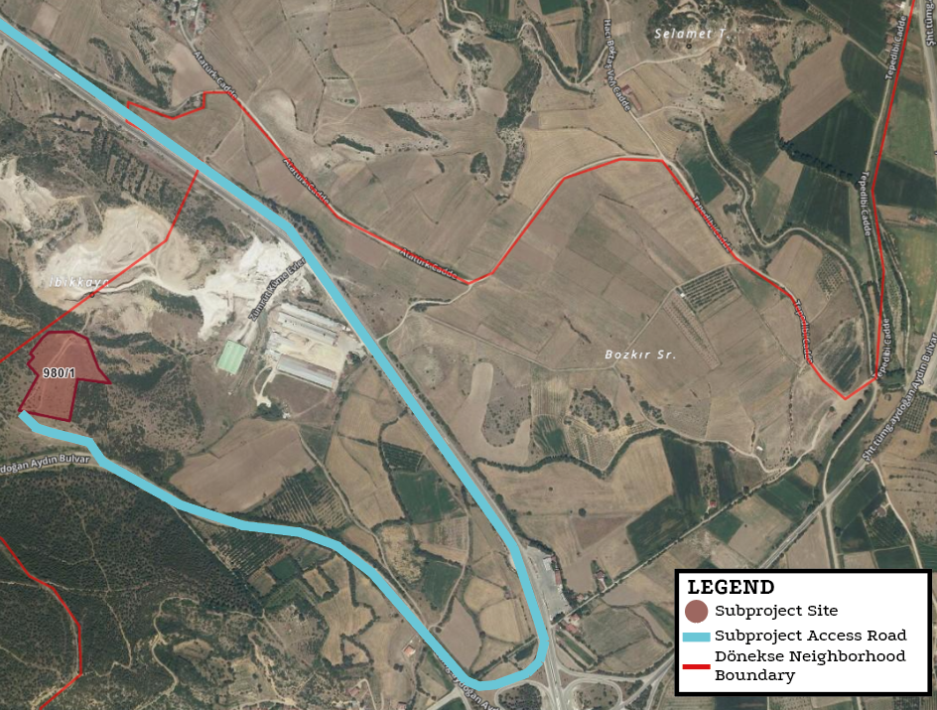  Figure 1. Subproject Access Road
Other Associated Facilities:  Are there any other associated facilities that are not funded as part of the Subproject and are (a) directly and significantly related to the Subproject, (b) carried out, or planned to be carried out, contemporaneously with the Subproject, and (c) necessary for the Subproject to be viable and would not have been constructed, expanded or conducted if the Subproject did not exist? | No
Existing Permits | - According to the opinion of the Provincial Directorate of Agriculture and Forestry, the land located in Tokat Province, Niksar District, Dönekse Neighborhood, parcel no. 980/1 is classified as marginal agricultural land and is outside the boundaries of the Great Plain Protection Area. The request for non-agricultural land use for the purpose of implementing a solar energy project has been approved in accordance with Article 13 of Law No. 5403. The permit is valid for two years and will be deemed invalid if the planning is not approved within this period (Appendix-14) The zoning plan has been approved by the City Council on 07/03/2023.  - As stated by the Tokat Provincial Directorate of Environment, Urbanization and Climate Change, the planned solar power plant project with an installed capacity of 0.96 MWe on parcel no. 980/1 (1.9432 ha) falls outside the scope of the Environmental Impact Assessment (EIA), as the project area is under 2 hectares and the installed capacity is below 1 MW. However, all relevant permits must be obtained and environmental protection measures must be taken during implementation (Appendix-2).  - Opinion letters from other relevant institutions and organizations have been shared in Appendix-15.
1.b) Site Description
Subproject Area | The parcel has an area of 19,432 m² and 13,440 m² will be used for the subproject area.  The sub-project is located in Dönekse Neighborhood, Niksar District, Tokat Province, on Lot 1 of Block 980.  Number of parcels to be used: 1  Total title deed area of the parcel: 19,432 m²  Total area to be used by the Subproject (within the fence area): 13,440 m²
Appendix-1: Site Map
Appendix-5: Photolog
Who owns the land? Since when? | Lot 1 of block 980 was transferred from the Treasury of Finance, that is, the public, to Niksar Municipality in 2017.The land ownership has belonged to Niksar Municipality since 2017 Appendix-4 Allocation Document
Land Registry Type according to Title Deed  (agricultural, pasture, vacant, etc.) | Field
Current Land Use  (are there any formal or informal agricultural users, herders, etc.) | Site visits and stakeholder consultations on 07.07.2025 have confirmed that no agricultural or livestock activities are being carried out on the parcel where the sub-project site will be established. The findings are based on this site visit, and the visual documentation of the visit is provided in Appendix-16. There is no land use by local communities, institutions, private entities, or third parties.  During the field visits, an old and unused road passing through the project site was observed. Based on on-site inspections and discussions with relevant stakeholders, it was determined that the road had previously been used on a temporary basis by a nearby stone and brick quarry. However, it is no longer in active use. A consultation was conducted with the operator of the stone and brick facility, who confirmed that the road is no longer utilized by the facility, and its closure would not result in any economic or operational loss.  In light of these findings, there is no anticipated physical or economic displacement, loss of access, or livelihood impact associated with the land acquisition for the sub-project.
Other Nearby Facilities and Activities  Are there other industrial or commercial activities operated/operating or planned by the Sub-borrower itself or other public or private third-parties in the vicinity of the Subproject or its components/associated facilities? | Two industrial facilities are located in the vicinity of the Sub-project site. To the northeast, a walnut processing facility is located approximately 250 meters from the project area, and a brick and stone manufacturing plant is situated around 350 meters away(The locations of the facilities are given in Figure 6.). Both facilities are owned and operated by third parties and have no affiliation with the sub-borrower.  Their operations are independent of the sub-project, and based on site observations and measured distances, their environmental and social impacts on the Sub-project are considered negligible. These activities have also been considered in the cumulative impact assessment, and no significant cumulative impacts have been identified.

Area of Influence | The sub-project is located approximately 700 meters from Dönekse Neighborhood. The access road follows a paved route branching from the E80 highway toward Tokat. Along the main access road, no residential buildings or vulnerable groups have been identified, confirmed through field visits and consultations with the local mukhtar.  However, the ETL will pass through a cadastral road segment where three residences are located. Consultations were held with the households in this area, and no objections or concerns have been raised by the residents.  The Area of Influence (AoI) has been defined considering the proximity of these residences to the ETL route, as well as potential impacts related to noise, dust, and traffic during construction. In addition, Yolkonak Neighborhood, through which the ETL route passes, has also been included in the AoI. Given the distance of 550 meters from the nearest neighborhood and the limited number of residences along the cadastral road, significant adverse impacts on local communities are not anticipated.  Noise modeling indicates that construction-related noise will decrease to insignificant levels beyond 300 meters, and dust emissions will be effective within approximately 50 meters of construction activities. These findings comply with the IFC standards (55 dBA) and national regulations (65 dBA) as per the Environmental Noise Control Regulation (Official Gazette No. 32029, dated 30.11.2022).  All modeling assumes conservative conditions with all equipment operating simultaneously; real-world impacts are expected to be lower. Environmental noise and dust emissions will be monitored throughout the construction phase, and mitigation measures such as noise barriers and regulated working hours will be implemented if complaints arise.  Dust emission calculations also confirm emissions remain below the regulatory limit of 1.0 kg/hour, in accordance with the Regulation on Control of Industrial Air Pollution (Official Gazette No. 27277, dated 03.07.2009), negating the need for additional air quality modeling.  Additionally, the Dönekse Neighborhood has been included in the AoI due to its proximity to the sub-project site and the project's commitment to prioritize local employment opportunities.  The AoI is visually represented in Figure 2.

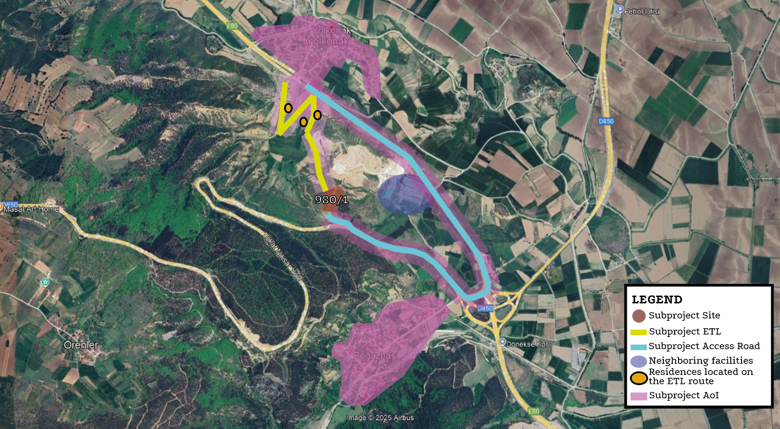
Figure 2. Subproject AoI

Description of geographic and physical characteristics as appropriate. | The settlement area of Niksar District is characterized by a complex geological structure comprising various rock and soil formations ranging from the Mesozoic to the Quaternary periods. The area includes Upper Jurassic–Lower Cretaceous micritic and cherty limestones, Eocene-aged carbonate sandstones containing Nummulite fossils, and volcano-sedimentary units. Volcanic formations such as the Eşekçiyolu and Ilıcak Tepe Formations consist of basaltic lava, tuff, agglomerate, and volcanic sandstones, covering wide areas of the region. Quaternary deposits include slope debris, debris cones, and alluvium, which are predominantly found in valley outlets and lowland areas. These unconsolidated units significantly influence surface and groundwater dynamics due to their high permeability. The geological diversity of the area should be carefully considered in construction planning, groundwater management, and the assessment of potential geotechnical risks.  According to the data obtained from the Türkiye Earthquake Hazard Maps Interactive Web Application for the sub-project area, the PGA 475 (g) value was determined as 0.734 g. This value indicates the horizontal peak ground acceleration (PGA) value with a return period of 475 years. The PGA value of 0.734 g indicates that the region has a hihg seismic hazard. The 0.1g threshold is usually an important limit considered in structural safety; therefore, the value of 0.734 g indicates a significant and critical shaking level (Figure 4).  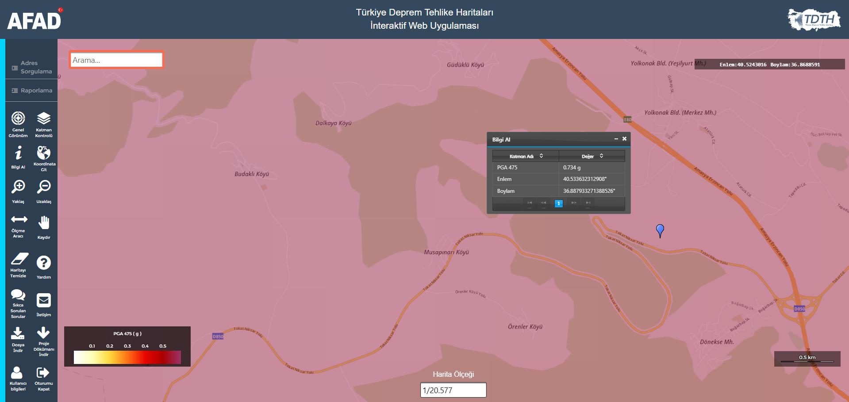  Figure 3. Sub-project Seismicity Map (https://tdth.afad.gov.tr/TDTH/)
Description of biological characteristics as appropriate. | Although SPP projects generally have low environmental impact, detailed ecological assessments are made during site selection in order not to harm biodiversity. The flora and fauna species identified as a result of studies conducted in the sub-project area of influence (AoI) are given in Appendix-11  Literature and field studies were carried out by ÇA Engineering Agricultural Engineer to determine the flora and fauna species present or likely to be present within the area (AoI).  Flora  Literature and field studies were conducted for the determination of flora and fauna species located or likely to be located within the sub-project AoI. Within the scope of the studies conducted in the sub-project AoI, no endangered or endemic plant species were encountered in the sub-project AoI. In this context, the books “Flora of Türkiye and East Aagean Island (1965- 1988)” and “Red Data Book of Turkish Plants” prepared by P. DAVİS were used. In addition, the databases prepared by TUBITAK, “http://bioces.tubitak.gov.tr” and Turkish Plants Data Service – TUBITAK:  “http://wwweski.tubitak.gov.tr/tubives/” were scanned and the literature was supported to check whether there were any endangered species.  There are no rare, endangered or protected plant species in the sub-project AoI according to Annex 1 of the Bern Convention.  Fauna  The fauna list in the immediate vicinity of the sub-project AoI, based on fieldwork and literature review, is given below. In literature studies; Mustafa Kuru’s ‘Vertebrate Animals’, A. Demirsoy’s ‘Türkiye Vertebrates– Mammals, Amphibians’, İbrahim Baran’s ‘Türkiye’s Amphibians and Reptiles’, İ. Kiziroğlu’s (2008) ‘Türkiye Birds Red List’ (Species List in Red Data Book) were used.  The species listed in Appendix-12 and protected by the Bern Convention and other wildlife species are not affected by this activity, such as hunting, deliberately killing or detaining these species, or damaging their eggs. The decisions of the Central Hunting Commission of the Ministry of Agriculture and Forestry for 2024-2025 and the provisions of the Bern Convention will be complied with in the activity in question.  As a result of the flora and fauna surveys conducted in the sub-project AoI, the existence of the species given in the tables (Appendix-13) was encountered. In this context, no species that are definitely protected under the BERN Convention were encountered. Species that are allowed to be hunted for certain periods by the decision of the Central Hunting Commission were identified, but these species are not within the subproject AoI but are in the immediate vicinity. It is not expected that the activities to be carried out within the scope of the filling activity subject to the sub-project will have a negative impact on these species. However, within the scope of the subproject, necessary measures will be taken for the protection of wildlife in accordance with the Land Hunting Law No. 4915 and the decisions of the Central Hunting Commission held every year. In the sub-project AoI; national parks, nature parks, nature monuments, nature conservation areas, wildlife conservation areas, wild animal breeding areas, cultural assets, natural assets, protected areas and protection areas, special environmental protection zones, biogenetic reserve area, biosphere reserve special protection areas, afforested areas, potential erosion and afforestation areas, protection areas related to drinking and utility water resources, densely populated areas, historical, cultural, archaeological and similar areas of importance, tourism regions and other protected areas; were not encountered in the database used as a source and other researches.  There is no nationally protected and internationally recognized high biodiversity value areas in the sub-project AoI. Additionally, there are no World Heritage Natural Protected Areas, Biosphere Reserves, Ramsar Wetlands of International Importance, Important Biodiversity Areas or Important Bird Areas. Furthermore, field surveys and desktop studies have confirmed the absence of any critical habitats, endemic or endangered species, or ecologically sensitive zones within the subproject AoI.
Description of geological and hydrographic characteristics as appropriate. | The selected subproject site’s geological and hydrographic characteristics play a crucial role in assessing the feasibility and sustainability of the solar power plant. The geological conditions, including soil composition, bedrock stability, and seismic activity, influence the foundation design and construction process. Additionally, hydrographic features such as surface water bodies, groundwater levels, and drainage patterns are evaluated to ensure minimal impact on local water resources. This section provides an overview of the site's geological and hydrographic attributes, highlighting any relevant environmental considerations for the subproject development.  Geological Characteristics  The topography of Niksar consists of a combination of low-lying plains and surrounding highland plateaus. The district is situated at an average elevation of approximately 350 to 400 meters above sea level. It is bordered by the Canik Mountains to the north and by the steep ridges of the Eastern Pontic Mountain range to the south and east. The Kelkit River (a major tributary of the Yeşilırmak River) flows through the Niksar Plain and contributes significantly to the region's agricultural productivity.  From a climatic perspective, Niksar is characterized by a transitional climate influenced by both the Black Sea coastal and Central Anatolian continental systems. Winters are relatively cold and wet, while summers are typically hot and dry. The annual average temperature ranges between 10°C and 14°C, and the mean annual precipitation is approximately 450 to 650 mm. Due to the area's geographical setting between mountainous terrain and valley plains, microclimatic variations may be observed over short distances.  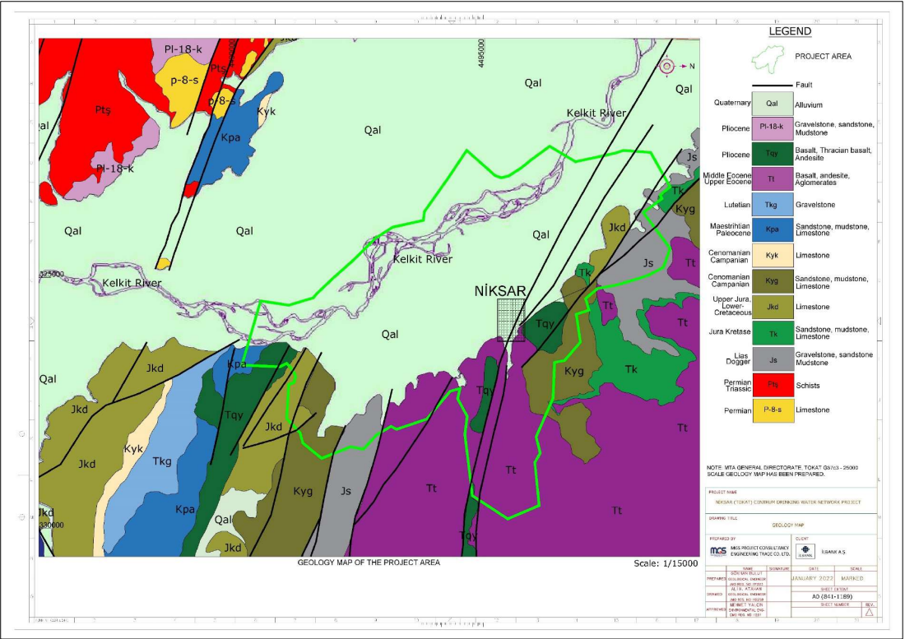  Figure 4. Geology Map  Hydrographic Characteristics  There is no flowing surface water body within the boundaries of the sub-project area. The nearest water source is the Suluca River, located approximately 1,000 meters to the southeast of the site. According to the National Water Information System, there are no identified underground water resources within the sub-project boundaries.  Taking into account the seasonal flow variations of the Suluca River, no flood risk has been identified for the project site, including during periods of heavy rainfall. Based on available hydrological data, the area is not subject to inundation or waterlogging risks.  A map illustrating the location of the nearest water source in relation to the sub-project area is provided in Figure 6.  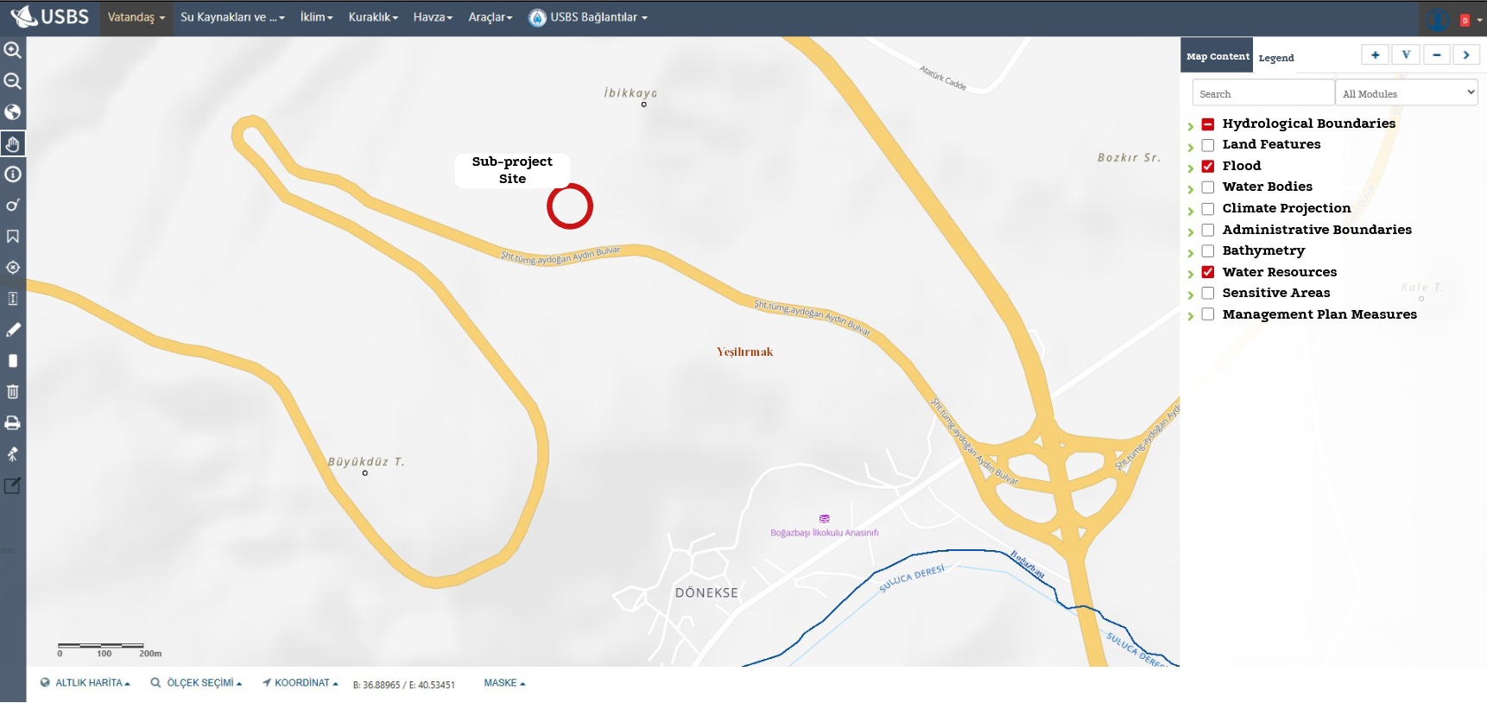  Figure 5. Sub-project Site Water Resources Map (Ministry of Agriculture and Forestry National Water Information System)
Description of socio-economic characteristics as appropriate. | Since Dönekse Neighborhood is within the impact area of the sub-project, it is important to provide an overview of the neighborhood’s general socio-economic structure. During the site visit, based on the available data obtained from interviews with the mukhtar, local residents, and nearby facilities, it is important to provide an overview of the neighborhood’s general socio-economic structure. Current data indicate that residents primarily rely on agriculture and animal husbandry for their livelihoods. As is commonly observed in rural settlements, Dönekse Neighborhood has experienced a declining population trend due to the migration of younger individuals to metropolitan cities. This has resulted in a shrinking local labor force and an increase in the elderly population.  According to data published by TurkStat in February 2025, the neighborhood’s population is 483. It is anticipated that the sub-project will generate short-term employment for approximately 10 people during the construction phase, and require a workforce of 2 people during the operation phase, primarily in construction, electrical-electronic, and energy-related roles. Although the direct employment opportunities are limited, priority will be given to local residents, and the project is expected to yield positive socio-economic impacts.
If relevant, provide information about the affected settlements. | Closest settlement(s):  - Dönekse neighborhood (with 483 population, according to TurkStat, 2024)  Closest structure(s) to the Subproject site:  - Two industrial facilities are located to the northeast of the sub-project site. A walnut processing facility is situated approximately 250 meters away, and a brick and stone manufacturing plant is located around 350 meters from the sub project area.
Locations and distance to nearest sensitive receptors such as health care units, schools? | The nearest sensitive receptors to the sub-project site include residential areas and a school. The closest receptors are the residential buildings located along the Electricity Transmission Line (ETL) route to the northwest of the project parcel, at a distance of approximately 550 meters from the sub-project site. Another residential building, belonging to Dönekse Neighborhood, is located approximately 650 meters away. The nearest school is situated at a distance of around 850 meters from the project site.  No health care units, fire stations, or other critical infrastructure have been identified in the vicinity of the sub-project area or along the access road.  In addition to these receptors, two industrial facilities (a walnut processing plant and a brick and stone manufacturing facility) are located to the northeast of the sub-project site, at distances of approximately 250 meters and 350 meters, respectively. However, these are not considered sensitive receptors, and no significant environmental or social impacts are anticipated due to their presence.

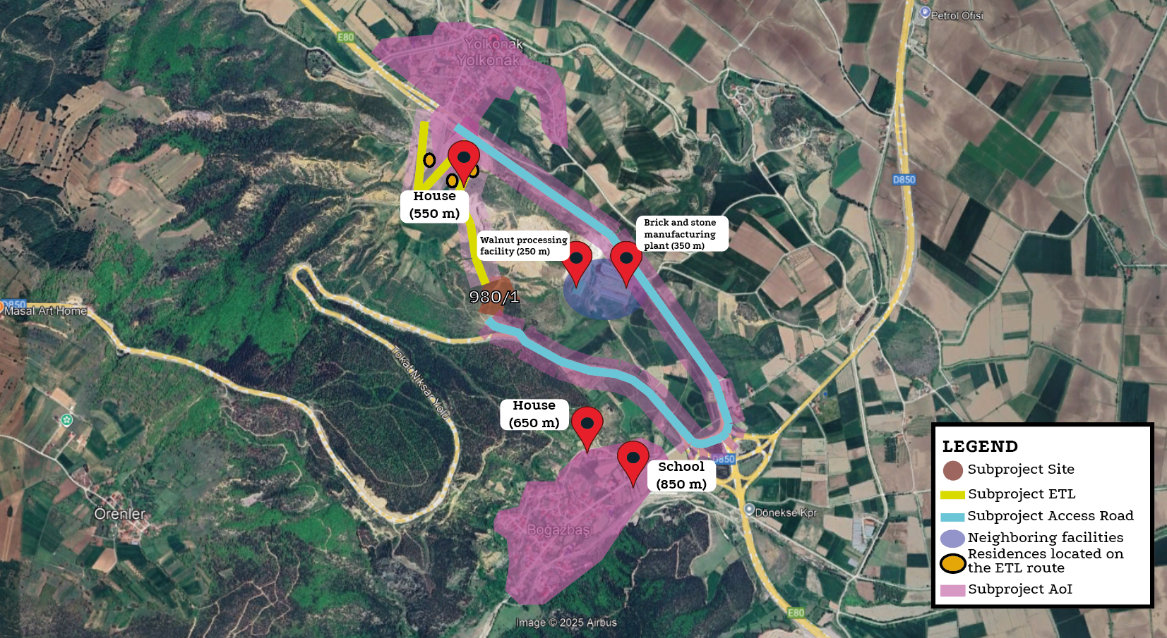
Figure 6. Sub project nearest sensitive receptors

Infrastructure services to be used during the life cycle of the subproject (sewage, electricity, water network, etc.) | Due to the subproject location, electricity, water will be supplied from the current infrastructure networks. No need to construct/renew infrastructure services due to subproject activities.
1.c) E&S Requirements applicable to the Subproject
The subproject will be implemented in line with requirements of applicable national legislation and international agreements and conventions to which Türkiye is a party of.

The following international standards will also be followed as applicable:
- ILBANK Environmental and Social Management System (ESMS)
- WB Environmental and Social Framework (ESF, 2018) and the Environmental and Social Standards (ESSs) forming part of the ESF
- Good International Industry Practices (GIIPs) including but not limited to WB Group (WBG) General and Industry Sector Environmental, Health and Safety Guidelines (EHSGs)
- International Finance Corporation (IFC) ESMS Implementation Handbook

In cases where the requirements of the ILBANK ESMS or national legislation differ from those of the WB ESSs or the levels and measures presented outline in the relevant WBG EHS guidelines, the more stringent standard will apply.

Part 2: Implementation Arrangements
2.b) Implementation Responsibility and Resources
The sub-borrower shall implement and cause the contractor to be adopt and implement this ESMP Checklist satisfactory to ILBANK throughout the sub-financing agreement life cycle.

The sub-borrower is responsible for ensuring that adequate financial and human resources are allocated for the effective implementation of this ESMP Checklist.

Roles and Responsibilities are provided in Appendix-9.
2.c) Organizational Capacity
Sub-borrower:
The sub-borrower shall establish an organizational structure (Project Implementation Unit – PIU) with qualified staff and resources to the satisfaction of ILBANK and maintain it by ensuring that there is qualified staff assigned and serving on the duty throughout the sub-financing agreement life cycle.

The sub-borrower assigns the following personnel to support management and monitoring of subproject E&S risks and impacts and ensure full compliance with the requirements of this ESMP Checklist:
- Environmental Focal Point: Saliha Dirim Burhan, Environmental Engineer, 19 years
- Social Focal Point ((who will also act as the Grievance Mechanism (GM) Focal Point): Rasim Berk Yılmaz, Project Expert, 5 years
- Occupational Health and Safety (OHS) Specialist: Mustafa Genç, OHS Expert, 1 years
Contractors:
The sub-borrower shall obligate awarded contractors to establish and maintain throughout the contract duration an organizational structure with qualified staff and resources.

This shall be achieved through assigning the following personnel under the contractor’s organization prior to commencement of works:
- One (1) Environmental Specialist: Please insert name-surname, position/title, length of professional experience
- One (1) Social Specialist: Please insert name-surname, position/title, length of professional experience
- One (1) Occupational Health and Safety (OHS) Specialist: Please insert name-surname, position/title, length of professional experience, expertise class

The sub-borrower shall in writing notify ILBANK of the assigned contractor personnel prior to commencement of works.
2.d) Monitoring and Reporting
The sub-borrower shall promptly notify ILBANK of any incident or accident related to the subproject which has, or is likely to have, a significant adverse effect on the environment, the affected communities, the public or workers, including, inter alia, cases of sexual exploitation and abuse (SEA), sexual harassment (SH), and accidents that result in death, serious or multiple injury.

This notification shall be done by using ILBANK’s E&S Incident Notification Form template (see Appendix-8). Completed E&S Incident Notification Form shall be submitted to ILBANK by the sub-borrower within 24 hours of the incident or accident (contractor shall notify the sub-borrower within 12 hours of the incident or accident).

The periodic E&S monitoring reporting requirements for the subproject is as follows:

- Construction contractor will prepare monthly E&S monitoring reports (ESMRs) and submit to supervision consultant (“müşavir”).
- During the construction phase, the sub-borrower, with support from supervision consultant, will prepare quarterly ESMRs and submit to ILBANK.
- During the operation phase (throughout sub-financing agreement lifecycle, until the completion of repayment period), the sub-borrower will prepare annual ESMRs and submit to ILBANK.

ILBANK will provide the sub-borrower with the required template for the periodic ESMRs.

The Roles and Responsibilities are provided in Appendix-9.

Part 3: ESMP Matrix: Risk and Impacts, Mitigation and Monitoring
As the Sub-project involves both construction and operational activities, the ESMP consist of two components applicable to respective Sub-project phase, as follows:
• Construction ESMP Matrix
• Operation ESMP Matrix

3.a) Construction ESMP Matrix
No. | Risks and Impacts | Receptor(s) | Proposed Mitigation Measure | Responsible Parties
Labor and Working Conditions
 | Working Conditions | Construction workforce  Employees | - Conduct daily toolbox talks covering the OHS Plan and labor conditions and record it for display on demand.  - Develop and implement a subproject-specific simplified Labor Management Procedure (SLMP, see Appendix-8) to ensure compliance in recruiting and managing all employees.  - Enforce strict prohibition of child labor, forced labor, and unregistered labor as per SLMP requirements.  - Workers will be provided with documented information that is clear and understandable regarding their rights under national labor law, including collective agreements, and their rights related to hours of work, wages, overtime, compensation, and benefits at the start of the working relationship and whenever any material changes occur.  - Recruitment procedures will comply with national labor legislation and ESS2, and an accessible grievance mechanism for workers will be implemented and maintained. | Niksar Municipality  Supervision Consultant  Contractor
 | General OHS risks | Construction workforce | - A comprehensive risk assessment document must be developed for the sub-project, identifying specific risks and corresponding mitigation measures. In addition to this general assessment, a task-specific risk assessment must be conducted before starting any non-routine work or activities that fall outside the normal scope of operations. In such cases, a work permit procedure must also be applied to ensure all safety precautions are in place.  - Ensure that all employees, including subcontractors, receive necessary OHS training covering identified risks.  - Prepare sub-project management plans, including Safe Work Procedures and an Emergency Response Plan.  - Emergency scenarios should be determined for all possible risks and every employee should receive training on these scenarios.  - Enforce safety procedures and provide appropriate PPE to all employees.  - Incorporate job-specific safety procedures and requirements in OHS training programs.  - Prepare machine and operation specific “Safe Working Procedures” for all safety critic equipment and machinery and notify all workforce by signature.  - Serious safety issues that may arise with primary suppliers and primary supply workers will be managed as described in the Occupational Health and Safety Sub-Management Plan, which will cover primary supply workers to the extent necessary.  - Written contracts will be provided to subcontractors, setting out detailed job descriptions, rights and obligations, and a Code of Conduct.  - In case of OHS accidents resulting in loss of life, loss of limbs or eyes, or temporary incapacity for work lasting more than 72 hours, the Contractor shall immediately notify the Social Security Institution and ILBANK (within 24 hours) and follow up by filling in the Environmental and Social Reporting Template (ESRT) forms in accordance with the instructions of ILBANK. This process shall also include root cause analysis and corrective action plan. | Niksar Municipality  Supervision Consultant  Contractor
 | Physical Hazards: Lifting Operations OHS Risks | Construction workforce | - Ensure that lifting area will be enclosed with fence to prevent access to the lifting area during lifting work.  - Ensure that warning signs will be installed for lifting activities  - Ensure that safety procedures will be used for lifting operations.  - Ensure that lifting work will be carried out by well trained, qualified, and certified lifting team and with proper communication means and flag man.  - Ensure that workers will be provided with all necessary PPE and safety materials.  - Ensure all equipment used for lifting operations including slings, chains and hooks are checked technically and records are kept according to local safety legislation.  - Ensure that tools are selected and designed that reduce force requirements and holding times and improve postures.  - Ensure that user-adjustable workstations are provided.  - Ensure that rest and stretch breaks are incorporated into work processes and job rotation is in place.  - Ensure that quality control and maintenance programs are in place to reduce unnecessary forces and effort, and personnel are trained in proper manual handling techniques.  - Ensure that additional special circumstances, such as left-handed people, are considered. | Niksar Municipality  Supervision Consultant  Contractor
 | Physical Hazards: Rotating and Moving Equipment | Construction workforce | - Design machines to eliminate trap hazards and ensure that extremities are kept out of harm’s way under normal operating conditions; i.e. availability of emergency stops dedicated to the machine and placed in strategic locations;  - If a machine or equipment has an exposed moving part or an exposed pinch point that could endanger the safety of any worker, ensure that the machine or equipment is equipped with and protected by a guard or other device that prevents access to the moving part or pinch point. Guards should be designed and installed in conformance with appropriate machine safety standards;  - Ensure that machinery with exposed or protected moving parts or in which energy can be stored (e.g. compressed air, electrical components) is turned-off, disconnected, isolated and de-energized (Locked Out and Tagged Out) during service or maintenance;  - Where possible, ensure that equipment is designed and installed to enable routine servicing, such as lubrication, to be carried out without removing guarding devices or mechanisms. | Niksar Municipality  Supervision Consultant  Contractor
 | Physical Hazards: Electrical Hazards | Construction workforce | - No one without a valid certification on vocational training on electricity will be allowed to work on electrical installations.  - Ensure that all energized electrical devices and lines are marked with warning signs;  - Ensure that the devices are locked (de-charging and leaving open with a controlled locking device) and labeled (warning sign placed on the lock) during service or maintenance;  - A “Lockout Tagout” (LOTO) Procedure specific to the subproject should be prepared, personnel should be trained and its implementation should be supervised.  - If extension cords are to be used, they must be selected based on the required current capacity and the length of the cable. Extension cords are intended for temporary use only. Ensure that all electrical cords, cables, and hand power tools are checked for frayed or exposed cords. Also, ensure that the manufacturer's recommendations for the maximum permitted operating voltage of portable hand tools are followed;  - Insulating mats should be placed under electrical panels, including portable panels.  - Ensure that portable electrical appliances are “portable electrical appliance tested (PAT)”  - Ensure that all electrical equipment used in environments that are or may be wet is double insulated/grounded; use equipment with ground fault interrupter (GFI) protected circuits;  - All panels will be equipped with a residual current relay.  - Ensure that power cords and extension cords are protected against damage from traffic by shielding or suspending above traffic areas;  - If extension cables are to be used, they should be selected according to the current they need to carry and the length of the cable. Extension cables are for temporary use. Outdoor extension cables should be used.  - Ensure that high-voltage equipment ('electrical hazard') and service rooms where access is controlled or prohibited are properly labeled;  - Ensure that "No Approach" zones are established around or under high voltage lines;  - Ensure that construction vehicles or other vehicles with rubber tires that come into direct contact with or arc across high-voltage cables are taken out of service for 48 hours;  - Ensure that all buried electrical cables are thoroughly identified and marked prior to any excavation work.  - Ensure that special training programs are organized for employees on electrical hazards and safety precautions.  - Ensure that rapid response teams and emergency plans are established for electrical accidents.  - Ensure that regular electrical safety inspections are conducted in the project area.  - Ensure that periodic inspections are conducted to ensure that employees use appropriate personal protective equipment (PPE).  - Fire extinguishers containing CO₂ will be provided for possible electrical fires. | Niksar Municipality  Supervision Consultant  Contractor
 | Physical Hazards: Welding and Hot Works | Construction workforce | - Ensure that appropriate eye protection, such as welder's goggles and/or a full-face shield, and respiratory protection is provided for all personnel involved in or assisting with welding operations;  - If welding or hot cutting is performed outside of established welding work stations, ensure that special hot work and fire prevention precautions and Standard Operating Procedures (SOPs) are in place, including "Hot Work Permits, stand-by fire extinguishers, fire blanket, stand-by fire watch and maintaining fire watch for up to one hour after welding or hot cutting is finished";  - Ensure that areas where welding or hot work is performed are cleared of flammable materials (e.g. fuel, solvent, spark-ignitable materials) and should be checked regularly.  - Ensure that all employees are trained and informed about welding operations and the safe management of hot work.  - Ensure that welding work is only carried out by employees who have the appropriate professional qualification (aluminum, steel, resistance etc.) | Niksar Municipality  Supervision Consultant  Contractor
 | Fire Safety Prevention Measures and Emergency Response | Construction workforce  Flora and fauna  Soil, water resources | - Prepare an Emergency Response and Evacuation Plan before the commencement of works.  - Ensure all employees are trained for their responsibility to report dangers and firefighting measures  - Ensure that all flammable and hazardous materials are stored in designated, secure areas away from ignition sources.  - Ensure firefighting systems and equipment are available  - Ensure fire and emergency drills are conducted regularly.  - Designate trained fire wardens for each area to lead evacuations and coordinate with emergency responders.  - Keep an up-to-date list of emergency contacts, including local fire departments and hospitals, for quick access in case of fire.  - Make sure that there are enough first aiders in the first aid regulations for the workplace hazard class. | Niksar Municipality  Supervision Consultant  Contractor
 | Physical Hazards: Ergonomics, Repetitive Motion, Manual Handling Lifting | Construction workforce | - Establish clear weight limits for manual handling tasks and label heavy loads accordingly;  - Ensure that mechanical assists are used to eliminate or reduce the effort required to lift materials, hold tools and work objects, and that more than one person is lifting if weights exceed thresholds;  - Ensure that tools are selected and designed that reduce force requirements and holding times and improve postures;  - Ensure that user-adjustable workstations are provided;  - Ensure that rest and stretch breaks are incorporated into work processes and job rotation is in place;  - Ensure quality control and maintenance programs are in place that reduce unnecessary forces and effort;  - Ensure that additional special circumstances, such as left-handed people, are considered.  - Whether a new employee can carry heavy loads should be determined during a health check by the workplace doctor. Make sure that these jobs are performed by people who are approved. | Niksar Municipality  Supervision Consultant  Contractor
 | Physical Hazards: Industrial Vehicle Driving and Site Traffic | Construction workforce | - Ensure that industrial vehicle operators are trained in the safe use of specialized vehicles such as forklifts, including safe loading/unloading, load limits;  - Make sure that they have a certificate of competence (driver's license, operator's certificate, etc.) from authorized institutions and organizations according to the type of work machine.  - Make sure drivers undergo medical supervision;  - Ensure that moving equipment with restricted rear visibility is equipped with audible back-up alarms;  - Ensure that rights of way, site speed limits, vehicle inspection requirements, operating rules and procedures, and control of traffic patterns or direction are established;  - Ensure that deliveries and movement of private vehicles are restricted to defined routes and areas, with 'one-way' movement preferred where appropriate.  - While the work equipment is in motion, it is prevented that anyone approaches the blind spots of the equipment. In cases where this cannot be achieved, object detection systems or warning systems are used. If this cannot be achieved either, a signal is used, coordination is ensured with the people around, or no one is allowed to enter the work area. | Niksar Municipality  Supervision Consultant  Contractor
 | Physical Hazards: Chemical Hazards | Construction workforce  Flora and fauna  Soil, water resources | - Ensure that the hazardous substance is replaced with a less hazardous substitute;  - Ensure that engineering and administrative control measures are in place to prevent or minimize the release of hazardous substances into the working environment, keeping the exposure level below internationally established or recognized limits;  - Ensure that the number of workers exposed or likely to be exposed is minimal;  - Ensure that chemical hazards are communicated to workers through labeling and marking according to nationally and internationally recognized requirements and standards, including International Chemical Safety Cards (ICSC),Safety Data Sheets (SDSs) or equivalent. Any means of written communication should be in an easily understood language and be readily available to exposed workers and first-aid personnel;  - Ensure that employees are trained in the use of available information (such as Safety Data Sheet), safe working practices and proper use of PPE.  - Ensure workers have access to suitable personal protective equipment (PPE), such as gloves, respirators, goggles, and protective clothing, based on the specific chemical hazards.  - Store hazardous substances in designated areas with appropriate ventilation, labeling, and secure containment to prevent accidental exposure or spills.  - Provide chemical overflow pallets and store chemical containers by placing them on them.  - Develop and implement a spill response plan, as part of the Emergency Response Plan, including containment measures, chemical spill/leak response drills, cleanup procedures, hazardous substance disposal, and emergency contact information.  - Dispose of chemical waste according to regulations to prevent environmental contamination and worker exposure.  - Regularly inspect and maintain chemical handling equipment, storage areas, and PPE to prevent leaks or accidental releases. | Niksar Municipality  Supervision Consultant  Contractor
 | Gender-Based Violence (GBV); Sexual Exploitation and Abuse/Sexual Harassment (SEA/SH) on Employees; Gender Inequality | Construction workforce | - Provide GBV and SEA/SH awareness sessions for the management teams of the construction contractor and consultants to promote understanding and accountability.  - Conduct regular awareness meetings with workers to educate them on GBV and SEA/SH issues and the importance of respectful workplace conduct.  - Ensure all workers receive training on recognizing, preventing, and responding to GBV and SEA/SH incidents.  - Require all workers to review, sign, and adhere to a Code of Conduct that explicitly addresses unacceptable behaviors related to GBV and SEA/SH.  - Implement a confidential and accessible grievance mechanism specifically designed to capture and address GBV and SEA/SH-related complaints in a timely manner. | Niksar Municipality  Supervision Consultant  Contractor
Resource Efficiency and Pollution Prevention and Management
 | Waste Management - General | Communities  Construction workforce  Flora and fauna  Soil, water resources | - Separate waste at the source into waste categories determined in Waste Management Regulation, establish temporary waste storage area  - Place labeled bins for each type of waste at strategic locations on-site to ensure correct disposal by workers.  - Implement practices to reduce waste generation by optimizing material use and reusing materials where possible.  - Contract with local recycling facilities to ensure that recyclable materials (e.g., metals, paper, plastic) are properly processed.  - Store waste in designated, secured areas to prevent littering, leaching, and environmental contamination.  - Use leak-proof containers for hazardous or liquid waste and ensure they are adequately labeled.  - Contract with licensed waste disposal companies to handle non-recyclable and hazardous wastes in accordance with Waste Management Regulation.  - Track and document the disposal process to ensure compliance and accountability.  - Conduct regular awareness sessions and training for workers on waste reduction techniques, proper disposal practices, and the importance of waste management.  - Regularly monitor waste management practices, conduct site inspections, and assess waste volumes to identify areas for improvement.  - Establish a reporting system to document waste types, quantities, and disposal methods.  - Develop a comprehensive waste management plan that includes waste reduction targets, disposal methods, monitoring schedules, and assigned responsibilities for effective waste management throughout the project.  - Use containment systems for waste that poses spill risks, and keep spill kits accessible. Train staff on immediate spill response actions to prevent soil and water contamination.  - Conduct maintenance tasks, such as oil changes and battery replacements, off-site.  - Ensure that excavated soil, construction materials and similar piles are not stored in areas close to the stream. | Niksar Municipality  Supervision Consultant  Contractor
 | Waste Management -Electronic Waste Disposal | Communities  Construction workforce  Soil and water resources | - Contract with recycling facilities and/or manufacturers to ensure proper disposal or recycling of obsolete equipment;  - Agreements will be set with e-waste recycling facilities to ensure responsible disposal of electronic waste from solar panels, inverters, batteries, etc. | Niksar Municipality  Supervision Consultant  Contractor
 | Wastewater Management | Flora and fauna  Soil, water resources | - Construct septic tanks for collecting wastewater from site staff;  - Regularly dispose/vacuum wastewater in the septic tank to prevent overflow, reduce the risk of contamination, and ensure the proper functioning of the system.  - Ensure that no chemical waste, concrete residue or fuel leakage from the construction site is dumped near the stream. | Niksar Municipality  Supervision Consultant  Contractor
 | Soil and Groundwater Contamination | Communities  Construction workforce  Flora and fauna  Soil and water resources | - Contain and clean up any oil, chemical, lubricant, or fuel spill immediately to prevent environmental contamination.  - Implement spill prevention and response measures. Maintain spill containment and clean-up kits on-site. Ensure all spills are contained, cleaned, and disposed of by licensed waste management companies.  - Conduct routine servicing of construction vehicles and equipment at designated off-site locations to minimize the risk of leaks or spills.  - Perform refueling in designated areas following strict protocols to prevent accidental spills.  - Collect and store waste oil securely for recycling or dispose of it through licensed waste vendors to ensure safe handling.  - Provide adequate sanitary facilities, including toilets and showers, for the construction workforce. Ensure prompt repairs and maintenance in the event of any leaks or spills to maintain hygiene and safety standards. Ensure water used by the personnel is tested and proved suitable regarding National Standards, if not provide appropriate filtration systems. | Niksar Municipality  Supervision Consultant  Contractor
 | Dust and Gaseous Emissions | Communities  Construction workforce  Flora and fauna  Ambient air quality | - Apply water spraying to suppress dust when dusting occurs on roads and construction area. Use water tankers to supply water for this purpose.  - Inform communities/residential areas nearby about the schedule and nature of construction activities as part of the Stakeholder Engagement Plan (SEP).  - Carry out loading and unloading of trucks carefully to prevent materials from dispersing or scattering.  - Cover transport trucks with tarpaulins on public roads when arriving at or leaving the site to minimize dust. Clean truck tires before leaving the site to prevent mud and debris from spreading onto public roads.  - Enforce a speed limit for trucks to reduce dust and improve site safety.  - Use modern equipment and vehicles that meet relevant emission standards. Regularly inspect and maintain exhaust systems to ensure emission levels remain within safe limits.  - Implement good site practices by using low-emission construction equipment and vehicles. Utilize cleaner fuels and technologies to reduce dust and other airborne pollutants.  - Implement a grievance mechanism to address community concerns. Halt work in case of grievances until corrective measures are in place. | Niksar Municipality  Supervision Consultant  Contractor
 | Environmental Noise | Communities  Construction workforce | - Prohibit the operation of construction machinery at night to minimize noise disturbances.  - Inform communities/residential areas nearby about the timing and nature of construction activities as part of the Stakeholder Engagement Plan (SEP).  - Ensure that machinery and equipment used during land preparation and construction are distributed evenly throughout the site rather than concentrated in one location.  - Choose construction machinery and equipment with low noise emissions to minimize noise impact on the surrounding area.  - Use noise barriers or enclosures for loud equipment.  - Conduct regular and periodic maintenance of construction machinery and equipment, including daily checks before each shift, to ensure optimal performance and reduce noise levels.  - Ensure all vehicles used for transportation comply with the speed limits to minimize noise and enhance safety.  - Establish a grievance mechanism to receive and address complaints related to noise and other nuisances from the community.  - Halt construction activities in response to grievances until appropriate preventive measures are implemented to address the issues raised.  - In case of any environmental noise complaints, measurements will be conducted by accredited laboratory to determine the environmental noise level caused by construction work and if it is over the limits, additional measures such as barriers, arrangement of working hours, etc. will be taken. | Niksar Municipality  Supervision Consultant  Contractor
 | Hazardous Substances Management | Construction workforce  Communities  Flora and fauna  Soil and water resources | - Maintain a comprehensive record of the types, quantities, and properties of hazardous materials to be stored on-site.  - Establish a designated storage area specifically equipped for the safe storage of hazardous and toxic materials.  - Ensure all storage containers are clearly labelled with appropriate hazard warnings, safety information, and emergency contact details to facilitate proper handling and identification. All chemicals will be managed in accordance with their Safety Data Sheets (SDS).  - Utilize suitable containers, tanks, and bunding systems to contain hazardous materials and prevent spills, leaks, or releases. Implement secondary containment measures, such as berms, dikes, or containment basins, to capture any accidental releases.  - Ensure adequate ventilation and venting systems are in place within storage areas to prevent the accumulation of hazardous vapours or gases.  - Identify and safely remove hazardous materials, including lead-containing components from solar panels and electronic waste from inverters, following proper disposal protocols.  - Implement appropriate containment and handling procedures to minimize the risk of spills or releases of hazardous substances during storage and handling.  - Arrange for the proper disposal or recycling of hazardous materials through licensed facilities to ensure safe and compliant waste management. | Niksar Municipality  Supervision Consultant  Contractor
Community Health and Safety
 | Increased traffic | Communities | - Coordinate traffic management to regulate construction vehicle movement.  - Schedule construction activities during off-peak hours to minimize traffic congestion.  - Ensure coordination and develop infrastructure upgrades or expansions in advance of the sub-project, including improvements to roads, utilities, and telecommunications if necessary.  - Use flagmen and signage to direct traffic safely around construction area.  - Provide regular updates to the community about construction schedules and traffic impacts.  - Ensure all construction vehicles comply with speed limits specified in the regulations and are maintained to minimize emissions and noise.  - Limit vehicle speed on unpaved roads to 30 km/h.  - Conduct safety training for construction workers on road safety protocols and provide road safety training for all drivers.  - Use safe traffic control measures, including road warning signs, speed bumps, and flag persons as necessary.  - Monitor traffic conditions and adjust operations as necessary to ensure safety.  - Repair any damage to the roads promptly.  - Establish a grievance mechanism for community members to report traffic concerns.  - Prepare an emergency response plan and protocols to address potential infrastructure failures, accidents, or natural disasters during construction.  - Place warning signs, speed bumps and signaling systems on roads passing in front of the school.  - Restrict construction site vehicles from passing through the area during school entrance and exit hours or determine alternative routes.  - Before construction work that may cause temporary disturbance, the public and nearby institutions and organizations, hospitals and schools will be informed.  - Assign direction officers to ensure safe passage of service vehicles and pedestrians  - The Contractor will prepare a 'Traffic Management Plan' to ensure traffic safety during construction, minimize adverse effects on local people and ensure access continuity and submit it to the relevant administration for approval. This plan will include the following:  - Vehicle routes, speed limits and working hours,  - Reducing speed limits and placing warning signs on roads passing through residential areas,  - Necessary guidance and barrier systems to ensure pedestrian safety,  - Timing and route optimization to minimize traffic congestion,  - Emergency response procedures,  - Communication mechanisms to inform local people.  - The Contractor will coordinate with the relevant local administration and, if necessary, security units before implementing the plan. The applicability of the plan will be regularly inspected and revised when necessary. | Niksar Municipality  Supervision Consultant  Contractor
 | Risks related with Gender Based Violence (GBV) Sexual Exploitation Abuse / Sexual Harassment (SEA/SH) | Communities | - Deliver ethical rules and public communication training to all employees to prevent gender-based violence (GBV), harassment, and abuse in the workplace.  - Require all workers to sign and adhere to a code of conduct that promotes respectful behavior.  - Conduct regular awareness-raising sessions on-site focused on GBV prevention and other relevant social issues.  - Establish a grievance mechanism to receive and address complaints related to GBV and workplace misconduct.  - Women's complaints of sexual abuse will be handled in a confidential manner and women staff (e.g. Women Social Workers) will be employed within the grievance mechanism to ensure that these complaints are shared. | Niksar Municipality  Supervision Consultant  Contractor
 | Local Economy, Livelihood Sources and Employment | Communities | - Prioritize local hiring for unskilled, semi-skilled, and skilled positions within the scope of the sub-project.  - Regularly engage with local communities and maintain a grievance mechanism to address community concerns and feedback. | Niksar Municipality  Supervision Consultant  Contractor
 | Impacts on Vulnerable and Disadvantaged Individuals and Groups | Communities | - Develop a recruitment policy that includes non-discriminatory hiring practices, tailored training programs for vulnerable groups, and support services such as transportation and childcare to facilitate workforce participation. | Niksar Municipality  Supervision Consultant  Contractor
Land Acquisition, Restrictions on Land Use and Involuntary Resettlement
 | Impacts on Local Communities using the Site and Its Environs for Grazing or Agriculture | Communities | - Ensure availability of grievance mechanism for stakeholders affected by land use.  - It will be ensured that construction activities do not restrict/obstruct the social and economic life of the local community.  - No work will be carried out outside the project area. In case additional land is needed, necessary permits and approvals will be obtained.  - If accidental damage to adjacent land, structures or crops/assets occurs, the Contractor shall provide appropriate shall compensate and indemnify. | Niksar Municipality  Supervision Consultant  Contractor
Biodiversity Conservation and Sustainable Management of Living Natural Resources
 | Disturbance on Biodiversity | Flora and fauna | - Engage qualified biodiversity experts to conduct pre-construction surveys to identify presence and distribution of flora and fauna on the subproject site, if any, with a focus on impact on habitats such as nesting or burrowing sites, to avoid disturbance or destruction during construction activities.  - Implement a gradual construction approach to allow fauna species time to escape or provide for their relocation to suitable habitats.  - Schedule construction activities during periods of low wildlife activity, avoiding nesting seasons for birds and hibernation periods for mammals.  - Minimize vegetation removal by conducting thorough surveys to avoid unnecessary clearing.  - Restore natural vegetation upon completion of construction activities to enable species to re-inhabit surrounding areas.  - Install exclusion fencing to prevent animals from entering construction zones, using wildlife-friendly designs that allow small animals to pass through safely.  - Install barriers around known burrows or nesting sites to protect them from disruption during construction, using temporary or permanent solutions as necessary.  - Clearly separate subproject construction sites and access roads from other areas with appropriate signage and fencing, limiting personnel and vehicle access to these areas.  - Reduce habitat degradation by keeping vehicles on designated access roads and minimizing pedestrian traffic in intact areas.  - Pruning will be carried out only in areas deemed necessary and at a minimum level.  - Branch trimming will be preferred instead of complete tree cutting.  - Pruning activities will be scheduled outside of breeding/reproductive seasons (e.g., avoiding the bird nesting period).  - Vegetation residues generated during pruning will be properly managed and disposed of, and will not be left scattered in the environment.  - If pruning activities are required, they will be conducted with the permission and under the supervision of the Regional Directorate of Forestry or the relevant local authority. | Niksar Municipality  Supervision Consultant  Contractor
Cultural Heritage
 | Impacts on Cultural Heritage | Cultural heritage | - Develop and implement the Chance Finds Procedure (see Appendix-9) to ensure timely identification and appropriate management of any chance findings during sub-project implementation.  - Include the Chance Finds Procedure as part of toolbox training sessions during construction to raise awareness among workers.  - Stop construction work immediately if any chance finds are encountered.  - Inform the relevant Preservation Board or Museum Directorate immediately, and ensure the security of the area by the contractor. Construction work will not resume until official notification is received. | Niksar Municipality  Supervision Consultant  Contractor
Stakeholder Engagement and Information Disclosure
 | Insufficient Stakeholder Engagement Activities and Public Consultation. | Communities  Construction workforce | - Create channels for interaction and communication with local communities, ensuring that engagement activities are scheduled at convenient times.  - Conduct regular consultations with relevant authorities and local communities to discuss project management and gather feedback.  - All channels of reaching out to the local people will be used to increase participation. Social media channels, posters and brochures will be prepared and delivered to the local people, especially the brochures will be hung in mukhtar office, mosques, tea houses and coffee houses. In addition, a section will be created for the sub-project on the Niksar Municipality website. All information about the sub-project will be shared here. The support they need will be provided to vulnerable and disadvantaged groups who may have difficulty in participation. | Niksar Municipality  Supervision Consultant  Contractor

3.b) Operation ESMP Matrix

Ref. | Impact Description | Sensitive Receptor(s) | Management/ Mitigation Measure | Responsibility for Implementation of Mitigation Measure
Labor and Working Conditions
 | Improper Working Conditions | Employees | - Conduct daily/weekly toolbox talks covering the OHS Plan and labor conditions.  - Apply the SLMP to ensure compliance in recruiting and managing all employees.  - Enforce strict prohibition of child labor, forced labor, and unregistered labor as per SLMP requirements.  - Provide employees with clear, documented information on their labor rights, including working hours, wages, overtime, compensation, and benefits at the start of employment and whenever material changes occur.  - Implement and maintain an accessible Grievance Mechanism for workers. Inform all workers at recruitment.  - Recruitment procedures will comply with national labor legislation and ESS2, and an accessible grievance mechanism for workers will be implemented and maintained.  - For non-routine work, a risk assessment must be made before the job. A work permit procedure must be implemented. | Niksar Municipality
 | General OHS risks | Employees | - A comprehensive risk assessment document must be developed for the sub-project, identifying specific risks and corresponding mitigation measures. In addition to this general assessment, a task-specific risk assessment must be conducted before starting any non-routine work or activities that fall outside the normal scope of operations. In such cases, a work permit procedure must also be applied to ensure all safety precautions are in place.  - Ensure that all employees, including subcontractors, receive necessary OHS training covering identified risks.  - Prepare sub-project management plans, including Safe Work Procedures and an Emergency Response Plan.  - Emergency scenarios should be determined for all risks and every employee should receive training on these scenarios.  - Enforce safety procedures and provide appropriate PPE to all employees.  - Incorporate job-specific safety procedures and requirements in OHS training programs. | Niksar Municipality
 | Physical Hazards: Lifting Operations OHS Risks | Employees | - Ensure that lifting area will be enclosed with fence to prevent access to the lifting area during lifting work.  - Ensure that warning signs will be installed for lifting activities  - Ensure that safety procedures will be used for lifting operations.  - Ensure that lifting work will be carried out by well trained, qualified, and certified lifting team and with proper communication means and flag man.  - Ensure that workers will be provided with all necessary PPE and safety materials.  - Ensure all equipment used for lifting operations including slings, chains and hooks are checked technically and records are kept according to local safety legislation. | Niksar Municipality
 | Physical Hazards: Electrical Hazards | Employees | - No one without a valid certification on vocational training on electricity will be allowed to work on electrical installations.  - Ensure that all energized electrical devices and lines are marked with warning signs;  - Ensure that the devices are locked (de-charging and leaving open with a controlled locking device) and labeled (warning sign placed on the lock) during service or maintenance;  - A “Lockout Tagout” (LOTO) Procedure specific to the subproject should be prepared, personnel should be trained and its implementation should be supervised.  - If extension cords are to be used, they must be selected based on the required current capacity and the length of the cable. Extension cords are intended for temporary use only. Ensure that all electrical cords, cables, and hand power tools are checked for frayed or exposed cords. Also, ensure that the manufacturer's recommendations for the maximum permitted operating voltage of portable hand tools are followed;  - Damaged electrical cables should be replaced with new ones, and no taping or splicing should be done.  - Insulating mats should be placed under electrical panels, including portable panels.  - Ensure that portable electrical appliances are “portable electrical appliance tested (PAT)”  - Ensure that all electrical equipment used in environments that are or may be wet is double insulated/grounded; use equipment with ground fault interrupter (GFI) protected circuits;  - All panels will be equipped with a residual current relay.  - Ensure that power cords and extension cords are protected against damage from traffic by shielding or suspending above traffic areas;  - Ensure that high-voltage equipment ('electrical hazard') and service rooms where access is controlled or prohibited are properly labeled;  - Ensure that "No Approach" zones are established around or under high voltage lines;  - Ensure that construction vehicles or other vehicles with rubber tires that come into direct contact with or arc across high-voltage cables are taken out of service for 48 hours;  - Ensure that all buried electrical cables are thoroughly identified and marked prior to any excavation work.  - Ensure that special training programs are organized for employees on electrical hazards and safety precautions.  - Ensure that rapid response teams and emergency plans are established for electrical accidents.  - Ensure that regular electrical safety inspections are conducted in the project area.  - Ensure that periodic inspections are conducted to ensure that employees use appropriate personal protective equipment (PPE). | Niksar Municipality
 | Fire Safety Prevention Measures and Emergency Response | Employees  Flora and fauna  Soil, water resources | - Ensure all employees are trained for their responsibility to report dangers and firefighting measures  - Ensure that all flammable and hazardous materials are stored in designated, secure areas away from ignition sources.  - Ensure firefighting systems and equipment are available.  - Ensure fire and emergency drills are conducted regularly.  - Designate trained fire wardens for each area to lead evacuations and coordinate with emergency responders.  - Keep an up-to-date list of emergency contacts, including local fire departments and hospitals, for quick access in case of fire.  - Ensure an appropriate number of trained first-aiders are present within the subproject area.  - Make sure that there are enough first aiders in the first aid regulations for the workplace hazard class. | Niksar Municipality
 | Physical Hazards: Ergonomics, Repetitive Motion, Manual Handling Lifting | Employees | - Establish clear weight limits for manual handling tasks and label heavy loads accordingly;  - Ensure that mechanical assists are used to eliminate or reduce the effort required to lift materials, hold tools and work objects, and that more than one person is lifting if weights exceed thresholds;  - Ensure that tools are selected and designed that reduce force requirements and holding times and improve postures;  - Ensure that user-adjustable workstations are provided;  - Ensure that rest and stretch breaks are incorporated into work processes and job rotation is in place;  - Ensure quality control and maintenance programs are in place that reduce unnecessary forces and effort;  - Ensure that additional special circumstances, such as left-handed people, are considered.  - . Ergonomics training should be given to personnel at regular intervals. | Niksar Municipality
 | Physical Hazards: Chemical Hazards | Employees  Flora and fauna  Soil, water resources | - Ensure that the hazardous substance is replaced with a less hazardous substitute;  - Ensure that engineering and administrative control measures are in place to prevent or minimize the release of hazardous substances into the working environment, keeping the exposure level below internationally established or recognized limits;  - Ensure that the number of workers exposed or likely to be exposed is minimal;  - Ensure that chemical hazards are communicated to workers through labeling and marking according to nationally and internationally recognized requirements and standards, including International Chemical Safety Cards (ICSC), Safety Data Sheet or equivalent. Any means of written communication should be in an easily understood language and be readily available to exposed workers and first-aid personnel;  - Ensure that employees are trained in the use of available information (such as Safety Data Sheet), safe working practices and proper use of PPE.  - Ensure workers have access to suitable personal protective equipment (PPE), such as gloves, respirators, goggles, and protective clothing, based on the specific chemical hazards.  - Store hazardous substances in designated areas with appropriate ventilation, labeling, and secure containment to prevent accidental exposure or spills.  - Provide chemical overflow pallets and store chemical containers by placing them on them.  - Develop and implement a spill response plan, as part of the Emergency Response Plan, including containment measures, chemical spill/leak response drills, cleanup procedures, hazardous substance disposal, and emergency contact information.  - Dispose of chemical waste according to regulations to prevent environmental contamination and worker exposure.  - Regularly inspect and maintain chemical handling equipment, storage areas, and PPE to prevent leaks or accidental releases. | Niksar Municipality
 | Gender-Based Violence (GBV); Sexual Exploitation and Abuse/Sexual Harassment (SEA/SH) on Employees; Gender Inequality | Employees | - Provide GBV and SEA/SH awareness sessions for the management teams of the construction contractor and consultants to promote understanding and accountability.  - Conduct regular awareness meetings with workers to educate them on GBV and SEA/SH issues and the importance of respectful workplace conduct.  - Ensure all workers receive training on recognizing, preventing, and responding to GBV and SEA/SH incidents.  - Require all workers to review, sign, and adhere to a Code of Conduct that explicitly addresses unacceptable behaviors related to GBV and SEA/SH.  - Implement a confidential and accessible grievance mechanism specifically designed to capture and address GBV and SEA/SH-related complaints in a timely manner. | Niksar Municipality
Resource Efficiency and Pollution Prevention and Management
 | Waste Management | Employees  Communities  Flora and fauna  Soil, water resources | - Separate waste at the source into waste categories determined in Waste Management Regulation, establish temporary waste storage area  - Place labeled bins for each type of waste at strategic locations on-site to ensure correct disposal by workers.  - Implement practices to reduce waste generation by optimizing material use and reusing materials where possible.  - Contract with local recycling facilities to ensure that recyclable materials (e.g., metals, paper, plastic) are properly processed.  - Store waste in designated, secured areas to prevent littering, leaching, and environmental contamination.  - Use leak-proof containers for hazardous or liquid waste and ensure they are adequately labeled.  - Contract with licensed waste disposal companies to handle non-recyclable and hazardous wastes in accordance with Waste Management Regulation.  - Track and document the disposal process to ensure compliance and accountability.  - Conduct regular awareness sessions and training for workers on waste reduction techniques, proper disposal practices, and the importance of waste management.  - Regularly monitor waste management practices, conduct site inspections, and assess waste volumes to identify areas for improvement.  - Establish a reporting system to document waste types, quantities, and disposal methods.  - Develop a comprehensive waste management plan that includes waste reduction targets, disposal methods, monitoring schedules, and assigned responsibilities for effective waste management throughout the project.  - Use containment systems for waste that poses spill risks, and keep spill kits accessible. Train staff on immediate spill response actions to prevent soil and water contamination.  - Conduct maintenance tasks, such as oil changes and battery replacements, off-site; | Niksar Municipality
 | Electronic Waste Disposal | Employees  Communities  Flora and fauna  Soil, water resources | - Contract with recycling facilities and/or manufacturers to ensure proper disposal or recycling of obsolete equipment;  - Agreements will be set with e-waste recycling facilities to ensure responsible disposal of electronic waste from solar panels, inverters, batteries, etc. | Niksar Municipality
 | Water Use | Employees  Flora and fauna  Soil, water resources | - Use water efficiently when cleaning solar panels to minimize water consumption and wastewater production.  - Implement wiper cleaning using rubber blade water sprayers that require minimal water, promoting water conservation practices.  - Ensure water used by the personnel is tested and proved suitable regarding National Standards, if not provide appropriate filtration systems. | Niksar Municipality
 | Wastewater Management | Flora and fauna  Soil, water resources | - Utilize septic tanks constructed during the construction stage to collect wastewater from operational staff.  - Ensure septic tanks are regularly vacuumed to prevent overflow, reduce contamination risk, and maintain system functionality. | Niksar Municipality
 | Soil and Groundwater Contamination | Employees  Communities  Flora and fauna  Soil and water resources | - Contain and clean up any oil, chemical, lubricant, or fuel spill immediately to prevent environmental contamination.  - Implement spill prevention and response measures. Maintain spill containment and clean-up kits on-site. Ensure all spills are contained, cleaned, and disposed of by licensed waste management companies.  - Conduct routine servicing of construction vehicles and equipment at designated off-site locations to minimize the risk of leaks or spills.  - Collect and store waste oil securely for recycling or dispose of it through licensed waste vendors to ensure safe handling.  - Provide adequate sanitary facilities, including toilets and showers, for the construction workforce. Ensure prompt repairs and maintenance in the event of any leaks or spills to maintain hygiene and safety standards. | Niksar Municipality
 | Hazardous Substances Management | Employees  Communities  Flora and fauna  Soil and water resources | - Maintain a comprehensive record of the types, quantities, and properties of hazardous materials to be stored on-site.  - Establish a designated storage area specifically equipped for the safe storage of hazardous and toxic materials.  - Ensure all storage containers are clearly labelled with appropriate hazard warnings, safety information, and emergency contact details to facilitate proper handling and identification. All chemicals will be managed in accordance with their Material Safety Data Sheets (MSDS).  - Utilize suitable containers, tanks, and bunding systems to contain hazardous materials and prevent spills, leaks, or releases. Implement secondary containment measures, such as berms, dikes, or containment basins, to capture any accidental releases.  - Ensure adequate ventilation and venting systems are in place within storage areas to prevent the accumulation of hazardous vapours or gases.  - Identify and safely remove hazardous materials, including lead-containing components from solar panels and electronic waste from inverters, following proper disposal protocols.  - Implement appropriate containment and handling procedures to minimize the risk of spills or releases of hazardous substances during storage and handling.  - Arrange for the proper disposal or recycling of hazardous materials through licensed facilities to ensure safe and compliant waste management. | Niksar Municipality
Community Health and Safety
 | Risk of accidents and injury (e.g. Electric Shock) involving community members (inc. Children) | Communities | - Project are must be fenced and access of the community members (especially children) must be physically restricted by any means.  - Security surveillance of the area must be maintained 7/24 | Niksar Municipality
 | Glare from Solar Panels which can be a Safety Hazard for Drivers, Pedestrians, and Nearby Residents, Particularly if it Impairs Visibility or Causes Discomfort | Communities | - Ensure correct orientation of solar panels to minimize glare and reduce potential impact on road safety near the solar plant.  - Apply anti-glare coatings to panels where required to further mitigate glare and enhance road safety in the vicinity. | Niksar Municipality
 | Risks Related With Gender Based Violence (GBV) Sexual Exploitation Abuse / Sexual Harassment (SEA/SH) | Communities | - Deliver ethical rules and public communication training to all employees to prevent gender-based violence (GBV), harassment, and abuse in the workplace.  - Require all workers to sign and adhere to a code of conduct that promotes respectful behaviour.  - Conduct regular awareness-raising sessions on-site focused on GBV prevention and other relevant social issues.  - Establish a grievance mechanism to receive and address complaints related to GBV and workplace misconduct. | Niksar Municipality
 | Impacts on Local Economy, Livelihood Sources and Employment | Communities | - Regularly engage with local communities and maintain a grievance mechanism to address community concerns and feedback. | Niksar Municipality
 | Impacts on Vulnerable and Disadvantaged Individuals and Groups | Communities | - Implement a recruitment policy that promotes non-discriminatory hiring, provides tailored training for vulnerable groups, and offers support services such as transportation or childcare. | Niksar Municipality
 | Security Personnel | Communities | - Security personnel will be present on site at all times. The sub-borrower will ensure that the security personnel are not involved in past abuses and have received adequate training. Security personnel will not carry weapons. Force will only be sanctioned in preventive or defensive circumstances proportionate to the threat and security will operate in accordance with the law. In addition, the solar power plant site will be closed with wire mesh. Entry and exit to the power plant area will only be through the security gate. The area surroundings and roads will be illuminated. The site will be monitored 24/7 by a camera system.  - The grievance mechanism will allow communities and workers to express concerns regarding security issues and behaviour of security personnel. | Niksar Municipality
Biodiversity Conservation and Sustainable Management of Living Natural Resources
 | Disturbance on Biodiversity | Flora and fauna | - Ensure proper maintenance of exclusion fencing around the site, utilizing wildlife-friendly designs that allow small animals, such as hedgehogs, to pass safely.  - Implement appropriate signage and fencing to separate project access roads from other areas, limiting personnel and vehicle access to designated zones. | Niksar Municipality
Stakeholder Engagement and Information Disclosure
 | Insufficient Stakeholder Engagement Activities and Public Consultation. | Communities  Construction workforce | - Create channels for interaction and communication with local communities, ensuring that engagement activities are scheduled at convenient times.  - Conduct regular consultations with relevant authorities and local communities to discuss project management and gather feedback. | Niksar Municipality

Appendices

Appendix-1. Site Map
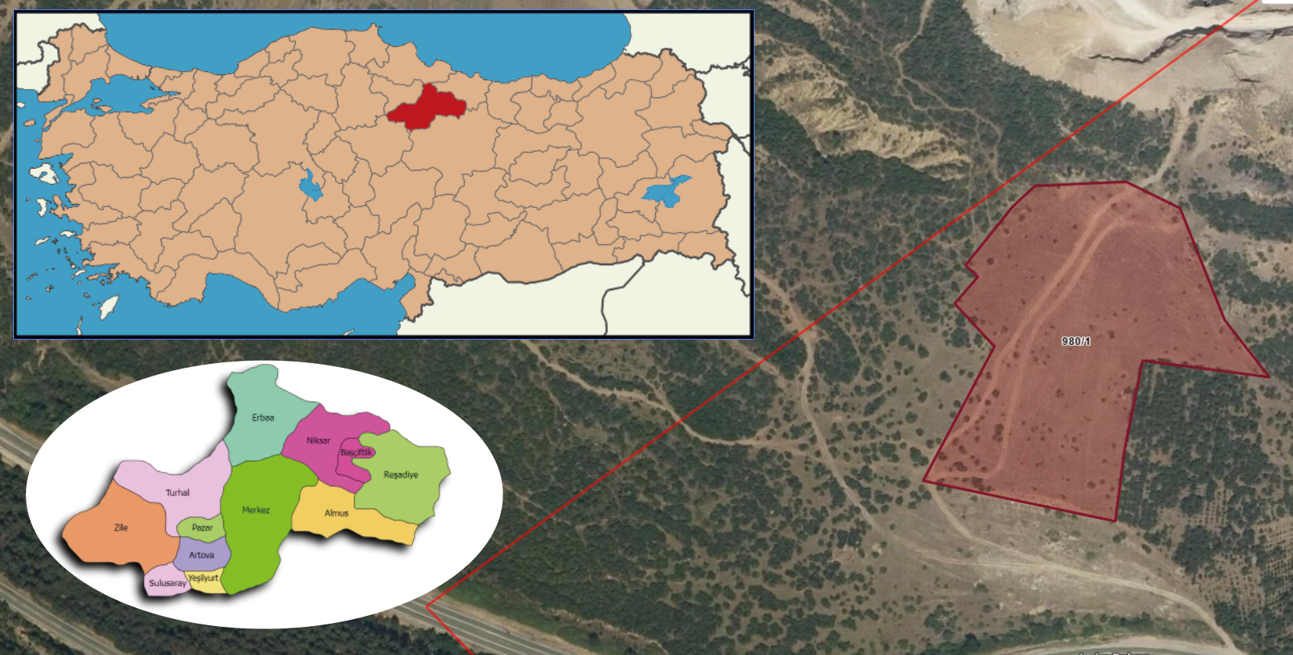

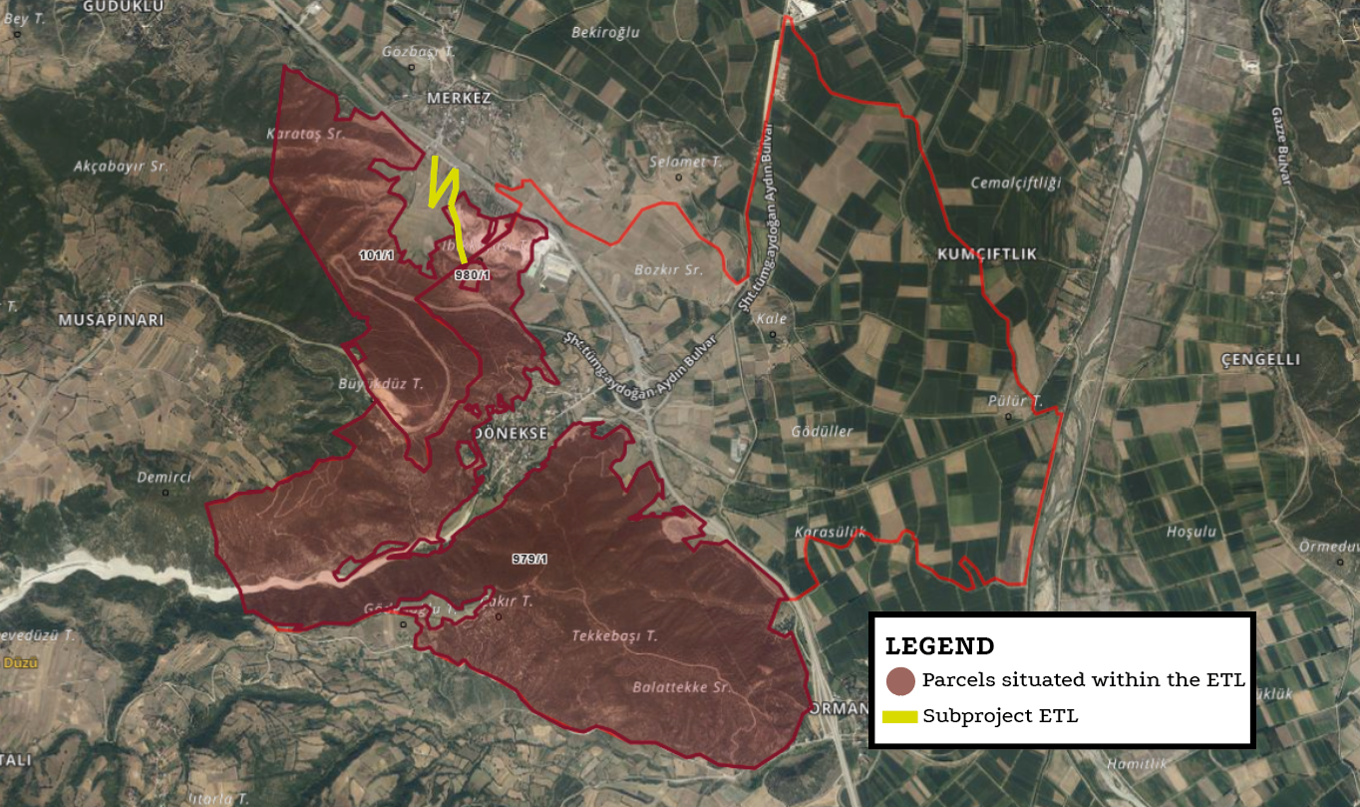

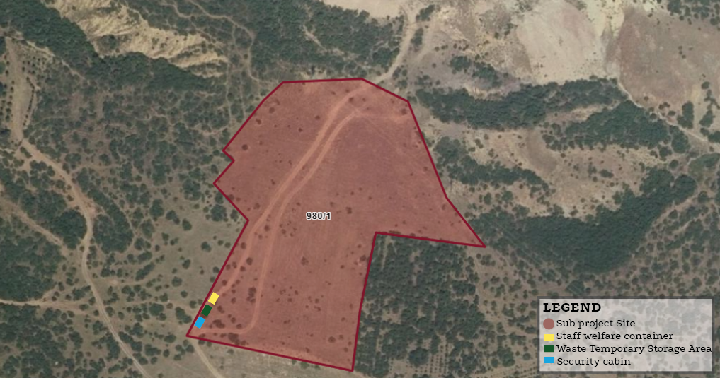

Appendix-2. EIA Not Required Certificate

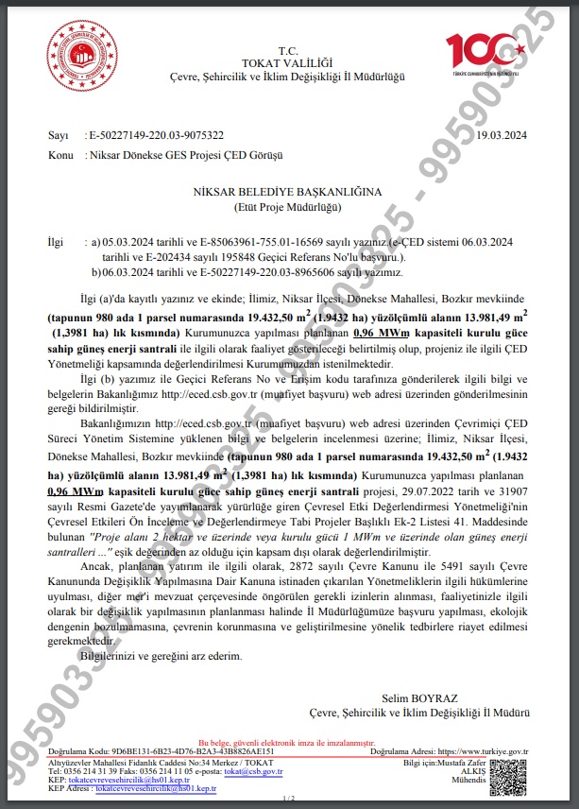

Appendix-3. Zoning Plan

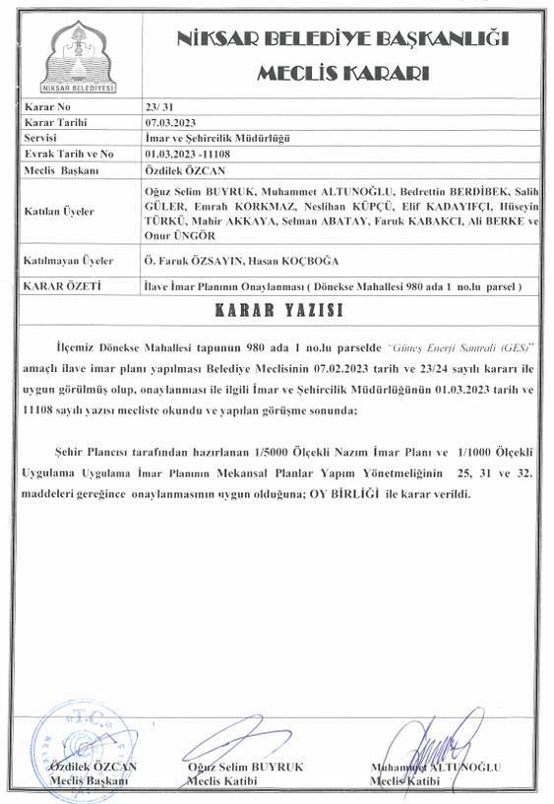

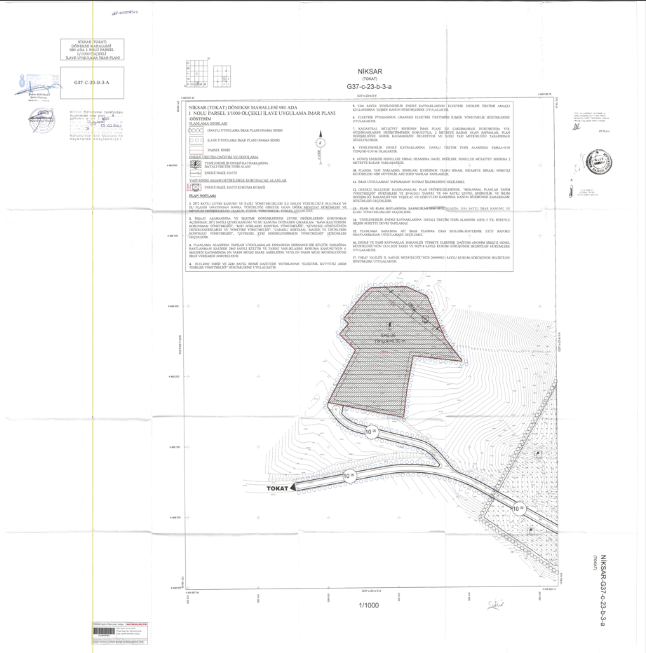
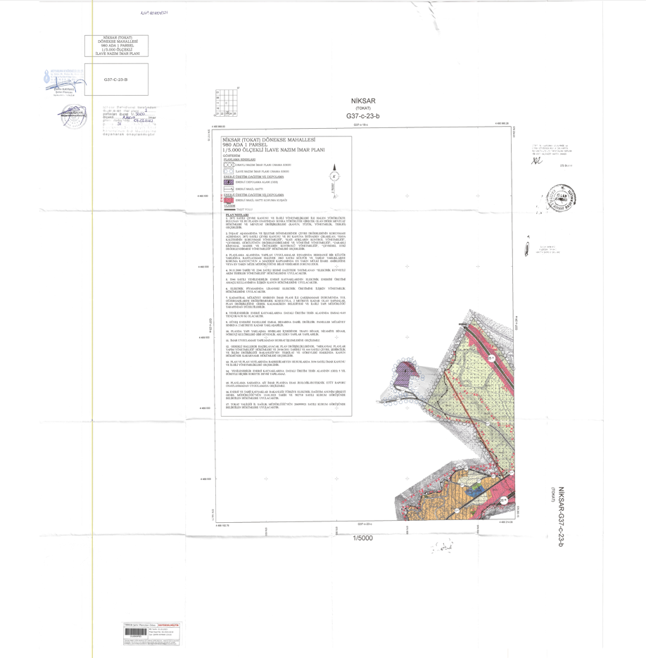
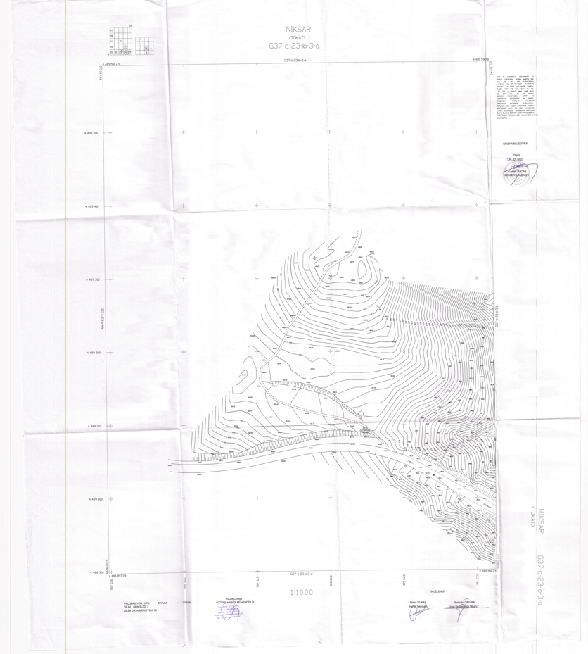

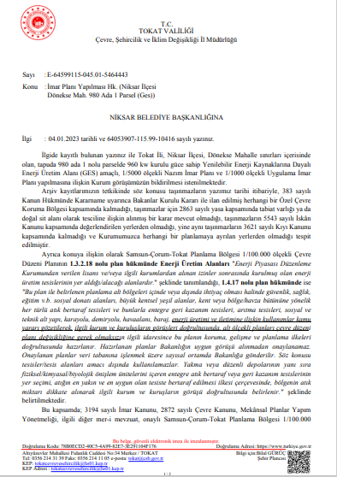
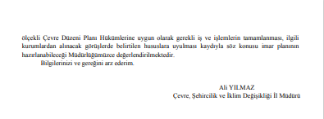
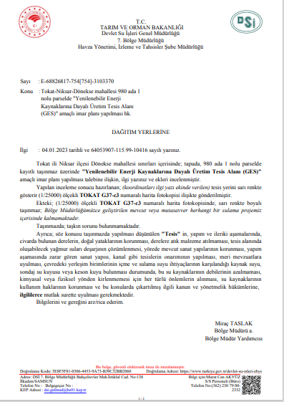

Appendix-4. Copies of Title Deed
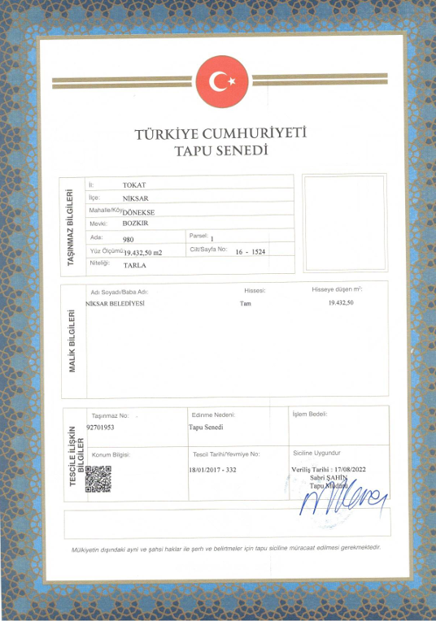

Appendix-5. Photographic Log
Photo No: Reference map | 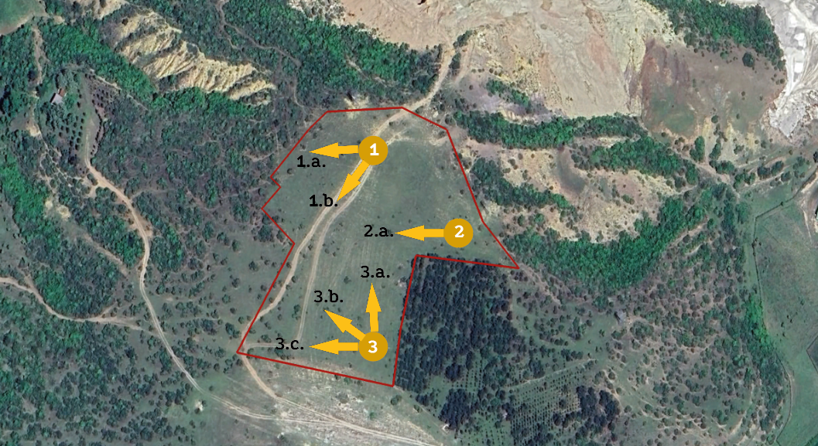
Date: 07.07.2025

Location: lot 1 of block 980

Details/Notes: Numbers 1, 2 and 3 in the photo show the locations where the photos were taken.
Photo No: 1.a. | 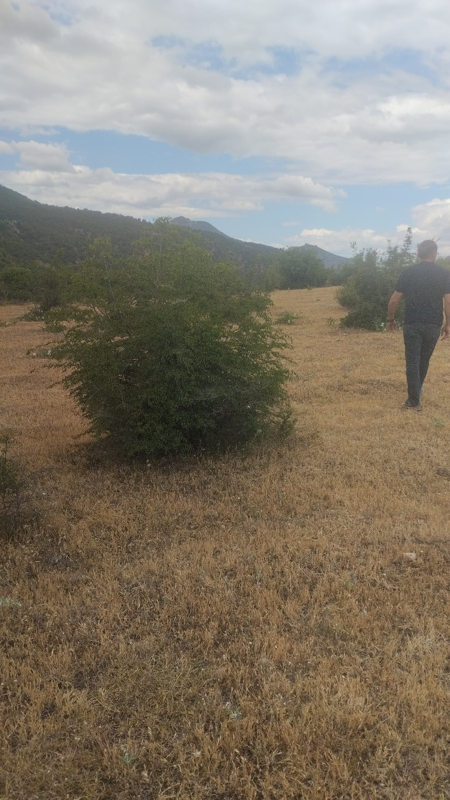
Date: 07.07.2025

Location: lot 1 of block 980

Details/Notes:
The photo above, showing the sub-project site, was taken facing west from Location 1. The site is predominantly covered with steppe vegetation.
Photo No: 1.b. | 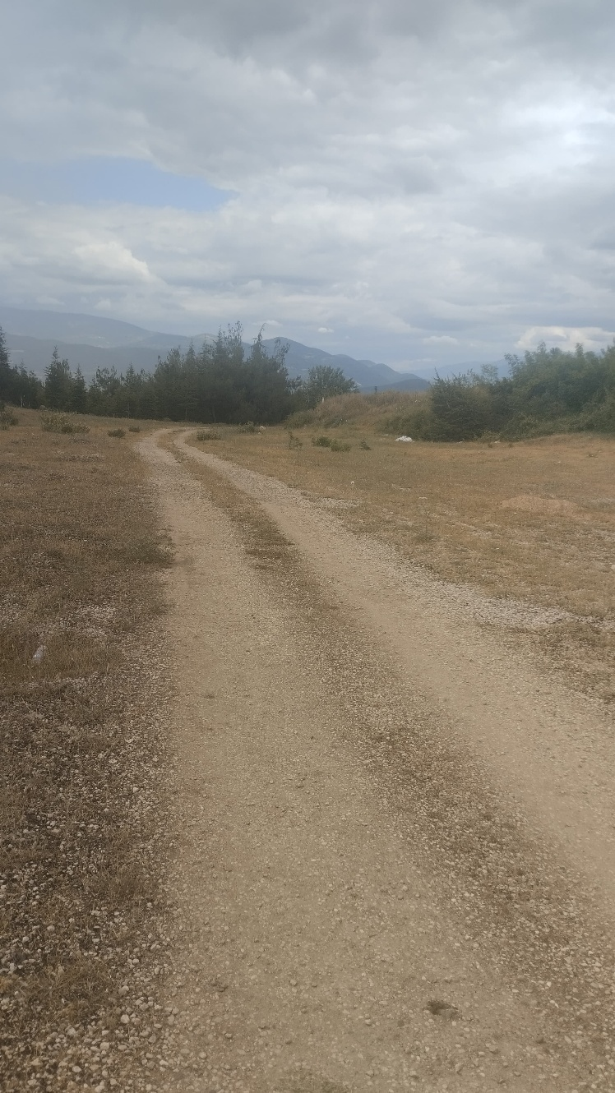
Date: 07.07.2025

Location: lot 1 of block 980

Details/Notes:
The photo above, showing the sub-project site, was taken facing southwest from Location 1. The site is predominantly covered with steppe vegetation.
Photo No: 2.a. | 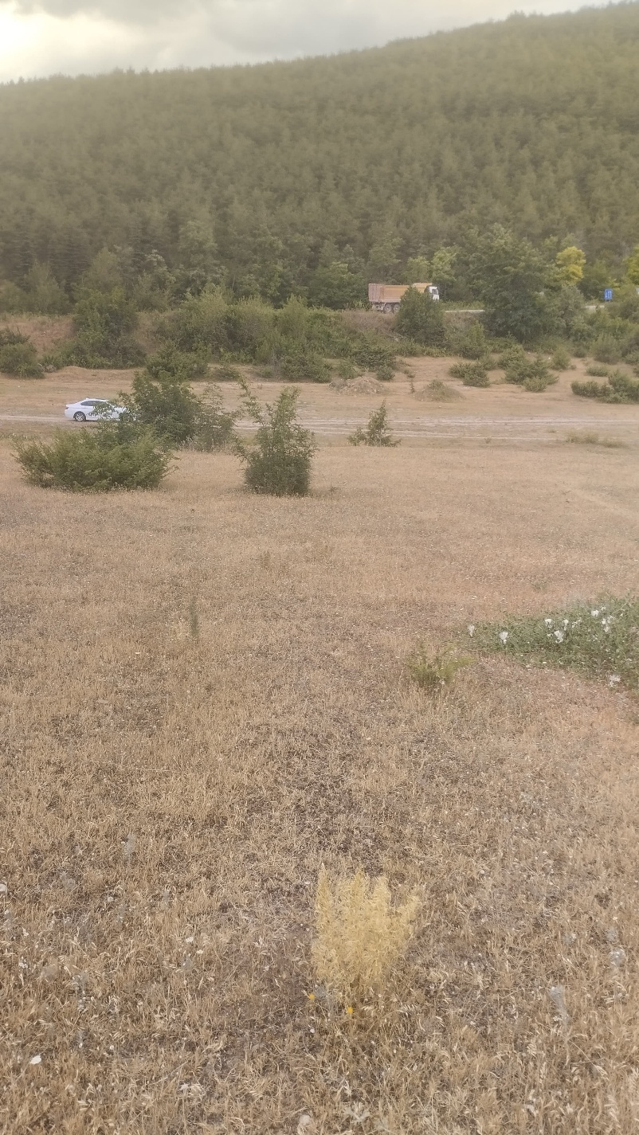
Date: 07.07.2025

Location: lot 1 of block 980

Details/Notes:
The photo above, showing the sub-project site, was taken facing north from Location 2. The site is predominantly covered with steppe vegetation.
Photo No: 3.a. | 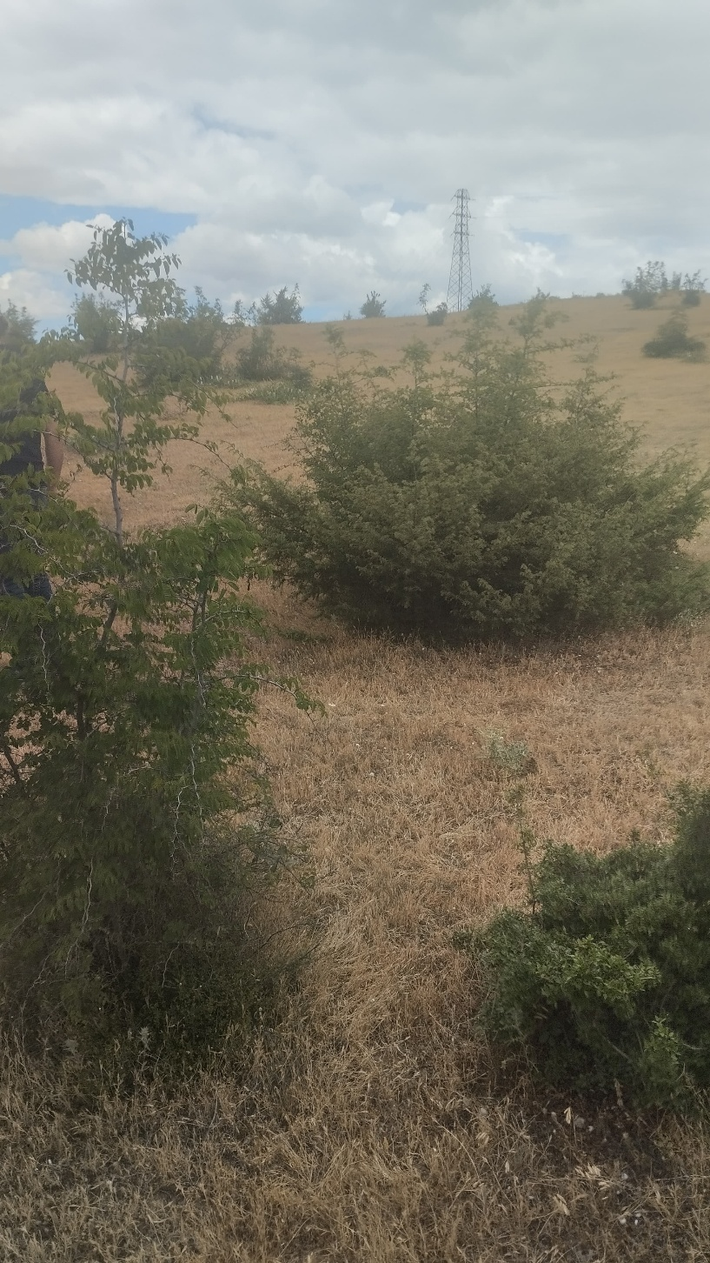
Date: 07.07.2025

Location: lot 1 of block 980

Details/Notes:
The photo above, showing the sub-project site, was taken facing north from Location 3. The site is predominantly covered with steppe vegetation.
Photo No: 3.b. | 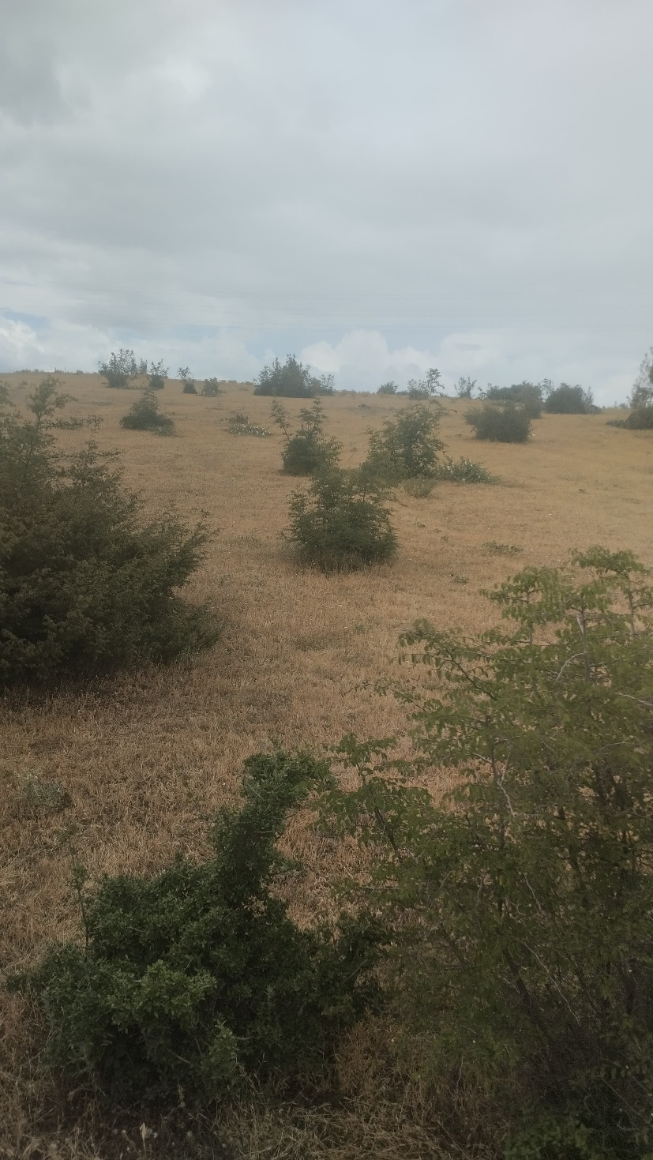
Date: 07.07.2025

Location: lot 1 of block 980

Details/Notes:
The photo above, showing the sub-project site, was taken facing northwest from Location 3. The site is predominantly covered with steppe vegetation.
Photo: 3.c. | 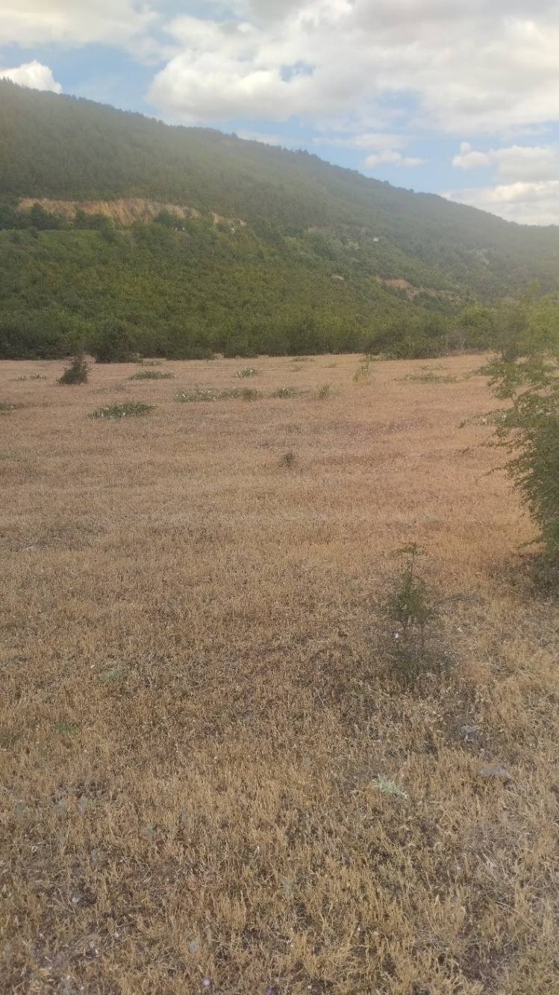
Date: 07.07.2025

Location: lot 1 of block 980

Details/Notes:
The photo above, showing the sub-project site, was taken facing west from Location 3. The site is predominantly covered with steppe vegetation.

Appendix-6. Construction Notice Template
“Çevreye verdiğimiz rahatsızlıktan dolayı özür dileriz!”

NİKSAR BELEDİYESİ
1,137.96 KWP/ 960 KWE GES ALTPROJESİ YAPIM İŞİ
İşin Süresi:

Şikâyet, istek, soru ve yorumlarınız için:

YÜKLENİCİ ADI | : |  | Adres:  Telefon:  E-posta:  İletişim Formu:
İŞVEREN | : |  | Adres: Yusufşah Mahallesi, Fatih Sultan Mehmet Cd. No:151, 60600 Niksar/Tokat, Türkiye  Telefon: +90 850 633 06 60  E-posta: info@niksar.bel.tr  İletişim Formu:
İller Bankası A.Ş.  (İLBANK) |  |  | Adres: İller Bankası A.Ş. Emniyet Mahallesi, Hipodrom Caddesi No:9/21, Yenimahalle/ANKARA  Telefon: 0 (312) 508 79 79  E-posta: uidbbilgi@ilbank.gov.tr  İletişim Formu: https://www.ilbank.gov.tr/form/bilgiedinmeuluslararasi | 

Appendix-7. E&S Incident Notification Form

1) Incident Details

Date of Incident: [Please insert] | Time of Incident: [Please insert]
Location of the Incident: | [Please insert]
Sub-borrower Name: | [Please insert]
Date Reported to ILBANK:  [Please insert] | Reported to ILBANK by:  [Please insert] | Notification Method:  [Please insert]
Date Reported to WB:  [Please indicate] | Reported to WB by:  [Please insert] | Notification Type:  [Please insert]
Contractor Name: | [Please insert]
Sub-contractor name  (please indicate if involved in the incident): | [Please insert]
2) Type of incident (please check all that apply)

☐ Fatality  ☐ Lost time injury  ☐ Child labor  ☐ Forced labor | ☐ Environmental pollution incident  ☐ Disease outbreaks  ☐ Acts of violence/protest  ☐ Other
3) Description/Narrative of Incident
4) Actions taken to contain the incident
For incidents involving a Contractor:
Name of Contractor: _______________________
Have the works been suspended? Yes ☐ No ☐
5) What support has been provided to affected people
[Please briefly describe]

6) Please provide the supporting documents for the incident, victims and involved persons
(e.g. copies of the social security registration records, victim and witness statements, notification to authorities, legal investigation reports, training records, photographs, etc.)

Appendix-8. Roles and Responsibilities
Party | Role | Key Responsibilities
Sub-borrower
Sub-borrower Niksar Municipality | Sub-borrower Management | - Hold ultimate responsibility for the E&S performance of the subproject to the satisfaction of the ILBANK, including the performance of subproject contractors throughout the sub-financing agreement life cycle.  - Establish Project Implementation Unit (PIU) following the execution of sub-financing agreements to carry out operational and administrative tasks to oversee the implementation of the E&S instruments and monitoring progress; allocate resources for the recruitment of in-house environmental, social and OHS staff under the PIU  - Ensure that E&S instruments and procedures required by ILBANK is prepared within the timeframes agreed with ILBANK and allocate adequate financial and human resources – either from the Sub-borrower’s own resources or from the Subproject loan and implement.  - Cooperate with the ILBANK representatives to discuss and agree on the ESAP and other E&S covenants for incorporation into sub-financing agreements to be executed between the ILBANK and the sub-borrower (with support from RD E&S team as necessary)  - Ensure that EHSS requirements of ILBANK are incorporated into relevant contractor tender and agreement documents to be prepared in collaboration with the construction supervision consultant  - Hold and use the authority and responsibility to stop any subproject related work activity if it poses an imminent danger to health, safety, or the environment.  - Allocate resource to ensure monitoring of subproject E&S performance and reporting to ILBANK at IFI standards in line with the sub-financing agreement conditions  - Facilitate monitoring visits and audits by ILBANK and their consultants  - Notify the ILBANK RD – E&S Teams of any significant E&S incident or accident within maximum 24 hours of the accident/incident; contractually require the supervision consultants and/or contractors to promptly report such incident and accidents (timeframe to be defined by ILBANK)  - Prepare and submit a detailed E&S Incident Investigation Form, supplemented by an RCA to be conducted pursuant to GIIPs, to ILBANK within 15 days of the accident/incident date for significant accidents or incidents (in line with the template presented in the E&S Supervision, Monitoring and Reporting Procedure). The investigation will be supplemented by a Root Cause Analysis (RCA).  - Prepare and submit semiannual E&S monitoring reports to ILBANK.
Sub-borrower Niksar Municipality | E&S Team  - Environmental staff  - Social staff  - OHS staff | - Participate in the training to be organized by ILBANK as part of ILBANK ESMS Training Procedure implementation  - Ensure that E&S documentation required by ILBANK is prepared by qualified independent specialists and submitted to ILBANK for appraisal and credit.  - Provide ILBANK with relevant adequate information to undertake the E&S due diligence in accordance with the ESMS (e.g. duly completed sub-borrower questionnaire and supporting documentation to be requested by ILBANK in accordance with the E&S Screening and Risk Classification and ESDD procedures)  - Support the sub-borrower management as required in the review and evaluation of ESAP and other E&S covenants for incorporation into sub-financing agreements to be executed between the ILBANK and the sub-borrower  - Ensure compliance of subprojects operations (including contractor activities on site) with national legislation and E&S requirements of the lending WB as included in the sub-financing agreements, ESAP and subproject-specific E&S documentation.  - Undertake monitoring of subproject E&S performance and reporting to ILBANK at WB standards in line with the sub-financing agreement conditions  - Ensure implementation of corrective actions in case of E&S non-compliances in coordination and agreement with ILBANK DG and RD E&S teams over reasonable timeframes  - Coordinate the construction supervision consultants, contractors and/or external E&S consultants for collection of the monitoring data and compilation of or providing input to periodic monitoring reports as necessary and appropriate  - Allow ILBANK representatives (including individual consultants) to access subproject facilities and records
Construction Supervision Consultants (“Müsavir”) | Management and E&S staff | Carry out the following tasks on behalf of the sub-borrowers:  - Participate in the training sessions to be organized by sub-borrowers in line with the requirements of ILBANK ESMS Training Procedure  - Supervise the construction works of contractors on-site, including implementation of subproject-specific E&S requirements by contractors on a daily basis  - Ensure sufficient E&S capacity for implementation of E&S requirements as set out in the sub-financing agreements between the sub-borrower and ILBANK  - Support the sub-borrowers for the supervision and review of E&S management documentation prepared by construction contractors and submit them to sub-borrowers upon finalization  - Review monthly self-monitoring reports prepared by the construction contractors for early identification of E&S issues and/or non-compliances and submit them to municipalities/municipal utilities upon finalization  - Prepare and submit regular monthly reports to Sub-borrower on the environmental, social and OHS issues of the Sub-Project during the construction phase  - Identify E&S non-compliances on site and enforce construction contractors to undertake corrective actions within defined and agreed timeframes  - Support the sub-borrowers (as requested) in the preparation of periodic E&S monitoring reports to be submitted to ILBANK in line with the ILBANK E&S Supervision, Monitoring and Reporting Procedure  - Notify the sub-borrower of any significant E&S incident or accident that have taken place in subproject related operations within 24 hours.
Construction Contractor | Management and E&S staff | - Ensure sufficient E&S capacity for implementation of E&S requirements as set out in the construction contracts  - Participate in the training sessions to be organized by sub-borrowers in line with the requirements of ILBANK ESMS Training Procedure  - Prepare subproject-specific E&S management plans and procedures prior to start of construction works as required by the construction contracts  - Comply with the requirements of national legislation and implement the E&S requirements as set out in the sub-financing agreements (executed between ILBANK and the sub-borrowers) and construction contracts  - Submit periodic (in frequencies to be set by ESAP) E&S self-monitoring reports to the municipalities/municipal utilities through construction supervision consultants (“müşavir”) – in line with the format provided by ILBANK.  - Fill in monthly occupational health and safety (OHS) forms – reviewed by construction supervision consultants.  - Implement corrective actions in case of E&S non-compliances under the supervision of sub-borrower’s construction supervision consultant  - Promptly notify the sub-borrower of any significant E&S incident or accident that have taken place in subproject related operations (timeframe to be defined by ILBANK no later than 24 hours).

Appendix-9. Chance Find Procedure
Introduction
This document describes the Chance Find Procedure for subproject, outlining the procedures that will be followed in case of chance finds occur during the construction activities associated with the subproject.
Scope
This Chance Find Procedure (CFP) will be implemented for Niksar Municipality 1,962 kWp/1,600 kWe Solar Power Plant of SPP sub-project in order to manage any chance finds that may be encountered during the construction activities. The purpose of the CFP document is to:
- outline the applicable legislation and standards relevant to this procedure;
- define roles and responsibilities;
- define project commitments, operational procedures, training requirements and guidance relevant to this procedure; and
- define monitoring and reporting procedures.
Although there are no known archaeological sites or remains within the subproject area, it is considered that there may be a potential to encounter archaeological findings during the construction of the subproject. Activities which have high potential to lead to discover or adversely affect the archeological resources are;
- topsoil stripping
- excavation and earthworks
This CFP is prepared in order to provide information to the contractors and employees regarding the actions to be taken in case of an archaeological chance find discovery.
Legislation and Standards
Legislation and standards that apply to the project comprise the following:
- Word Bank Environmental and Social Standard (ESS) 8: Cultural Heritage
- applicable Turkish laws and national standards
- other commitments to and requirements of Turkish government authorities
- other industry guidelines with which the project has committed to comply
In Türkiye, movable and immovable cultural and natural assets are protected and preserved by the Law on Preservation of Cultural and Natural Assets (Law No. 2863) published in the Official Gazette dated 23.07.1983 and numbered 18113. Law 2863 establishes legal protection for the following:
- all natural assets and immovable cultural assets constructed up until the end of the 19th century,
- any immovable cultural asset from after the end of the 19th century, identified by the Ministry of Culture and Tourism as an important asset worthy of preservation,
- all immoveable cultural assets located within archeological sites,
- buildings/areas that have witnessed significant historical events during the National War and the foundation of the Turkish Republic and dwellings that have been used by Mustafa Kemal ATATÜRK, regardless of time and registration.
The Ministry of Culture and Tourism is the responsible body to take decisions for protection of cultural heritage in Turkey at the national level. As part of the Ministry, the High Commission for the Protection of Cultural Assets is responsible for protecting and restoring immovable cultural assets. Implementation of the decisions and regulations issued by the Ministry are undertaken by local administrations. At local level, there are Cultural Assets Protection Regional Boards defined by the Ministry of Culture and Tourism, which are responsible for preservation, registration and classification of cultural heritage within their respective jurisdictions. The relevant Regional Board for the project is the Tokat Cultural Heritage Protection Regional Board Directorate.” According to Law 2863, all the natural and cultural assets qualified for legal preservation are properties of the State. Therefore, regional boards have the power and authority to provide legal protection to the preservation sites and to approve or reject all the activities, which have potential negative impacts on the preservation sites such as construction, demolition and excavation activities.
Roles and Responsibilities
Principal roles and responsibilities for the implementation of this procedure are outlined below.
Role | Responsibilities
Contractor -Project Manager | - Overall responsibility for the development, review, approval and coordination of the numerous activities required to initiate, conduct and complete construction.  - Ensure that this procedure is prepared, and updated as required, based on the activities undertaken as part of the project.  - Ensure that adequate resources are made available to implement the procedures and guidelines outlined in this procedure.
Contractor -Environmental and Social (E&S) Expert | - Initiation, development, implementation and coordination of the CFP during construction.  - Ensure that adequate training is given to all site personnel and sub- contractors, covering the procedures and guidelines outlined in this procedure. Establish appropriate control procedures and conduct audits as necessary.  - Consultation with and reporting to relevant government bodies in case of potential archeological chance finds.  - Record all confirmed chance finds by filling up the “Chance Find Reporting Form” and maintain copies in a log-book. Ensure that the chance finds log-book is up to date.
Contractor - Site Manager | - Day-to-day implementation of the provisions of the CFP in the field during construction.  - Notify the E&S Expert regarding potential chance finds during construction.
Employees | - Understand and comply with archeological chance finds procedures and guidelines outlined in this procedure.  - Reporting of the potential chance finds to the Site Manager.

Impact Avoidance and Mitigation
In the event of an archaeological discovery, the following actions will be implemented:
- All staff involved in land clearance and excavation activities will take the responsibility for managing archaeological protection and will be trained in these aspects by the E&S Expert.
- In case any potential chance find is encountered, all construction activities will cease immediately in the vicinity of the chance find.
- The Site Manager will be contacted immediately. The discovered site location, the characteristics of the potential archaeological material and photos will be recorded by the Site Manager, who in turn will inform the E&S Expert.
- Tokat Museum Directorate will be notified at the latest within three days after the chance find is encountered. Contact details of the Tokat Museum Directorate are given below:
Address: Camiikebir Mahallesi,Sulusokak Caddesi, No:86 Arastalı Bedesten Tokat
Telephone: +90 356 214 15 09
E-mail: tokatmuzesi@ktb.gov.tr
- The site and its vicinity will be secured 24 hours a day against damage or loss, until inspection by the authority.
- The E&S Expert will fill up a “Chance Find Report Form” for each confirmed chance find and inform the Project Manager about the date that the construction work can resume, which is determined by the authorities concerning the conservation of the heritage.
- Further steps to be followed and proper plan to be implemented for the management of the finds (Changes in the layout, conservation, preservation, restoration and salvage) will be decided and reported in writing by the authorities in charge.
- Photographs of the potential artifacts that are likely to be encountered in the construction site are presented in the following pages to be used during the training of the relevant staff.

Verification and Monitoring
E&S Expert/s will record all cases of archaeological chance finds. He/she will fill up a “Chance Find Reporting Form” for each chance find confirmed by the authority and maintain copies in a logbook. A sample of a reporting form which can be used to record chance finds is included below. The chance find logbook will be summarized on an annual basis and records included in semi-annual monitoring reports to verify that correct management procedures have been followed. Action items will be taken in cases of non-adherence to this CFP.
Reporting
Contractor will comply with reporting requirements including chance finds defined in site-specific ESMP (contractor will develop monthly and quarterly monitoring reports and submit to Niksar Municipality through supervision consultant; Niksar Municipality will examine submit the reports to ILBANK quarterly (and monthly if requested by ILBANK); ILBANK will inform the World Bank by providing regular semi-annual monitoring reports.

Niksar Municipality 1,137.96 kWp/ 960 kWe Subproject
Chance Find Reporting Form
REGISTRATION
Name of recorder:
Date and time of discovery:
Site Name: | Coordinates  X Y
Description of find:
Photograph:
Estimated weight and dimensions:
CONTACT PERSON
Name/Title/Duty:
Date and Time:
Contact information:
Details of conversation:
DECISIONS
Any protection measures to be implemented:
Movable or immovable: If moved, please specify the new location.
Further actions required:
Recommence date and time:
Notes:
SUBMISSION
Name: |  | Date:

Appendix-10. Change Notification Form
Change Notification Form
Subproject Name
Subproject Location
Subproject Phase | ☐ | Pre-construction
Subproject Phase | ☐ | Construction
Subproject Phase | ☐ | Operation
Name of the Institution Notifying the Change
Date
Category of the Change  (please select all that apply) | ☐ | Legislative Change
Category of the Change  (please select all that apply) | ☐ | Design Change
Category of the Change  (please select all that apply) | ☐ | Schedule Change due to E&S factors
Category of the Change  (please select all that apply) | ☐ | Project Schedule Changes due to technical, financial, legal or administrative factors
Category of the Change  (please select all that apply) | ☐ | Changes due to E&S issues encountered at subproject implementation
Category of the Change  (please select all that apply) | ☐ | Contractor or Construction Supervision Consultant Change
Category of the Change  (please select all that apply) | ☐ | Other (please specify below)
Detailed Description of the Change(s)

Documents Submitted with Change Notification Form

Name of the Staff Notifying the Change

Position of the Staff Notifying the Change

Signature

Appendix-11. Biological Characteristics
Flora
Family/Species | Endemism | IUCN | Bern
Datura stramonium | - | LC | -
Datura innoxia | - | LC | -
Cichorium intybus | - | LC | -
Allium schoenoprasum | - | LC | Annex-I
Paliurus spina-christi | - | LC | -
Achillea millefolium | - | LC | -
Source: http://www.tubitak.gov.tr/ (Türkiye Bitkileri Veri Servisi – TUBİTAK) Baytop T., 1994, Türkçe Bitki Adları Sözlüğü, TDK, Ankara http://www.iucnredlist.org/
Fauna
Species | MAK | IUCN | Bern
Mammalia
Sus scrofa | - | LC | -
Vulpes vulpes | - | LC | ANNEX III
Mus musculus | - | LC | -
Mustela nivalis |  | LC | ANNEX III
Apodemus sylvaticus | - | LC | ANNEX III
Meles meles | - | LC | -
Lepus europaeus | - | LC | -
Source: Demirsoy, A., 2003, Türkiye Omurgalıları ‘Amfibiler’, Çevre Bakanlığı Çevre Koruma Genel Müdürlüğü, Proje No: 90-K-1000-90. Ankara., Baran, İ, 2005, ‘Türkiye Amfibi ve Sürüngenleri’, Ankara
Species | MAK | IUCN | BERN
Aves
Pica pica | - | LC | -
Coturnix coturnix | - | LC | ANNEX II
Buteo buteo | - | LC | -
Luscinia megarhynchos | - | LC | -
Streptopelia decaocto | - | LC | ANNEX III

Species | RDB | MAK | IUCN | BERN
Reptilia
Mauremys caspica | - | - | LC | ANNEX II
Testudo graeca | - | - | LC | ANNEX II
Pseudopus apodus | - | - | LC | ANNEX III
Lacerta media | - | - | LC | ANNEX III
Natrix natrix | - | - | LC | ANNEX III
Source: Kiziroğlu, İ., 2008, ‘Türkiye Kuşları’ (SpeciesList in Red Data Book), Ankara
Species | AYK | MAK | IUCN | BERN
Amphibia
Bufo bufo | - | - | LC | ANNEX III
Bufotes variabilis | - | - | LC | ANNEX II
Pelophylax ridibundus | - | - | LC | ANNEX III
Source: Demirsoy, A., 2003, Türkiye Omurgalıları ‘Memeliler’, Çevre Bakanlığı Çevre Koruma Genel Müdürlüğü, Proje No: 90-K-1000-90. Ankara.
AYK (Decision on the List of Game and Wild Animal Species Determined by the Ministry of Forestry and Water Affairs, published in the Official Gazette dated April 29, 2015 and numbered 29341):
(I) The species indicated with are the wild animal species determined by the Ministry.
(II) The species indicated with are the game animal species determined by the Ministry.
(III) The species indicated with are the wild animal species protected by the Ministry.
MAK (National Parks Game-Wildlife 2024-2025 Central Hunting Commission Decision):
(I) The species indicated with are the game animal species protected by MAK.
(II) The species indicated with are the game animal species permitted to be hunted by MAK.
These are;
Fauna species are protected under two of the annexes of the Bern Convention.
Annex-II: Species of fauna that are strictly protected
a) All kinds of deliberate capture and detention, deliberate killing,
b) Intentionally damaging or destroying breeding or resting places,
c) Intentionally disturbing wild fauna, especially during breeding, development and hibernation periods, in a manner contrary to the purpose of this agreement,
d) Collecting eggs from the wild environment or deliberately destroying them or keeping these eggs, even if they are empty,
e) Keeping and domestic trade of fauna species, whether alive or dead, is prohibited.
Annex-III: Protected Fauna Species
a) Temporary or regional bans in appropriate cases in order to bring wild fauna to sufficient population levels. Closed hunting seasons and other national principles.
According to IUCN, fauna species that are protected are classified as follows.
EX: Extinct
EW: Extinct in the Wild
CR: Critically Endangered
EN: Endangered
DD: Insufficient Data
NE: Not Evaluated
VU: Vulnerable
LR: Less Threatened
a-(cd): Requiring Conservation Measures
b-(nt): May Be Threatened
c-(lc): Least Concern
According to the work titled “Red List of Birds of Türkiye” (Kiziroğlu, 2008), the Red Data Book classification of bird species found and likely to be found in the subproject area and its surroundings and their status in Türkiye are given below.
I. Birds that incubate in Türkiye; in other words, bird species falling into the “A” category consist of either annual bird species and local; or summer migrants, in other words, migratory species that leave Türkiye after incubating.
A.1.1: Species that are undoubtedly satiated and no longer seen in the wild.
A.1.2: Species with extinct natural populations continue their lives for human support and protection.
A.1.3: Species whose populations have decreased significantly in Türkiye. They are species that must be protected because they are largely under threat.
A.2: Species that are under significant threat of extinction.
A.3: Species that are at risk of extinction and have a high risk of extinction in natural life.
A.3.1: Species that have decreased according to old records in the regions where they are observed.
A.4: Species that have a local decrease in their populations and are close to becoming endangered over time.
A.5: Species that do not yet have a decrease or threat of extinction in their observed populations.
A.6: Species that have not been sufficiently studied and do not have reliable data.
A.7: It is not possible to make an assessment about these species at the moment because the records of these species obtained in Türkiye are not fully reliable and sound.
II. Species in Group “B” are either winter visitors or transit migrants. These species are also under significant threat of extinction and will be subject to the same assessment as in Group “A”. Therefore, criteria in steps B.1.0-B.7 are used for species in Group “B”. The flora and fauna in the subproject’s AoI do not include endemic species.

Appendix-12. Emissions and Environmental Noise Calculations
Air Quality/Emission
Air pollution will mainly originate from dust emissions and exhaust emissions as well as Greenhouse Gas (GHG) emissions. Considering the location of the sub-project area, sensitive receptors are not expected to be affected. During the construction phase of the sub-project, the impacts on air quality will mainly originate from dust, exhaust and greenhouse gas emissions:
• Dust emissions during site preparation, excavation, filling and compaction works carried out for construction works.
• Dust emissions from vehicle movements for transporting various construction materials to the project site.
• Exhaust emissions from vehicles used in construction activities.
• Greenhouse gas emissions from small amounts of vehicles and machinery.
Since a limited number of equipment and machinery will be operating on the sites, these air quality impacts will be limited to the area and in the short term.
Calculation of dust emission topsoil stripping
In the calculation of the dust emissions to be generated, the emission factors given in Table 2.7 of the “Regulation on Control of Industrial Air Pollution” (Amended Table: RG-20.12.2014-29211) published in the Official Gazette dated 03.07.2009 and numbered 27277 were used and the results were evaluated within the framework of the same regulation.
The calculations were made using both “uncontrolled” emission factors, considering that the most adverse conditions could occur during dust formation, and “controlled” emission factors, assuming that the necessary control measures were taken.
The area where the SPP project site will be established is 22,400 m². In this area, 10 cm topsoil stripping will be used to strip 2,240 m³ of soil.
(Soil Bulk Density is taken as 1.6 tons/m³)
2,240 m³* 1.6 tons/m³=3,840 tons
Daily working time is planned as 8 hours. Excavation work is planned as 288 hours in total.
15,936 tons/192hours= 13.3 tons/h
Table 1. Control of Industrial Air Pollution
Sources | Uncontrolled | Controlled | Unit
Extraction | 0.025 | 0.0125 | kg/ton
Loading | 0.0100 | 0.005 | kg/ton
Unloading | 0.010 | 0.005 | kg/ton
Transportation (total round trip distance) | 0.7 | 0.35 | kg/km-vehicle
Storage | 5.8 | 2.9 | Dust/ha-day

Mass Flow Rate of Dust Emission to Occur During Extraction, Loading and Unloading of topsoil
Uncontrolled; E1 = 13.3 tons/hour x (0.025+0.01+0.01) kg/ton = 0.6 kg/hour
Controlled; E1 = 13.3 tons/hour x (0.0125+0.005+0.005) kg/ton= 0.3 kg/hour
Mass Flow Rate of Dust Emission to Occur During the Transportation of Topsoil
Topsoil taken from the field during construction work will be temporarily stored in the topsoil storage area that will also be located within the work area; this distance is an average of 0.6 km round trip. Assuming that each truck used during transportation can carry 25 tons of material and therefore will make 1 trip in approximately 1 working day (25 tons/23.32 tons/hour), the mass flow rate of dust emissions that will occur during transportation is;
Uncontrolled; E2 = (0.7 kg/km.vehicle) x (0.6 km/1 trip/vehicle) x (1 trip/1 hour) = 0.42 kg/hour
Controlled; E2 = (0.35 kg/km.vehicle) x (0.6 km/1 trip/vehicle) x (1 trip/1 hour) = 0.21 kg/hour
Dust Emission Mass Flow Rate to be Formed During the Storage of Vegetal Soil
Uncontrolled; E3 = (5.8 kg/ha-day)x(1 ha/6 weeks/ 6 days/week/8 hours/day)= 0.020 kg/hour
Controlled; E3 = (2.9 kg/ha-day)x(1 ha/6 week/6 days/week/8 hours/day)= 0.010 kg/hour
Accordingly, the total mass flow rate of dust emission to be formed from the stripping operations of the vegetal soil to be carried out;
Uncontrolled; ETOTAL-1 = 0.6 kg/h + 0.4 kg/h + 0.020 kg/h ≈ 1,02 kg/h
Controlled; ETOTAL-1 = 0.3 kg/h + 0.2 kg/h + 0.010 kg/h ≈ 0.51 kg/h
When calculating the dust emission to be generated during the vegetative soil stripping operations, it was taken into account that the works would be carried out under the most adverse conditions. As stated in the “Regulation on Control of Industrial Air Pollution; for newly established facilities, “Calculation of the Contribution Value to Air Pollution” is required if the pollutant mass flow rates are exceeded.
Considering that all the works to be carried out within the scope of the vegetal soil stripping operations to be carried out at the construction site will be carried out in the same time period (worst case scenario), the dust emission to be generated has been calculated as 1,02 kg/hour for the uncontrolled case and 0.51 kg/hour for the controlled case. Therefore, as stated in “Regulation on Control of Industrial Air Pollution”; since the specified pollutant mass flow rates are not exceeded for the topsoil stripping operation, it has not been deemed necessary to calculate the “Contribution Value to Air Pollution” using an internationally accepted distribution model in the facility AoI.
The construction equipment and transportation vehicles in question will be used at different times during the day.
Emission calculation from vehicles
The provisions of the Exhaust Gas Emission Control and Gasoline and Diesel Quality Regulation, which was published in the Official Gazette dated 30.11.2013 and numbered 28837 and entered into force, and the Exhaust Gas Emission Control Regulation, which was published in the Official Gazette dated 11.03.2017 and numbered 30004, shall be complied with.
During construction, the fuel to be spent is only necessary for the work machines to be used, there will be no fuel consumption for heating etc. The usage periods and fuel consumptions of the work machines to be used during the construction phase of the business are shared in Table 2.
Table 2. Usage periods of the work machines to be used in the facility
Machine type | Number | Power (hp/h) | Working Time (h/day)
Crane | 1 | 200 | 8
Excavator | 1 | 200 | 8
Truck | 1 | 200 | 8
Pile Driver | 1 | 90 | 8
Water Tank | 1 | 120 | 8

The fuels to be used in the land preparation and construction phase of the sub-project will be diesel fuel to be used during the work of the construction equipment. Apart from this, there is no other type of fuel to be used in the sub-project. Diesel fuel will be preferred as fuel for the construction equipment to be used within the scope of the sub-project. There will be no fuel storage in the sub-project area and the fuel supply to the construction equipment will be made with fuels supplied from authorized stations. The characteristics of diesel fuel are given below:
Table 3. Diesel Properties
Properties | Diesel | Properties | Diesel
Consistency | Very fluid | Carbon Wastes (%) | Trace
Type | Distilled | Sulfur (%) | 0.4-0.7
Color | Amber | Oxygen-Nitrogen (%) | 0.2
Density (150c-gr/cm³) | 0.8654 | Hydrojen (%) | 12.7
Viscosity (380 ºC) | 2.68 | Carbon (%) | 86.4
Pour Point (0ºC) | -18 | Water and Sediment (%) | Trace
Atomization Temperature (0ºC) | Atmospheric | Ash (%) | Trace
Pumping Temperature (0ºC) | Atmospheric | Heat Value | 9.387
Source: Air Pollution Control and Supervision, Chamber of Chemical Engineering, May, 1999
The emission factors table determined by the EPA (Environment Protection Agency) was used for the construction equipment to be used within the scope of the sub-project.
Table 4. Emission Factors Used in Calculations
Power | Year | CO (g/kWh) | HC (g/kWh) | NOx (g/kWh) | PM (g/kWh)
56 ≤ kW < 130  (75 ≤ kW <175) | 2012 and above | 5,0 | 0,19 | 0,40 | 0,02
130 ≤ kW < 560  (175 ≤ kW <560 | 2011 and above | 3,5 | 0,19 | 0,40 | 0,02
Source: USEPA Standards
Using the data in the table above, exhaust gas emissions that will occur during the construction and operation phases are calculated with the formula below and entered into the tables.
Emission Value (kg/h) = Emission Factor x Engine Power (kW) x Number x kg/1000 gr
Table 5. Emission calculations
Equipment to be used | Piece | Hp | kW | Emission Factor (g/kWh) |  | Emission Value (kg/sa)
Excavator | 1 | 200 | 149 | CO | 3,5 | 0,52
 |  |  |  | HC | 0,19 | 0,03
 |  |  |  | NOx | 0,4 | 0,06
 |  |  |  | PM | 0,02 | 0,003
Crane | 1 | 200 | 149 | CO | 3,5 | 0,52
 |  |  |  | HC | 0,19 | 0,03
 |  |  |  | NOx | 0,4 | 0,06
 |  |  |  | PM | 0,02 | 0,003
Pile Driver | 1 | 90 | 67.05 | CO | 5 | 0,34
 |  |  |  | HC | 0,19 | 0,013
 |  |  |  | NOx | 0,4 | 0,026
 |  |  |  | PM | 0,02 | 0,0013
Truck | 1 | 200 | 149 | CO | 3,5 | 0,52
 |  |  |  | HC | 0,19 | 0,03
 |  |  |  | NOx | 0,4 | 0,06
 |  |  |  | PM | 0,02 | 0,003
Water Tanker | 1 | 120 | 89.5 | CO | 5 | 0,4475
 |  |  |  | HC | 0,19 | 0,017
 |  |  |  | NOx | 0,4 | 0,036
 |  |  |  | PM | 0,02 | 0,002
1 Hp = 0.745 kW.
When emissions from all vehicles are added together;
Table 6. Amount of Emission
Pollutant | Amount (kg/h) | Working Time (h) | Total Amount (kg/8 h) | 24 hour emissions
CO | 2.3475 | 8 | 18.78 kg | 18.78 kg/24 h= 0.7875 kg/h
HC | 0.12 | 8 | 0.96 kg | 0.96 kg/24 h = 0.04 kg/h
NOx | 0.242 | 8 | 1.936 kg | 1.936 kg/24 h = 0.08 kg/h
PM | 0.0123 | 8 | 0.0984 kg | 0.0984kg/24 h = 0,004 kg/h

The calculation was made assuming that all vehicles were operating at maximum operating time and in the same month.
Pollutant | Amount (kg/h) | Mass flow rate (kg/hour) given in Annex-2 Table 2.1 of the “Regulation on Control of Air Pollution from Industrial Sources” | Evaluation
CO | 0.7875 | 50 | Below the limit value
HC | 0.04 | 2 | Below the limit value
NOx | 0.08 | 4 | Below the limit value
PM | 0.004 | 1 | Below the limit value

The calculated exhaust gas emission amounts were calculated cumulatively assuming that all machinery and equipment operate at the same time and are entered in the table above. When the calculated hourly mass flow rate (kg/hour) value was compared with the mass flow rate (kg/hour) values given in Annex-2 Table 2.1 of the “Regulation on Control of Industrial Air Pollution”, it was seen that the emission mass flow rates were below the limit values given in the regulation. The calculations were made based on the assumption that all work machines operate simultaneously and continuously in their areas of use, and in reality, such an application is not very possible. Therefore, the emission levels that will occur in reality will be lower than the emission levels found in the calculations.
Where the requirements in Türkiye differ from the levels and measures presented in the EHS Guidelines, the more stringent (such as the most stringent discharge and emission standards) will be applied in the project specification.
Noise
The sub-project activities are planned to be completed in ~2 month. Within the scope of the sub-project, work will be carried out during the daytime, 6 days a week, 8 hours a day.
The sound power levels of the equipment were calculated according to the formulas given below according to the permitted sound power levels defined in the table given in Article 5 of the “Regulation on Noise Emission in the Environment Created by Equipment Used in Open Areas”, which was published in the Official Gazette dated 30.12.2006 and numbered 26392 and entered into force, and data from similar activities were also taken into account.
Table 7. Equivalent Noise level to the distances According to Distribution
Distance (m) | 50 | 100 | 250 | 500 | 1000
Equivalent noise level (dBA) | 74.05 | 66.41 | 57.68 | 50.70 | 48.82
Considering that the residential areas are located approximately 250 meters away, the expected environmental noise level at these points is estimated to be approximately 57.68 dBA. This value is in line with the limit values ​​specified in national legislation (Environmental Noise Control Regulation published in the official gazette dated 30.11.2022 and numbered 32029), but remains above the noise limits determined by IFS General EHS Guides Noise Levels. Therefore, the necessary control and improvement measures to reduce possible environmental impacts are presented in detail in the ESMP Matrix. The calculations were made assuming that all equipment will operate simultaneously. In real life, lower environmental noise levels are expected. In addition, in case of any complaints about noise, measurements will be taken to determine the environmental noise level caused by construction work and if it is high, additional measures such as barriers, arrangement of working hours, etc. will be taken.
Table 8. Environmental Noise Level Limit Values (Environmental Noise Control Regulation)
Noise Source | Measured Parameter | Environmental Noise Level
Noise Source | Measured Parameter | Daytime (07:00 - 19:00) | Evening (19:00 - 23:00) | Night (23:00 - 07:00)
Industrial facilities transportation resources | LAeq,5min. | 65 dB(A) | 60 dB(A) | 55 dB(A)
Workplaces(2) | LAeq,5min. | Background + 5 dB(A) |  | Background + 3 dB(A)
In case of more than one workplace | LAeq,5min. | Background + 7 dB(A) |  | Background + 5 dB(A)
All sources | LCmax | 100 dB(C)
- : These limit values are valid as of 31.12.2023. These limit values are valid for each 1/3 octave of the specified frequency range band. In the acoustic reports prepared until this date, environmental noise measurement results and measurement results measures identified are included.
- : Each workplace contributing to the background noise level is jointly responsible for meeting this limit value. Each workplace takes necessary measures according to their contribution to noise.

Table 9. IFC General EHS Guides Noise Levels
Buyer | Daytime (07:00 - 22:00) | Night (22:00 - 07:00)
Settlement Areas | 55 dB(A) | 45 dB(A)
Commercial/industrial areas | 70 dB(A) | 70 dB(A)

Appendix-13. Permission letter from the Provincial Directorate of Agriculture and Forestry
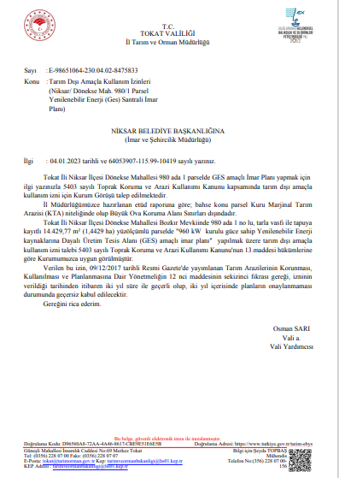

Appendix-14. Opinion letter from other relevant institutions and organizations
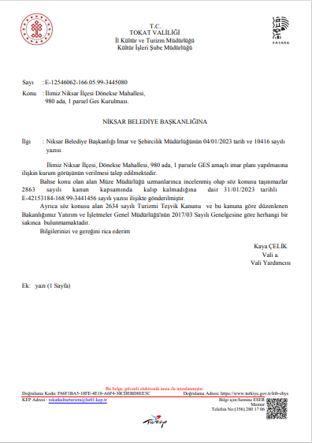
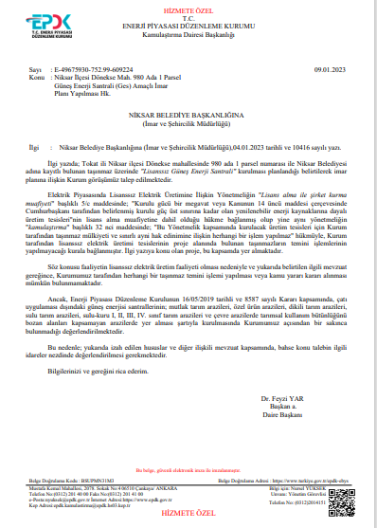
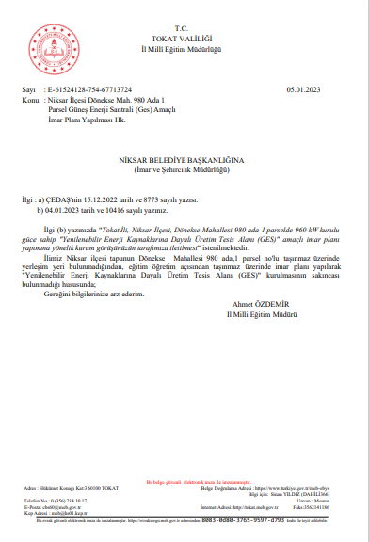
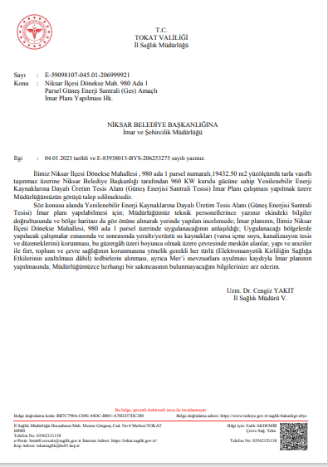
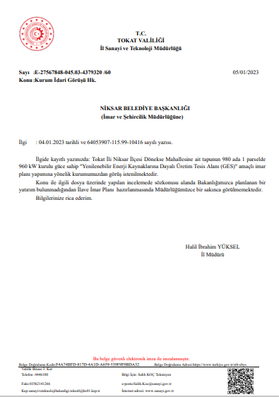
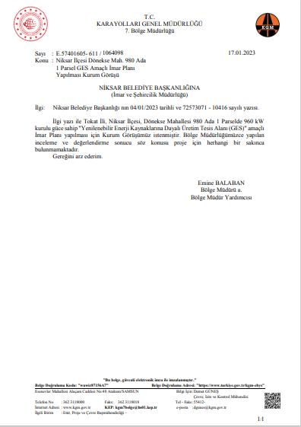
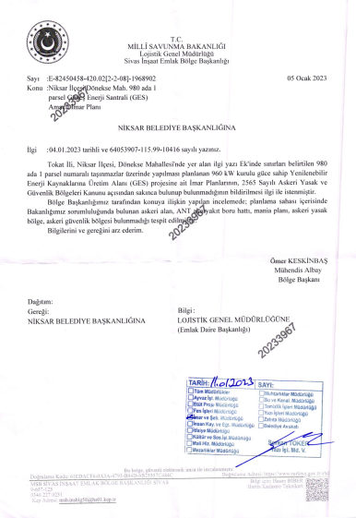

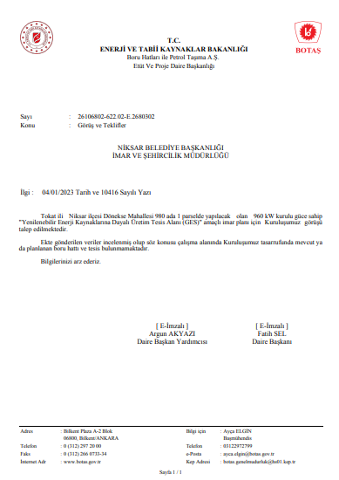
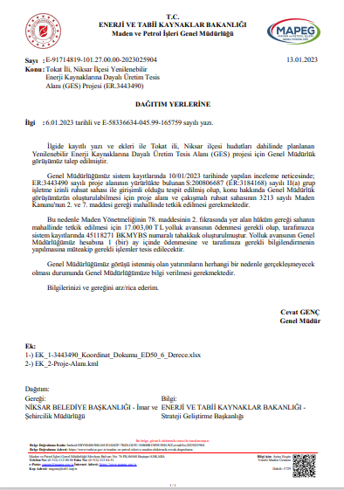
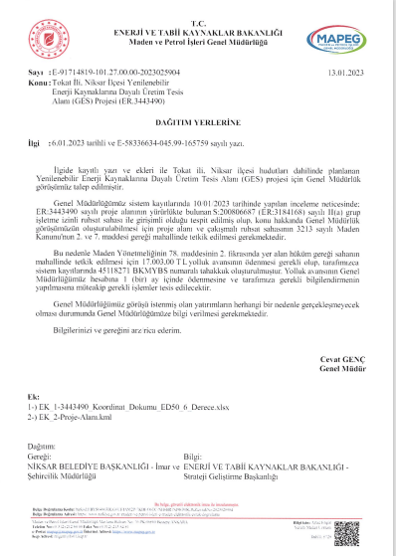
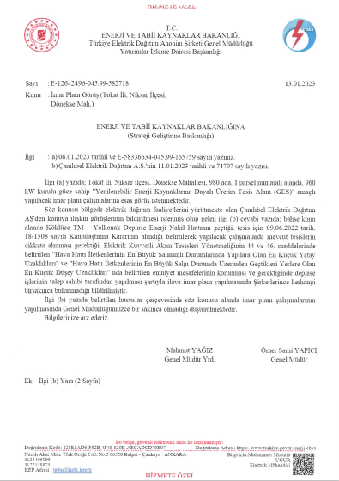
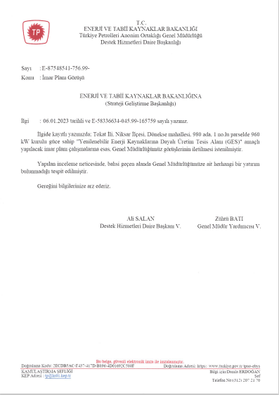
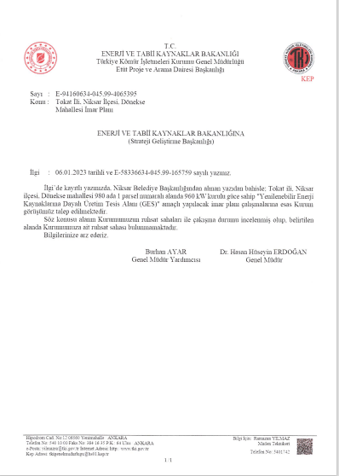
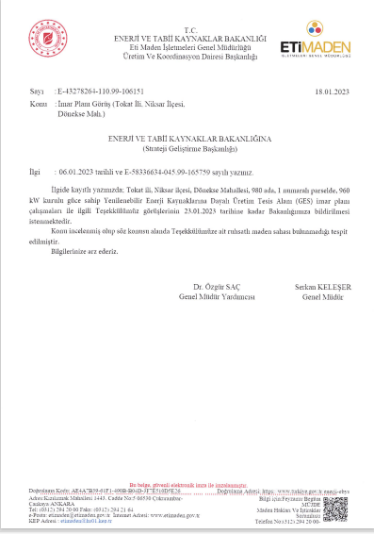
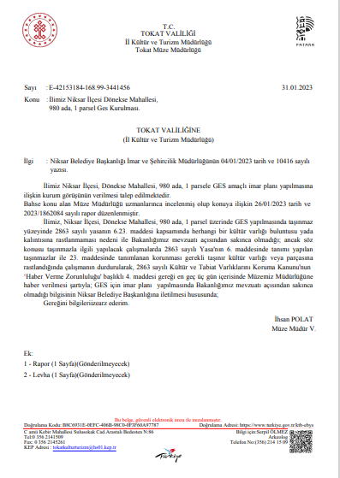
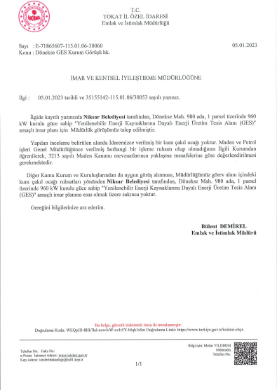
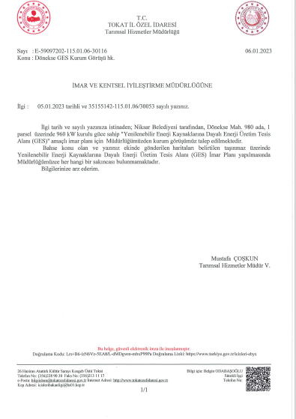
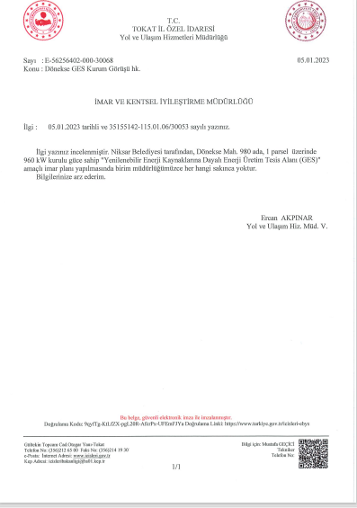
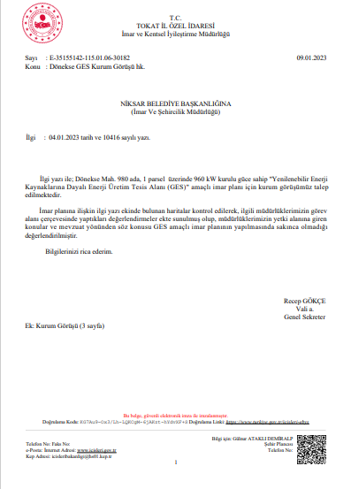

Appendix-15. Permit documents for the ETL route

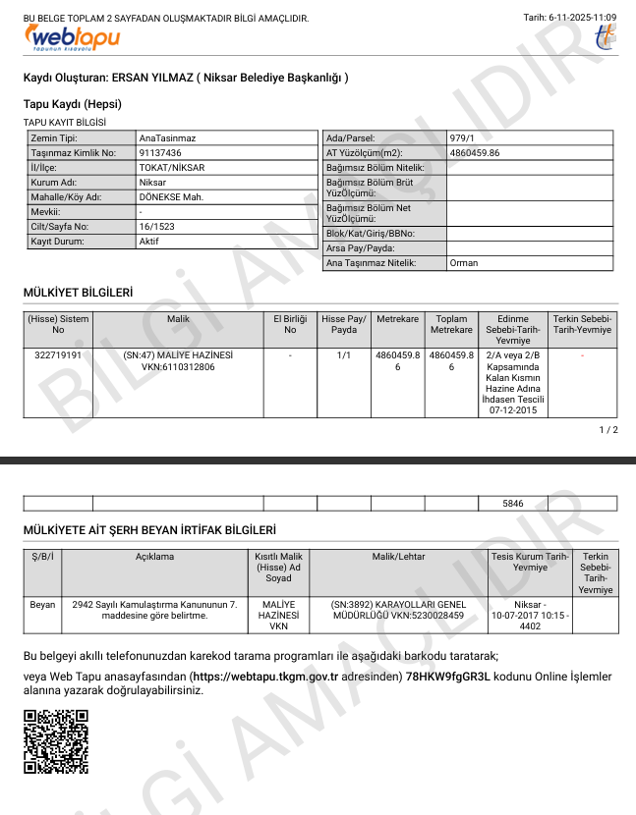

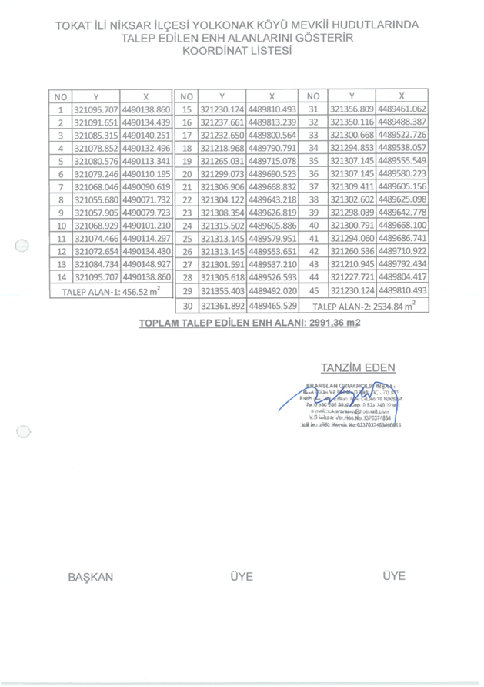
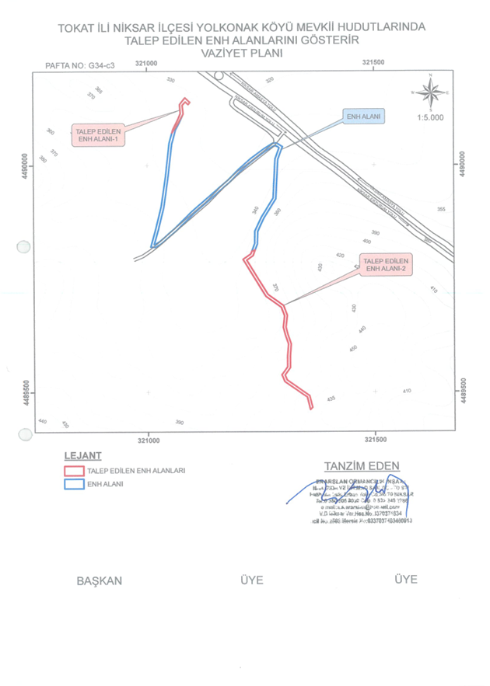
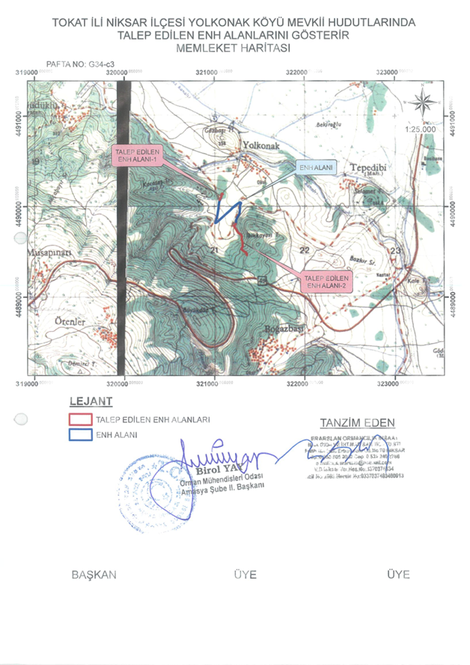

Appendix-16. Field Interviews
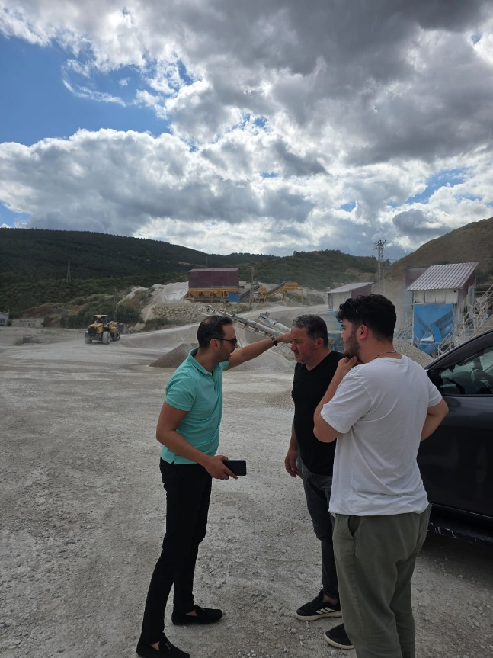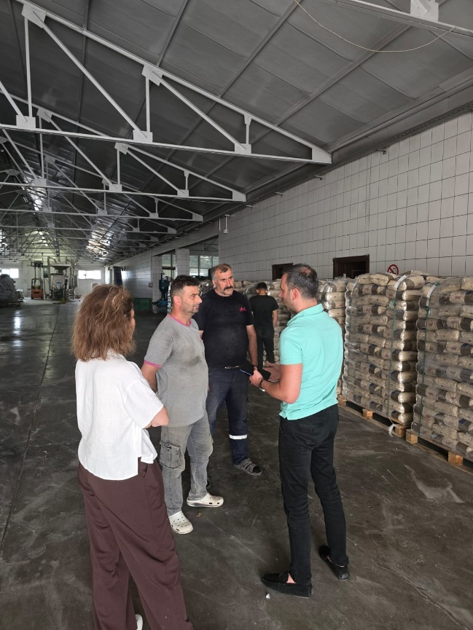
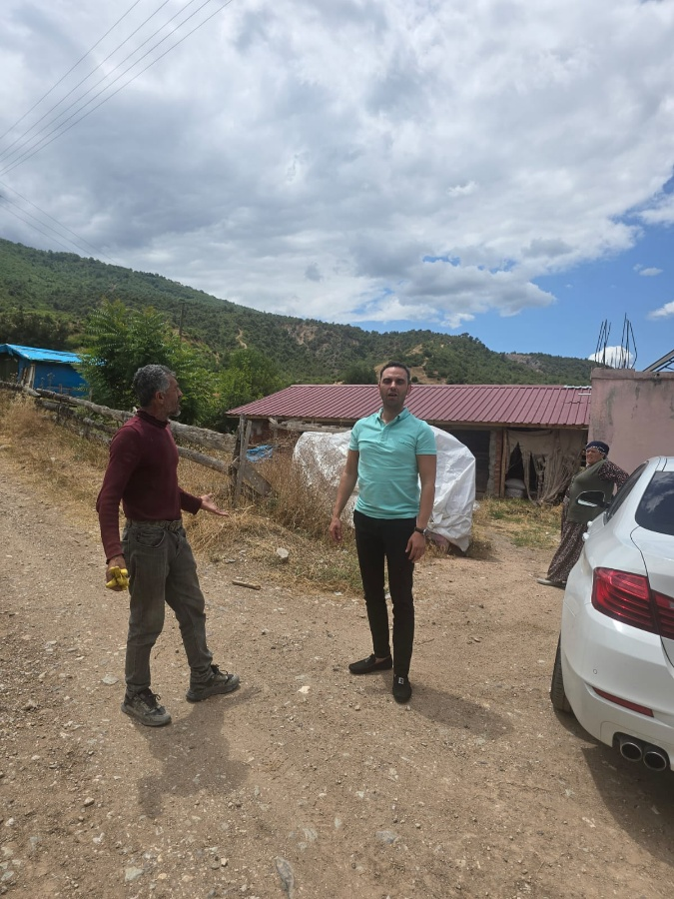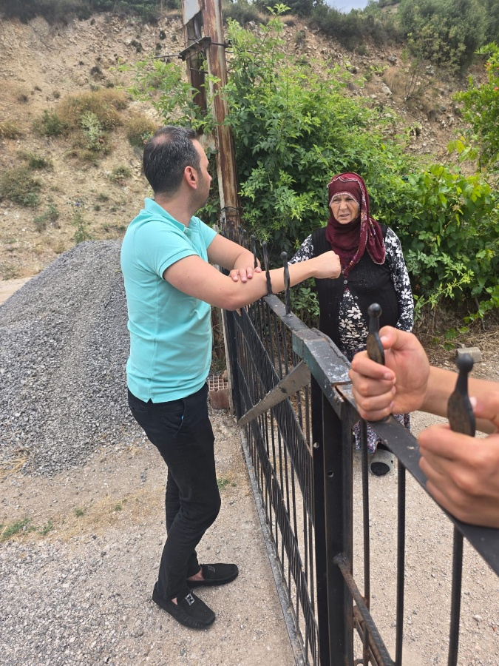
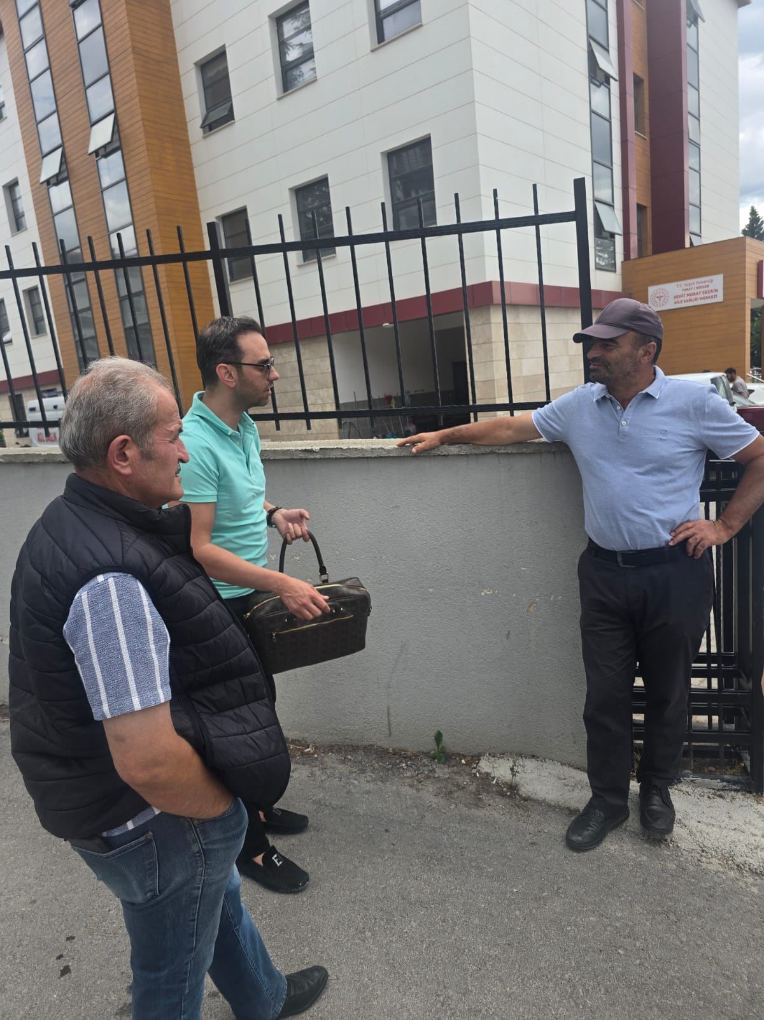

https://www.ifc.org/en/insights-reports/2000/general-environmental-health-and-safety-guidelines
Any incident or accident relating to the subproject which has, or is likely to have, a significant adverse impact on the environment and/or health and safety of communities or employees (direct or contracted) involved in the subprojects related operations will be considered significant, including, inter alia, chemical and/or hydrocarbon materials spills; fire, explosion or unplanned releases, including during transportation; ecological damage/destruction; traffic or other type of accidents that could result in fatalities or serious injuries affecting employees and/or public complaint or protest; failure of emissions or effluent treatment; legal/administrative notice of violation; penalties, fines, or increase in pollution charges; negative media attention; chance cultural finds; labor unrest or disputes; local community concerns.
https://www.soilquality.org.au/factsheets/bulk-density-measurement
https://sbsolar.com.tr/1kw-kac-hp-bir-beygir-kac-kw?srsltid=AfmBOopeJLuU2e08CtSYKdRWghT6TSx7iJDNzzfTjy0U2vio8kOh7QKR

