TÜRKİYE PUBLIC AND MUNICIPAL RENEWABLE ENERGY PROJECT

NİKSAR MUNICIPALITY
960 kWp/1,137.96 kWe SOLAR POWER PLANT PROJECT

STAKEHOLDER ENGAGEMENT PLAN

DECEMBER 2025

TABLE OF CONTENTS
TABLE OF CONTENTS i
LIST OF TABLES ii
LIST OF FIGURES iii
LIST OF ABBREVIATIONS iv
EXECUTIVE SUMMARY 5
1. INTRODUCTION/PROJECT DESCRIPTION 7
1.1. Objectives 7
1.2. Components 7
1.3. Location 8
1.4. Area of Influence 8
2. OBJECTIVE/ DESCRIPTION OF SEP 10
3. STAKEHOLDER IDENTIFICATION AND ANALYSIS 12
3.1. Methodology 12
3.2. Project Affected Persons and Other Interested Parties 12
3.3. Disadvantaged/ vulnerable individuals or groups 13
4. STAKEHOLDER ENGAGEMENT PROGRAM 17
4.1. Summary of stakeholder engagement done during project preparation 17
4.2. Summary of project stakeholder needs and methods, tools, and techniques for stakeholder engagement 17
4.3. Stakeholder engagement plan 18
4.4. Reporting back to stakeholders 21
5. RESOURCES AND RESPONSIBILITIES FOR IMPLEMENTING STAKEHOLDER ENGAGEMENT ACTIVITIES 23
5.1. Project Implementation Unit (PIU) 23
5.2. Resources 23
5.3. Management functions and responsibilities 23
6. GRIEVANCE MECHANISM 25
6.1. Grievance Mechanism at National Level 25
6.2. Project Level Grievance Mechanism 26
6.3. Grievance Mechanism for Workers 28
7. MONITORING AND REPORTING 30
7.1. Summary of how SEP implementation will be monitored and reported 30
ANNEXES 31
Annex-A 31
Annex-B 33
Annex-C 34
Annex-D 35
Annex-E 37
Annex-F 39

LIST OF TABLES
Table 1. Location of Sub-project 8
Table 2. Dönekse Neighborhood vulnerable and disadvantage groups 13
Table 3. Influence/Interest Table for stakeholder prioritization 14
Table 4. Stakeholder Engagement Plan 19
Table 5. Sample Table for Stakeholder Engagement Log 22
Table 6. Roles and Responsibilities 23
Table 7. Grievance Mechanism Flow Chart 26

LIST OF FIGURES
Figure 1. Sub project Components 7
Figure 2. Location of Sub-project 7
Figure 3. Sub-project Area of Influence 9
Figure 4. Niksar Municipality Website 29

LIST OF ABBREVIATIONS
AoI | Area of influence
CIMER | Presidency’s Communication Centre
DC | Distributing center
EIA | Environmental Impact Assessment
ESMP  ESMS | Environmental and Social Management Plan  Environmental and Social Management System
ESS  GBV | Environmental and Social Standard  Gender Based Violence
ETL | Energy Transmission
GM | Grievance Mechanism
GMCP | Grievance Mechanism Contact Personnel
IFC | International Finance Corporation
IFI | International Financial Institutions
ILBANK | Iller Bankası A.Ş.
LMP | Labor Management Procedure
MoEUCC | Ministry of Environment, Urbanization and Climate Change
NGO | Non-Governmental Organizations
OHS  OIP | Occupational Health and Safety  Other Interested Parties
PAP | Project Affected People
PIU | Project Implementation Unit
PUMREP | The Turkish Public and Municipal Renewable Energy Project
RE | Renewable Energy
SEA/SH | Sexual Exploitation and Abuse/Sexual Harassment
SEP  TurkStat | Stakeholder Engagement Plan  Turkish Statistical Institute
WB  YIMER | World Bank  Foreigners Communication Centre

EXECUTIVE SUMMARY
The Turkish Public and Municipal Renewable Energy Project (PUMREP) aims to support the Government of Türkiye in expanding the use of renewable energy in the public sector, focusing on central government buildings and municipalities. By addressing the obstacles discussed above, the project will contribute to expanding the market for distributed Renewable Energy (RE) in public facilities and will help demonstrate leadership in the public sector to use sustainable energy solutions to meet the country’s climate mitigation commitments and increase energy security. PUMREP will support the introduction of RE technologies in municipalities and will be implemented by İller Bankası A.Ş. (ILBANK). RE installations will primarily be used to offset the overall energy consumption from public facilities (e.g. administrative buildings, water supply and water treatment, public lighting, etc.), thereby reducing municipalities’ energy bills.
ILBANK has established an Environmental and Social Management System (ESMS) that entered into force on December 24, 2023. The ESMS aims to systematically identify, assess, manage, monitor and report environmental and social (E&S) risks and impacts of projects and sub-projects financed by International Financial Institutions (IFIs). This process should be implemented continuously throughout the loan period in line with the requirements of national legislation, international agreements and conventions ratified by Türkiye, and the E&S standards of the lending IFIs (World Bank for PUMREP). As a critical element of the ESMS, ILBANK has adopted and published an E&S Policy that applies to all ILBANK projects and sub-projects financed through IFIs.
Niksar Solar Power Plant 960 kWp/1,137.96 kWe, Projects (sub-project) are planned to be realized by Niksar Municipality in lot 1 of block 980, Dönekse Neighborhood, Niksar district, Tokat province. The lands where the SPP projects will be implemented have a total area of 1.94 ha. 1.34 ha will be used for the sub project. The ownership of the sub-project site belongs to the Niksar Municipality on 18.01.2017.
The sub-project is classified as Moderate Risk Category in accordance with ILBANK ESMS. One of the tasks within the scope of the project is to prepare a Stakeholder Engagement Plan (SEP) in accordance with ILBANK ESMS, WBG ESF and national legislation in force in Türkiye.
Therefore, this Stakeholder Engagement Plan (SEP) has been prepared to identify all stakeholders, inform them about the sub-project and its potential environmental and social risks and impacts and their interest in the sub-project, and define the procedures and principles to establish effective communication with stakeholders and increase participation. This Plan aims to establish long-term relationships based on mutual trust and transparency between the sub-project and local communities. In addition, it is aimed to reduce the negative impacts that may arise from the sub-project and increase the positive impacts. With the implementation of this SEP, stakeholders will be able to access information about the sub-project, its investments, installation works and operational activities in a timely manner.
This plan includes the legal framework, the process of identifying stakeholders, and the description of the stakeholder engagement program (including the purpose and timing, the proposed strategy for information sharing, the proposed strategy for consultation, future engagement activities, the grievance mechanism covering the receipt and closure of internal and external grievances, the necessary measures to be taken and the management of grievances). In addition, specific engagement and information activities targeting vulnerable groups/individuals identified within the scope of the SEP have been defined. Based on the information obtained from the mukhtars during the consultations, it was determined that there are disadvantaged/vulnerable individuals/groups in sub-project Area of Influence (AoI) such as households living on the assistance of donors or the state, unemployed individuals, individuals migrating from the village seasonally to earn a living, households with physically disabled members, female-headed households and individuals over the age of 70 living alone. Programs have been defined for the identified disadvantaged/vulnerable groups/individuals to facilitate their participation in the consultations.
The sub-project AoI consists of environmental and social aspects including: the sub-project site, surrounding residential areas sub-project access roads and Energy Transmission Line (ETL) routes. Environmental and social impacts caused by the sub-project have been taken into consideration to determine the AoI from the sub-project area. The satellite image of the nearest settlement and its distances to the sub-project area are given in Figure 2 below. As can be seen from the figure, the nearest settlement to the sub-project area is Dönekse Neighborhood, which is 650 m away.
The field studies aimed to obtain information about the current socio-economic structure of the neighborhood, while also determining the level of knowledge, opinions and concerns about the sub-project. Finally, at the end of this SEP, a Grievance Monitoring Table was presented that suggested the monitoring activities to be carried out to evaluate the performance and effectiveness of the sub-project.

INTRODUCTION/PROJECT DESCRIPTION

Objectives
The primary objective of the sub-project is to support Niksar Municipality in increasing the share of renewable energy generation by installing a 1,137.96 kWe / 960 kWp solar power plant. The project aims to reduce dependency on fossil-fuel-based electricity, decrease greenhouse gas emissions, contribute to national renewable energy targets, and improve the municipality’s long-term energy efficiency.
The sub-project will also reduce operational energy costs for municipal services, strengthen local energy security, and promote sustainable urban development. Through the construction and operation of the solar power plant, the project is expected to generate clean electricity and contribute to the resilience of the regional electricity grid.
Additional components—including the temporary accommodation container, security booth, access through the existing cadastral road, waste temporary storage area, and 3 km Energy Transmission Line (ETL)—support the implementation and long-term operation of the facility.

Components
SPP
SPP facilities will be established as solar power plants within the scope of sub-project activities.
Access Road
The existing stabilized road will be used as the sub-project access road within the scope of the sub-project. A new road will not be constructed.
Accommodation
The accommodation needs of the personnel who will work during the sub-project construction phase are the responsibility of the contractor company and accommodation will be provided in the Niksar city center. However, a container that the personnel will use during the day will be positioned within the sub-project site. This area will be removed upon completion of the construction phase.
Waste Temporary Storage Area
Panels that become idle during the construction and operation phases will be collected in this area and delivered to the Licensed company.
Security Booth
Securities and security booths will be provided to ensure the security of the facility during construction and operation.
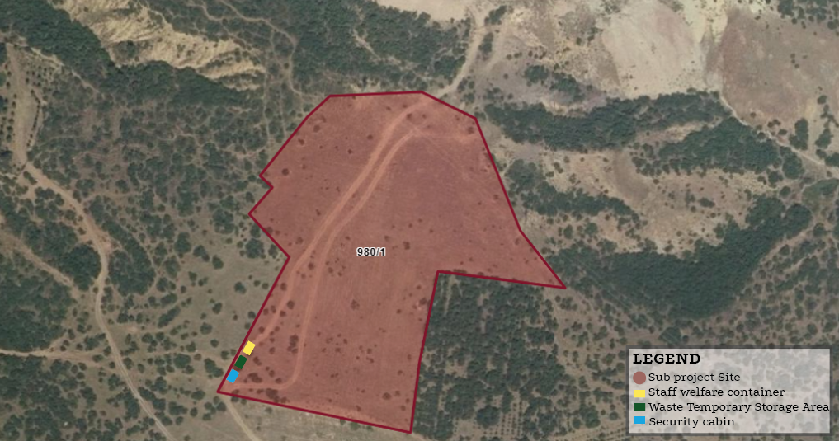
Figure 1. Sub project Components

Location
The sub-project activity subject is related to the establishment and operation of "Niksar Municipality Solar Power Plant 960 kWp/1,137.96 kWe on lot 1 of block 980 within the borders of Dönekse Neighborhood, Niksar District, Tokat Province. The location coordinates of the parcels in question are given in Annex-A. There is no agricultural or animal husbandry activity area or commercial enterprise on the land. It has not been used as a commercial enterprise by the municipality or 3rd parties before. There is no area around the SPP land where agricultural and livestock activities are carried out.
Table 1. Location of Sub-project
Province | Distirct | Neighborhood | Block | Lot
Tokat | Niksar | Dönekse | 980 | 1

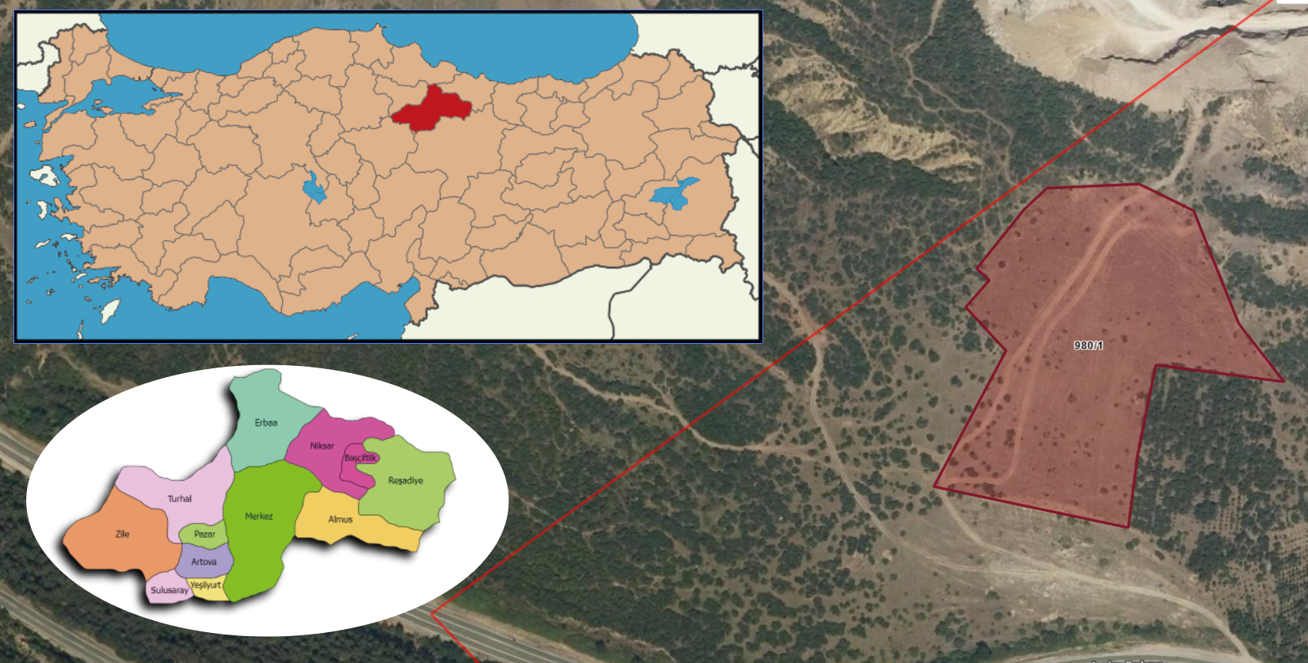
Figure 2. Location of Sub-project

Within the scope of the sub-project, a 3 km Energy Transmission Line (ETL) will be constructed. The entire ETL route passes through the cadastral road.
There is currently a cadastral road to access the site. Therefore, there is no need for land acquisition for the road.

Area of Influence
The sub-project is located approximately 700 meters from Dönekse Neighborhood. The access road follows a paved route branching from the E80 highway toward Tokat. Along the main access road, no residential buildings or vulnerable groups have been identified, confirmed through field visits and consultations with the local mukhtar.
However, the ETL will pass through a cadastral road segment where three residences are located (Figure 3). Consultations were held with the households in this area, on 07.07.2025, and no objections or concerns were raised by the residents. Photographs and consultation documentation are provided in Annex-E..
The Area of Influence (AoI) has been defined considering the proximity of these residences to the ETL route, as well as potential impacts related to noise, dust, and traffic during construction. Given the distance of 700 meters from the nearest neighborhood and the limited number of residences along the cadastral road, significant adverse impacts on local communities are not anticipated.
Noise modeling indicates that construction-related noise will decrease to insignificant levels beyond 300 meters, and dust emissions will be effective within approximately 50 meters of construction activities. These findings comply with the IFC standards (55 dBA) and national regulations (65 dBA) as per the Environmental Noise Control Regulation (Official Gazette No. 32029, dated 30.11.2022).
All modeling assumes conservative conditions with all equipment operating simultaneously; real-world impacts are expected to be lower. Environmental noise and dust emissions will be monitored throughout the construction phase, and mitigation measures such as noise barriers and regulated working hours will be implemented if complaints arise.
Dust emission calculations also confirm emissions remain below the regulatory limit of 1.0 kg/hour, in accordance with the Regulation on Control of Industrial Air Pollution (Official Gazette No. 27277, dated 03.07.2009), negating the need for additional air quality modeling.
Additionally, the Dönekse Neighborhood has been included in the AoI due to its proximity to the sub-project site and the project's commitment to prioritize local employment opportunities.
The AoI is visually represented in Figure 3.

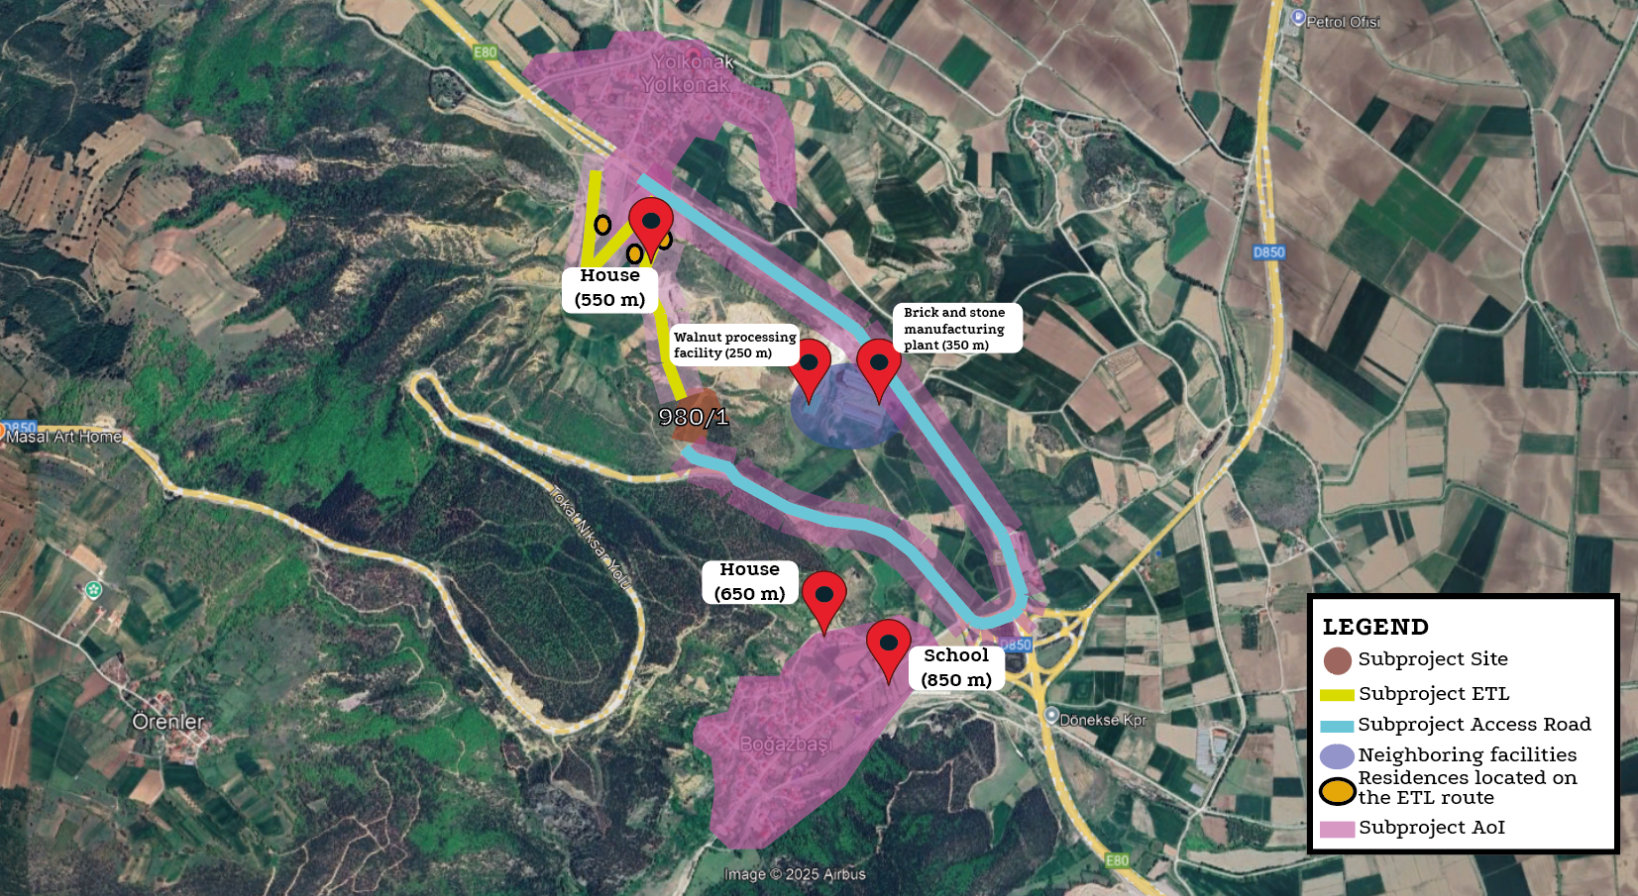
Figure 3. Sub-project Area of Influence

OBJECTIVE/ DESCRIPTION OF SEP
Within the scope of ILBANK ESMS and World Bank ESF, 2018, projects are classified as High Risk, Significant Risk, Moderate Risk or Low Risk, taking into account the relevant potential risks and impacts such as the type, location, sensitivity and scale of the project; the nature and magnitude of potential E&S risks and impacts; the capacity and commitment of the Borrower and other relevant risk areas that may cause undesirable impacts. Following the screening process based on İLBANK ESMS and World Bank ESF, 2018, "Niksar Municipality 1,137.96 kWp/ 960 kWe Solar Power Plant Projects" have been categorized as Moderate Risk.
As stated by the Tokat Provincial Directorate of Environment, Urbanization and Climate Change, the planned solar power plant project with an installed capacity of 0.96 MWe on parcel no. 980/1 (1.9432 ha) falls outside the scope of the Environmental Impact Assessment (EIA), as the project area is under 2 hectares and the installed capacity is below 1 MW. However, all relevant permits must be obtained and environmental protection measures must be taken during implementation Annex-C.
In order to support the implementation of this Moderate Risk project, this Stakeholder Engagement Plan (SEP) has been prepared by CA Engineering for Niksar Municipality to ensure that all risks and adverse impacts during the construction and operation phases are taken into account and appropriate mitigation measures are proposed in accordance with the ILBANK ESMS, relevant national laws and regulations, and the World Bank's ESF. The main objectives of this SEP are as follows:
- To help Niksar Municipality identify its stakeholders and establish and maintain constructive relationships with all identified stakeholders, especially sub-project affected parties,
- To assess the level of interest and support of stakeholders for the sub-project and to ensure that their views are taken into account in the sub-project design and environmental and social (E&S) performance,
- To encourage and provide tools for effective and inclusive engagement with sub-project affected parties throughout the sub-project lifecycle on potentially impactful issues,
- To ensure that technically and culturally appropriate sub-project information on environmental and social risks and impacts is disclosed in a timely, understandable and accessible format,
- To provide sub-project affected parties with accessible and inclusive tools to voice their concerns and complaints and to enable Niksar Municipality to respond to and manage such complaints.
This SEP aims to;
- Establish and operate in a manner that is fully informed on issues related to external relations and concerns,
- Develop an environment in which the participation capacities and cultural norms of each relevant group are respected within the scope of methods to understand stakeholder issues and concerns,
- Understand the concerns of stakeholders and establish a fair, transparent and open dialogue with them based on their concerns.
The SEP is organized as follows:
Introduction/Sub-project Description: Summary and explanatory information about the scope of the sub-project,
Purpose/Description of the SEP: Objectives, scope, requirements and implementation of the SEP, definitions of some key words in the SEP,
Stakeholder Identification and Analysis: Identification of who the project stakeholders are and what their impact on the project objectives may be,
Stakeholder Engagement Program: A systematic approach plan for the disclosure of project information and consultation with stakeholders during the project, communicated to relevant stakeholders at the right time and through the most efficient and effective means of communication,
Resources and Responsibilities for Implementing Stakeholder Engagement Activities: Status of existing and planned resources for Stakeholder Engagement Activities and which personnel will be allocated to manage and implement the SEP,
Grievance Mechanism (GM): Description of the process by which project-affected persons can bring their complaints and concerns to the attention of project management and how they will be assessed and addressed,
Monitoring and Reporting: Explanation of stakeholder engagement activities, complaints and monitoring and mitigation.
The World Bank’s Environmental and Social Framework (ESF) Environmental and Social Standard (ESS) 10 “Stakeholder Engagement and Information Disclosure” recognizes the importance of open and transparent engagement between Niksar Municipality (PUB) and project stakeholders as a fundamental element of good international practice. According to requirements set by ESS10, Niksar Municipality will;
- engage with stakeholders throughout the sub-project life cycle, initiating this engagement as early as possible in the sub-project development process and within a timeframe that allows for meaningful consultation with stakeholders on sub-project design. The nature, scope and frequency of stakeholder engagement will be commensurate with the nature and scale of the sub-project and its potential risks and impacts.
- engage with all stakeholders meaningfully. Niksar Municipality will provide timely, relevant, understandable and accessible information to stakeholders and will consult with them in a culturally appropriate manner that is free from manipulation, interference, coercion, discrimination and intimidation.
The stakeholder engagement process will include the following, as further detailed in this ESS:
- identification and analysis of stakeholders;
- planning how to engage with stakeholders;
- disclosure of information;
- consultation with stakeholders;
- handling and responding to complaints;
- reporting to stakeholders.
Niksar Municipality will maintain and disclose a documented record of stakeholder engagement as part of the environmental and social assessment, including a description of stakeholders consulted, a summary of feedback received and a brief explanation of how or why feedback was not taken into account (World Bank, 2017: 98).

STAKEHOLDER IDENTIFICATION AND ANALYSIS
The purpose of stakeholder identification is to identify which stakeholders may be directly or indirectly affected - positively or negatively - ("project affected parties") or have an interest in the Sub-project ("other interested parties"). Effective stakeholder engagement requires identifying who the stakeholders are, understanding their needs and expectations, and their priorities and goals for the sub-project. This information was then used to tailor the engagement to each type of stakeholder.

3.1. Methodology
The intensity of the impacts (direct or indirect) requires different forms of interaction in terms of participation. During the stakeholder identification process, the characteristics of the project impacts are defined and the methods and frequencies of the relationships to be established with the stakeholders are examined.
This determination will ensure that an effective SEP is created for the correct analysis of all stakeholders of the project, including those who are interested/not interested in the project or directly and indirectly affected.
The interest levels of the stakeholders in the project and the levels of being affected by the sub-project are rated as low, moderate and high and are listed in Table 2. It is critical that particular efforts are given to identify disadvantaged and vulnerable stakeholders who may be differentially or disproportionately affected by the subproject or who may have difficulty participating in the engagement and development processes. Stakeholder identification is also an ongoing process and will need to be regularly reviewed and updated.
Two factories located within the project’s area of influence, as well as several residential houses situated along the electricity transmission line (ETL) route, will not be subject to any physical or economic displacement (See Figure 3). There is no anticipated loss of income or requirement for relocation for these structures.
However, due to their proximity to the project footprint, these structures may be subject to indirect impacts during the construction phase, such as increased noise, dust, temporary access limitations, or local traffic disruptions. Therefore, although the residents and factory operations in question are not expected to experience direct adverse impacts, they have been identified as primary stakeholders to ensure they are appropriately informed and engaged throughout the project lifecycle. Nonetheless, they will have full access to the project’s grievance mechanism, and will be included in information disclosure and, where necessary, consultation activities.

3.2. Project Affected Persons and Other Interested Parties
The key PAP’s who will be cooperated and consulted about and during the sub-project, including individuals, groups and communities are:
Residents of Dönekse Neighborhood: Since the Dönekse neighborhood falls within the sub-project’s area of Influence, its residents may experience direct and indirect impacts. These may include potential environmental impacts such as dust, noise, and increased traffic, as well as socio-economic changes related to local infrastructure, access to public services, and fluctuations in demand for essential facilities (e.g., healthcare centers, markets, commercial businesses).During site assessments, it was identified that an unlicensed residential structure, not included in the official zoning plan but located immediately adjacent to the project parcel, may be affected by the sub-project activities more significantly than other nearby households.
In addition to the residents of Dönekse Neighborhood, the project’s area of influence also includes individuals working at nearby facilities (64 persons) who may experience temporary disturbances such as increased traffic, noise, and dust during the construction period. Furthermore, 10 employees members employed under the sub-project may be exposed to occupational health and safety risks, which will be managed through relevant mitigation measures described in the ESMP.
It is estimated that a total of 483 residents live within Dönekse Neighborhood, and approximately 3,327 residents live in the adjacent Yolkonak Neighborhood, located along the route of the ETL. Due to their proximity, Yolkonak residents may also be subject to indirect socio-environmental impacts (e.g., access restrictions, dust during excavation works, temporary noise increase). Both communities require careful consideration and transparent engagement throughout the project lifecycle.
Although the structure lies outside the fenced sub-project boundary and is not expected to be directly physically or economically affected, its proximity to the sub-project area requires careful consideration.
In this context, a face-to-face consultation was conducted with the occupant on 07.07.2025, in line with the principles of transparency, inclusiveness, and early engagement. The scope and potential impacts of the sub-project were explained in detail, as well as the mitigation measures outlined in the Environmental and Social Management Plan (ESMP). During the face-to-face consultation held on 07.07.2025, the consulted household expressed general support for the project.
Since Dönekse Neighborhood is located within the sub project’s impact area, so residents may experience both direct and indirect effects. Theseinclude potential environmental impacts such as dust, noise, and increased traffic, as well as socioeconomic changes related to local infrastructure, access to public services, and fluctuations in demand for basic facilities (e.g., health centers, markets, and commercial establishments).
The closest structures to the sub-project site are two industrial facilities to the northeast: a walnut processing facility (~250 meters away) and a brick and stone manufacturing plant (~350 meters away).In line with transparency, inclusiveness, and early engagement, an in-person consultation was held with neighborhood residents and the local mukhtar on 07 July 2025. The scope of the sub-project and its potential impacts were explained in detail, along with the mitigation measures outlined in the Environmental and Social Management Plan (ESMP)were explained, including anticipated construction phase, such as dust, noise, and visual disturbance. Information was provided on the Grievance Mechanism established to enable residents to express concerns or complaints related to the project. Channels for submitting grievances were clearly explained.
Based on site observations and stakeholder consultations, it was confirmed that there are no vulnerable or disadvantaged individuals residing within the immediate vicinity of the sub-project footprint. However, within the broader Area of Influence (AoI), a limited number of households are located near the ETL route. While no specific adverse impacts are anticipated on vulnerable or disadvantaged groups due to the distance from construction activities and the absence of traffic through residential areas, the project will continue to ensure accessibility of information and engagement opportunities for these households.. Any future concerns or requests will be addressed through the established Grievance Mechanism (GM).Other Interested Parties (OIPs) include individuals, groups, or entities who may have an interest in the sub-project due to their location, proximity to natural or other resources, or their involvement in relevant sectors. These include public authorities, local government officials, community leaders, media representatives, and Non-Governmental Organizations (NGOs). NGOs have been identified as key OIPs due to their role in facilitating communication among communities, shaping public opinion, and enhancing access to different social groups. Their participation contributes to addressing local concerns through direct engagement.
Although it is unlikely that mandatory eviction or loss of income will occur, these individuals are included in the potential OIP category.
NGOs have been identified in Table 3 and included in the stakeholder engagement process.
Government bodies have been classified as OIPs due to their regulatory, supervisory, and coordination roles.
Mass communication channels at both the national and local levels have also been identified as OIPs, due to their essential role in disseminating information to a broader audience, shaping public perception, making project developments accessible to non-technical stakeholders, ensuring transparency, and increasing public awareness.
In the context of potential research needs, Gaziosman Paşa University has been identified as a key stakeholder within the sub-project.
In Niksar District, maintaining regular communication with media stakeholders at the local and national levels is considered sufficient. The media plays a significant role in informing the public and shaping public opinion on the sub-project. Detailed information on other interested parties is provided in Table 3.
Workers to be employed under the sub-project (including supply chain workers) will be directly engaged in construction, operation, and maintenance activities. Their primary concerns will relate to occupational health and safety.

3.3. Disadvantaged/ vulnerable individuals or groups
During the construction phase of the sub-project, certain vulnerable and disadvantaged groups (such as elderly individuals, persons with disabilities, women, individuals relying on social aid, state or private assistance, and the unemployed) may face difficulties in accessing project sub benefits and participating in stakeholder engagement processes.
Elderly individuals living alone may experience mobility limitations and have limited access to social support networks, making them more susceptible to the impacts of sub project activities. Persons with physical or mental disabilities may require assistance or adapted communication materials to access sub project-related information and participate meaningfully. Female-headed households often face time constraints, heavy domestic responsibilities, and, in some cases, cultural barriers that limit their ability to engage in community consultations and sub project-related opportunities.
Individuals who rely on state or private assistance are considered vulnerable due to their economic dependence and restricted access to information and resources. This may limit their ability to benefit from services, opportunities, or information provided under the sub project. Similarly, unemployed individuals may experience financial hardship and be less able to engage with the sub project or benefit from temporary employment opportunities or social services offered during implementation, making them a key vulnerable group.
Considering the distance between the sub project footprint and nearby settlements, direct physical impacts on vulnerable and disadvantaged groups are not anticipated. No construction-related access restrictions or safety risks are expected, as sub project traffic will not pass through residential areas and work zones are located outside community spaces. While temporary noise and dust will be generated during construction, these impacts are expected to remain below significance thresholds at the nearest residences.
Nevertheless, some community members—particularly those who may have limited mobility or face barriers to information access—may have higher sensitivity to potential disturbances or require tailored engagement channels. To ensure inclusive participation, the sub project will provide accessible communication methods and allow individuals who cannot attend public meetings to receive information and submit feedback through alternative means, including individual consultations or home visits when required. The grievance mechanism will also be accessible and responsive to address concerns raised by vulnerable and disadvantaged groups.
According to information obtained from the mukhtar of Dönekse Neighborhood details on these vulnerable and disadvantaged groups are provided in Table 2.
Table 2. Vulnerable and disadvantaged groups in Dönekse Neighborhood
Vulnerable and Disadvantage Groups | Number of People
Over 70 years of age and living alone | 13
Mentally disable | 1
Physically disable | 4
Surviving on social assistance from the state, associations or individuals | 40
Female-headed household | 10
Individuals with chronic diseases or those in need of care who require constant medical attention | 10
Total Vulnerable and Disadvantage Groups | 78
Source: Mukhtar and Local People Meetings, 2025.
Informational materials will be prepared using visual aids and written in clear, simple language. If deemed necessary, home visits and small group meetings will be organized. Printed materials will be designed in a clear and easy-to-read format. To ensure broad public participation, meetings will be held in accessible venues that do not pose any barriers for persons with disabilities. Meeting times will be scheduled to accommodate the availability of women and working individuals. Transparent and consistent communication will be maintained throughout the process to ensure that participants do not experience a loss of trust.
Table 3. Influence/Interest Table for stakeholder prioritization
Stakeholder Group |  | Cause of Impact/Risk | Level of Interest | Level of Influence
Project Affected Parties | - Dönekse Neighborhood | Heavy vehicles used during the construction process may create temporary traffic congestion in the neighborhood, but other than that, the sub-project is not expected to have any permanent socio-economic or environmental impact on the neighborhood and nearby facilities. | High | Medium
Project Affected Parties | - Workers (including supply chain) to be employed for the sub-project activities | Potential risks related to working conditions, etc. | High | High
Vulnerable individuals or groups | - Over 70 years of age and living alone  - Mentally disable  - Physically disable  - Surviving on social assistance from the state, associations or individuals  - Female-headed household  - Individuals with chronic diseases or those in need of care who require constant medical attention | - People Over 70 Years of Age may have difficulty physically attending stakeholder consultation meetings or information activities.  - Unemployed individuals also have difficulties in accessing temporary employment opportunities or benefiting from social support services that can be offered within the scope of the project due to their economic fragility.  - Female Head of Households may have obstacles in terms of time and access to participating in information meetings due to family responsibilities.  - Individuals with mental disabilities may have limited access to education and employment, may not be aware of their rights, and may have difficulty living independently without support.  - Individuals with physical disabilities may have difficulty participating in sub-project activities without support. If the necessary infrastructure is not provided, they may experience education and employment difficulties.  - Individuals with chronic diseases or those in need of care who require constant medical attention, individuals with chronic illnesses or those requiring continuous medical care are considered vulnerable groups due to their heightened sensitivity to health-related risks and limited coping capacity. | High | Medium
Other Interest Parties | NGOs:  - Federation of Associations of Tokat Province  - Tokat Social Assistance and Solidarity Foundation | NGOs can submit suggestions on the environmental and social impacts of the sub-project depending on their field of activity; therefore, it is important to effectively manage the information and transparency processes. | Medium | Low
Other Interest Parties | - Governmental Bodies  - Ministry of Environment, Urbanization and Climate Change  - Ministry of Labor and Social Security  - Tokat Governorship  - Tokat Provincial Directorate of Civil Society Relations Centre District Governorship  - Tokat Environment, City and Culture Presidency  - Local administration  - Tokat Municipality  - National Press  - Anadolu Agency  - Demirören News Agency  - Local Press  - Kelkit Newspaper  - Tokat News  - Niksar Danişment Newspaper  - Gaziosman Paşa University | A positive impact is expected with the energy generated from the sub-project. Government agencies may be involved in the permitting process or in organizing consultations with communities. | High | Low

STAKEHOLDER ENGAGEMENT PROGRAM
The main objectives of the stakeholder engagement program and the planned timetable for the various stakeholder engagement activities are to define at what stages and at what intervals these activities will be carried out throughout the life of the sub-project. Information is provided on how the public will be made aware of future opportunities to review information and provide their views, if decisions about public meetings, locations and timing of meetings have not yet been made.

4.1. Summary of stakeholder engagement done during project preparation
A field visit was carried out on 07.07.2025 in order to inform the local people about the sub project and to receive their opinions and suggestions in accordance, and interview was held with Dönekse neighborhood mukhtar and Niksar Municipality officials about the usage status of the sub-project site and the disadvantaged groups living in the region.
Within the scope of the interviews;
It was determined that the sub-project site was not currently used by the local people for any purpose, and that there were no refugees or child-headed people living in Dönekse neighborhood, the closest settlement to the sub-project site.
In addition, within the scope of the Stakeholder Engagement Plan, stakeholder consultation meetings were held with Dönekse neighborhood residents and the mukhtar by CA Engineering authority A**** G***** on 07.07.2025. In order to obtain general information about the socio-economic situation of Dönekse neighborhood and to learn about their knowledge levels about the sub project, the mukhtar of Dönekse neighborhood applied a "Community Level Survey (See Annex-F)". The Community Level Survey Form is used to gather information on the socio-economic structure of settlements, assess their level of awareness regarding the proposed sub-project, identify their preferred communication channels for future consultation activities, and understand their environmental and social concerns. The findings help develop alternative mitigation measures tailored to these concerns within the scope of the ESMP.
Consultations have been conducted with local community members, nearby factory management and employees, as well as residents along the ETL route. During these consultations, detailed information regarding sub-project activities was provided, and the grievance mechanism was clearly explained to all stakeholders to ensure transparent communication and accessible channels for raising concerns or complaints.
After the approval of draft ESMP and SEP, a Stakeholder Consultation Meeting will be organized. Minutes of Stakeholder Consultation Meeting will be held within the scope of sub-project activities. Before the meeting, informative posters, brochures and announcements will be prepared and will be hung in places with intense human circulation or broadcast on screens. In addition, the meeting will be announced on the Niksar Municipality website, together with local and national newspapers at least 10 days in advance. Meetings with high participation will be held as much as possible.

4.2. Summary of project stakeholder needs and methods, tools, and techniques for stakeholder engagement
Stakeholders have been identified within the scope of the sub-project and consultations or key information meetings have been held with these stakeholders. Stakeholders identified in the region have been informed about the location, components and content of the sub-project. The preliminary consultations conducted during the ESMP process aimed to inform regional public authorities about the sub-project and to obtain their feedback and concerns about the potential impacts of the sub-project.
This plan shows the nature and level of stakeholder interest in the sub project, how the participation will be conducted, the frequency of participation and the responsible unit of Niksar Municipality, and the following matrix provides a tabular version of this program (See Table 4).
The responsible party/person should be determined by the representatives of Niksar Municipality. The SEP will be implemented at the sub-project level. Registration forms and full meeting minutes of those who participated in the consultations will be recorded as an annex to the SEP, but personal information will not be made publicly available. When the SEP is disclosed, relevant data containing personal data will be blurred, taking into account the Personal Data Protection Law.
All supporting documentation for stakeholder activities (newspaper notices, attendee list, full meeting minutes (as an annex), the presentation, sample brochure) will be included in the SEP.

4.3. Stakeholder engagement plan
The main objectives of the stakeholder engagement program are to provide early information, explanation and consultation on various sub project documents and activities in order to establish a dialogue with sub project stakeholders from planning to implementation and operation. All environmental and social documents prepared in anticipation of the financing agreement from the World Bank will be disclosed and consulted before the sub-project appraisal takes place.
Final decisions on public meetings, locations and timing of meetings have not yet been determined. Niksar Municipality will ensure that the sub-project is communicated to all stakeholders and that meaningful participation and consultation activities are carried out. Consultation activities are designed with some basic guiding principles, including the following:
- Consultations should be widely advertised, especially among PAPs, at least 10 days before any meeting or engagement.
- A non-technical briefing should be provided prior to any event to ensure that people are informed about the assessment and results prior to the planned meetings.
- The location and timing of meetings should be designed to maximize stakeholder participation and compliance.
- The information provided should be clear, non-technical and in all appropriate local languages ​​where necessary.
- Participation should be facilitated so that stakeholders can voice their views and concerns.
- Any issues that arise should be addressed in the meetings or at a later time.
The following information should be included when documenting the stakeholder engagement activities to be carried out within the scope of the sub-project:
- Date(s) and location(s) of the consultation(s) and related notification(s) (newspaper advertisements, screenshots of social media announcements, etc.)
- Participant details (as per the Personal Data Protection Law),
- Meeting schedule/program (as well as information on what was presented and by whom),
- Summary meeting minutes (comments, questions and responses from presenters),
Review of comments, agreed actions, issues requiring follow-up actions and activities, including clarification of how stakeholders were informed about decisions taken.
Special efforts will be made to ensure that vulnerable and disadvantaged individuals/groups are able to access information and participate effectively in consultation processes. Measures will include:
- Providing information materials in accessible formats (e.g., large font, Braille, visual aids, and plain language),
- Organizing meetings in accessible venues and/or providing transportation and necessary support services (e.g., sign-language interpretation),
- Conducting small-group meetings or individual consultations when required, including home visits if deemed necessary,
- Offering multiple feedback channels such as a sub project website, social media, brochures, and face-to-face meetings,
- Scheduling meetings at convenient times to ensure participation of women, working individuals, and other potentially marginalized groups,
- Coordinating with relevant NGOs and community-based organizations, including disability associations.
These measures are designed to eliminate participation barriers, ensure equal access to sub project information, and maintain transparent and consistent engagement throughout implementation, thereby supporting trust-building with stakeholders.

The proposed Stakeholder Engagement Schedule is provided in Table 4.

Table 4. Stakeholder Engagement Plan
Project Stage | Estimated Date/Time Period | Topic of Consultation/ Message | Method Used | Target Stakeholders | Responsibilities
Pre-construction | At least 10 days before the construction phase begins | Information Statement  - General information about the purpose, stages, Project and E&S impacts/risks  - Purpose, start date, duration and nature of land preparation, construction and operation activities  - Implementation of mitigation measures related to relevant social and environmental impacts/risks  - Grievance Mechanism  - Information (ESMP and SEP) on Niksar Municipality website for review  - E&S documents (ESMP and SEP) | Stakeholder Consultation Meeting  Niksar Municipality website  Social Media  Notice Boards  Booklets etc.  Posters to be hung in work areas etc. | Resident of Dönekse neighborhood,  Local communities,  Local government, | Supervision Consultant,  Niksar Municipality
Pre-construction | At least 10 days before the construction phase begins | Employment and Supply Strategies  - Hiring employees  - Staff training  - Purchasing materials and services  - Grievance Mechanism | Stakeholder Consultation Meeting  Niksar Municipality website  Social Media  Notice Boards  Booklets etc.  Posters to be hung in work areas etc. | Local businesses,  All local communities | Niksar Municipality, Contractor
Construction | Once a month | Information Statement  - Monitoring targets and activities to be carried out  - Monitoring targets and activities and regular reporting of monitoring results to stakeholders | Stakeholder Consultation Meeting  Niksar Municipality website  Social Media  Notice Boards  Booklets etc.  Posters to be hung in work areas etc. | Resident of Dönekse Neighborhood,  Local communities,  Local government, | Supervision Consultant,  Niksar Municipality, Contractor
Construction | Once a month | Traffic and Transport Management  - Road safety awareness, including safe passage through bypasses and connecting roads  - Types, number and frequency of vehicles to be used during construction  - Collaboration with local communities and responsible authorities to improve signage, visibility and overall road safety, especially along roads near schools or other places where children are present,  - Regarding training on traffic and pedestrian safety cooperating with local communities (e.g. school education campaigns)  - Traffic measures and sub-project road use sharing with association president  - Grievance Mechanism | Face-to-face meetings,  Depending on the demands of the stakeholder group,  Posters to be hung in work areas, etc.,  Niksar Municipality website | All local communities | Supervision Consultant,  Niksar Municipality, Contractor

4.4. Reporting back to stakeholders
Stakeholder engagement is an ongoing process that begins prior to the development of the Stakeholder Engagement Plan (SEP) and continues throughout the entire lifecycle of the sub-project. Niksar Municipality will maintain active communication with all identified stakeholders during the implementation and operation of the sub-project. In particular, Niksar Municipality will solicit feedback from stakeholders on the E&S performance of the sub-project and the implementation of the identified mitigation measures and the Grievance Mechanism. In the event of significant changes in the sub-project that lead to risks and impacts that will particularly impact the parties affected by the sub-project, Niksar Municipality will provide information on these risks and impacts and consult with the parties affected by the sub-project on how to mitigate these risks and impacts.
Different information methods and tools can be used to increase the level of information for each of the targeted stakeholder groups. In particular, for public participation meetings, the meeting place(s), time and date will be set and this information will be announced to the public at least ten (10) days before the event, ensuring that all community members are informed about the event to be held.
Below are the minimum requirements for the content of the Minutes to be prepared after each stakeholder engagement activities and meetings:
- Location of consultation(s)/event,
- Date(s) of consultation(s)/event,
- Details on attendees (as per Personal Data Protection Law),
- Meeting/Event Program/Schedule (What was presented and by whom),
- Meeting Minutes (Comments, Questions and Response by Presenters and Photos from the meeting),
- Agreed actions.
Throughout all stages of the sub-project, comments collected through the website, grievance mechanism, and all stakeholder engagement activities such as public and/or individual meetings will be subject to evaluation and review by the relevant responsible personnel such as the Grievance Mechanism Contact Person (GMCP) and the Public Relations Assistant to be assigned by the Project Management Unit (PMU).
The contractor and Niksar Municipality officials will be in regular contact. Face-to-face meetings will be held when necessary, and the contractor and Niksar Municipality will meet periodically (monthly).
Depending on their content, stakeholder comments will be evaluated and reviewed both within the PMU and by the relevant responsible personnel of the contractor(s).
Niksar Municipality will be responsible for engagement with stakeholders as an on-going process throughout the life of the sub-project. Stakeholder logs will also be filled out for engagement activities (Table 5).
A summary of the implementation of the grievance mechanism will be published annually on Niksar Municipality’s website (https://www.niksar.bel.tr/) after removing the identity information of the persons to protect their identity. Sub-project’s environmental and social performance and implementation reports will be shared at least annually to stakeholders, and the frequency will be higher during particularly active periods, when the public may experience more impacts or when phases are changing (for example, monthly reports during the 2-month construction period).
All stakeholders will be able to share their opinions and grievances via a range of options such as Niksar Municipality’s website, letters, and face to face meetings with the implementation of the SEP.
The grievance mechanism will be advertised and announced to affected stakeholders on Niksar Municipality’s website so that they are aware of the process, know they have the right to submit a grievance, and understand how the mechanism will work and how their grievance will be addressed.
Stakeholders will be informed as the sub-project develops, including reporting on the environmental and social performance of the sub-project, implementation of the SEP and the grievance mechanism.
During the construction phase, there will be no road closures or infrastructure service limitations. Therefore, voice announcements by Niksar Municipality and/or Contractors regarding such restrictions will not be necessary. Environmental and social performance indicators will be shared with stakeholders monthly via Niksar Municipality's website.
The commencement and completion of the construction activities of the sub-project, changes in the sub-project design and important stages such as commissioning will be communicated to stakeholders through local media channels as much as possible.
The minutes and relevant details of the consultations to be held on draft ESMP and draft SEP could be annexed to the final version of this SEP; and details for the rest of the consultations will be disclosed on Niksar Municipality’s webpage.
Table 5. Sample Table for Stakeholder Engagement Log
Sub-Project Phase | Date and Location | Method used | Purpose of Activity | Target Stakeholders | Meeting Summary/ Key Issues Raised | Follow-up Actions | Information Shared/Documents Disclosed and Consulted

RESOURCES AND RESPONSIBILITIES FOR IMPLEMENTING STAKEHOLDER ENGAGEMENT ACTIVITIES

5.1. Project Implementation Unit (PIU)
PIU will be established within Niksar Municipality and will consist of Niksar Municipality personnel. The duties and responsibilities of PIU are explained in Table 6.
Contact details of the responsible personnel are not yet available. Therefore, contact information such as telephone number, address, e-mail address, title, etc. will be provided in this section of the SEP to be updated.
A sufficient budget will be allocated for communication and complaint resolution mechanism to be established with stakeholders. The budget is included in the sub project budget.

5.2. Resources
Niksar Municipality is ultimately responsible for the environmental and social performance of the entire sub-project, including the performance of its own contractors and other contractors. A Project Implementation Unit (PIU) will be established to carry out operational and administrative tasks. The PIU staff will be Niksar Municipality’s own staff.
The PIU will be primarily responsible for coordinating stakeholder engagement activities with the Contractors as outlined in this SEP. The collection of complaints, questions and feedback will be the direct responsibility of the PMU’s GM contact (GMCP) and the Contractors’ Social Specialist.
The resources to be provided by Niksar Municipality are as follows:
- A project-specific area on the Niksar Municipality’s official website,
- An electronic database for grievances,
- Stakeholder engagement records,
- Printed documents (guides, brochures, posters, etc.) to be used in accordance with the SEP requirements.

5.3. Management functions and responsibilities
Niksar Municipality/PIU will be the main party responsible for the implementation of the SEP and coordination with contractors, implementation, monitoring and reporting. Detailed roles and responsibilities regarding the stakeholder participation of the sub-project are provided in Table 6.
Table 6. Roles and Responsibilities
Responsible Entity | Roles and Responsibilities
PIU of Niksar Municipality | - Planning and implementation of the SEP;  - Leading stakeholder engagement activities in close collaboration with the ILBANK PMU;  - Management and resolution of grievances;  - Consultation on specific SEP activities;  - Announcing the important construction activities;  - Reporting on implementation of SEP activities to ILBANK PMU;  - Proper implementation of the grievance mechanism defined in the SEP, and  - Executing defined grievance mechanism in the SEP properly and informing ILBANK PMU about the overall implementation status.
GMCP | - Act as a focal point for the GM in the PIU  - Keep records and monitor sub-project-related grievances  - Manage and coordinate the resolution process of sub-project related grievances  - Review grievance records for relevant non-compliance issues or recurring issues related to stakeholder engagement and other sub-project activities  - Coordinate and monitor PIU contacts at the contractor level  - Collect sub-project related grievances from all different parties  - Inform PIU and management about the resolution process  - Prepare compiled PIU reports on the sub-project  - Monitor contractors’ grievance records and grievance resolution process and report to PIU in monthly progress reports  - Maintain communication with PIU to respond/resolve grievances
E&S Consultant | - E&S Consultant is responsible for preparing the Environmental and Social Assessment Reports, i.e. ESMP, SEP, sLMP for the approval of ILBANK,  - Providing the necessary information to the Niksar Municipality,  - Taking a part in organizing the stakeholder consultation meeting to be held for all stakeholders and  - Submit final drafts of the reports as per the concerns/opinions of the stakeholders.
Supervision Consultant | - Ensure that the sub-project complies with the methodology and other requirements specified in the E&S Documents (ESMP, SEP, sLMP) during the implementation of sub-projects,  - Recording and monitoring the resolution of grievances from contractors and reporting them to Niksar Municipality (PIU) in the monthly progress reports,  - Maintaining communication with PIU GM Focal Point for follow-up of grievances.
Contractor | - Recording and monitoring resolution of contractor grievances and reporting them to PIUs in monthly progress reports,  - Maintaining communication with PIU GM Focal Point to follow up on grievances,  - Organizing and conducting Stakeholder Consultation Meetings and related events for public information sharing,  - Informing ILBANK (PMU) and Niksar Municipality on all matters related to their relations with stakeholders,  - Informing local communities on all environmental and social issues (e.g. noise, vibration, water quality monitoring, community health and safety, etc.)  - Developing and implementing a grievance mechanism for both the E&S performance of the sub-project and the workforce, including subcontractors, prior to the commencement of works in accordance with Niksar Municipality’s GM requirements.  - Submits monthly Environmental and Social Monitoring Reports (ESMRs) to Niksar Municipality,

GRIEVANCE MECHANISM
Managing, preventing, minimizing and effectively addressing complaints is an integral part of a sound stakeholder engagement strategy. Experience shows that a significant number of complaints arise from misunderstandings and that such complaints can be prevented or reduced through proactive and consistent engagement with communities. Participation also helps to anticipate and review community concerns and prevent them from turning into complaints. Therefore, according to the WB, the following Grievance Mechanism (GM) will be implemented by Niksar Municipality/PIU throughout the life of the sub-project, including pre-construction, construction and operation phases. In the GM, comments/grievances will be received in Turkish, since almost everyone in the developed GM speaks Turkish, there will be no need to use another language. The grievance channels used in applications will be published in Turkish. GM forms and consultation records will be kept in Turkish.

Grievance Mechanism at National Level
Presidential Communication Center: The Presidential Communication Center (CIMER) provides a centralized complaint system for Turkish citizens, legal entities and foreigners. The Presidential Communication Center (CIMER) will serve as an alternative and well-known channel through which Project stakeholders can directly communicate their complaints and feedback regarding the Project to government officials.
- www.cimer.gov.tr
- Call Centre (hotline): 150
- Phone number: +90 312 525 55 55
- Fax number: +90 0312 473 64 94
- Address for Official Letter/Petition: Republic of Türkiye, Directorate of Communications Kızılırmak Neighborhood. Mevlana Boulevard No:144 Çankaya/ANKARA
Mail addressed to Republic of Türkiye, Directorate of Communications
Individual applications at the community relations desks at governorates, ministries and district governorates.
Foreigners Communication Center (YIMER) will be available to Project stakeholders as an alternative and well-known channel for conveying their Project-related grievances and feedback directly to state authorities.
- www.yimer.gov.tr
- Call Centre (hotline): 157
- Phone number: +90 312 515 11 22
- Fax number: +90 0312 920 06 09
- Address for Official Letter/Petition: Republic of Türkiye, Directorate General of Immigration Management Çamlıca Neighbourhood No: 4 Yenimahalle/ANKARA
Mail addressed to Republic of Türkiye, Directorate General of Immigration Management
Individual application to the General Directorate of Migration Management of the Republic of Türkiye
ILBANK has established a transparent and comprehensive GM in September 2021 in order to receive, evaluate and address grievances pertaining to every international project it finances, and relevant mechanism will be in place during the course of the Project. In case of sensitive complaints such as SEA/SH, ILBANK will step in. The GM Procedures for ILBANK GM is available on its official webpage.
Below is the list of communication channels for ILBANK GM:
- ILBANK Website: https://www.ilbank.gov.tr/form/bilgiedinmeuluslararasi
- ILBANK Phone number: +90 312 508 7979
- ILBANK E-mail: uidbbilgi@ilbank.gov.tr and etikuidb@ilbank.gov.tr
ILBANK Address for Petition Service (ILBANK International Relations Department, Grievance Mechanism Team - Emniyet Mahallesi Hipodrom Caddesi 9/21 Yenimahalle/Ankara

Project Level Grievance Mechanism
As part of the stakeholder engagement, information and consultation process, an effective and accessible grievance mechanism should be established. The purpose of the grievance mechanism is to provide channels free from manipulation, coercion and intimidation through which local community members can submit their demands, concerns and complaints regarding the sub-project and its impacts. Responding to and resolving complaints in a timely, proactive, impartial, effective and efficient manner is essential according to international standards and requirements regarding stakeholder engagement. In particular, it provides a transparent and reliable process for fair and sustainable results. In this way, mutual trust and cooperation can be developed between the sub-project stakeholders and Niksar Municipality through corrective actions. The main components of a successful grievance mechanism include the principles of anonymity, confidentiality, transparency and right to appeal (temyiz hakkı).
If the grievance cannot be resolved with the existing process, applicants can always apply to relevant legal institutions. Such institutions can be summarized as follow:
- Civil Courts of First Instance
- Administrative Courts
- Commercial Courts of First Instance
- Labor Courts, and
- Ombudsman (https://ebasvuru.ombudsman.gov.tr/)

Niksar Municipality/PIU Team will be informed about the guide prepared by the World Bank on preventing sexual exploitation and abuse and sexual harassment (SEA/SH) and Gender Based Violence (GBV) cases in projects financed by the World Bank. Grievances regarding SEA/SH can create a culture of silence due to negative reactions from the society. SEA/SH complaints should be separated from each other and reported to the relevant institutions. In SEA/SH victimizations, confidentiality and ethical filing information should be taken into consideration in order to protect the victim and prevent the disclosure of confidential information and the creation of new victimization. In addition, the authorities dealing with grievances should handle such issues confidentially and with an impartial approach.
The grievances, requests, suggestions and opinions of the public will be recorded through the GM contact person (GMCP) to be assigned by Niksar Municipality. All grievances are examined to be classified according to whether they are real or not and whether they are related to sub-project activities. If a grievance is deemed unsuitable for investigation because it is not genuine or not related to sub-project activities, the complainant will be provided with an explanation as to why the grievance could not be followed up. Grievances received within Niksar Municipality are evaluated and forwarded to the relevant units. Appropriate complaints are responded to according to the sub-projects social and environmental requirements defined in the ESMP and SEP.
Grievance mechanism operation diagram details are given in Table 7.
Table 7. Grievance Mechanism Flow Chart
Grievance Process | Requirement / Action
Submission of a grievance | Receiving the grievance by any communication channel explained above. (At this point, if the grievance is a sensitive grievance involving child abuse, sexual harassment abuse or Gender Based Violence (GBV) immediate action will be taken within 2 days after receiving of the grievance. For the cases relevant to sexual exploitation and abuse/sexual harassment at workplace or any potential child abuse in the sub-project sites, the grievance will be directed by the GM focal point (based in ILBANK headquarter) to relevant legal authorities/service providers such as Ministry of Family and Social Services and Prosecutors Office.”)
Registration of grievance | Registering/recording through making an entry in the sample grievance register table. All the grievances will be registered within two working days and feedback will be given to the complainant. If the complainant requests that this grievance be treated anonymously, this grievance will be recorded anonymously and the request will be met.
Forwarding of grievance | The grievance is forwarded to relevant persons (site manager on construction sites and experts of the PIU) responsible for handling the grievance in not later than three working days upon receiving the grievance (except for any emergent grievance, which would be handled as appropriate).
Evaluation of a grievance | Evaluating the grievances within 10 working days and determining whether the grievance meets the admissibility criteria. If the grievance is not valid, providing relevant explanation to the complainant.
Response for a grievance | If the grievance is valid, identifying and taking corrective measures for resolving the grievance in not later than 15 working days upon receiving.  All comments and grievances will be responded to either verbally or in writing, in accordance with the preferred method of communication specified by the complainant, if contact details of the complainant are provided.  At this point, it should be noted that the action taken and the result of this anonymously recorded grievance should be shared on the Niksar Municipality website, so that anonymous complainants is informed about their grievance and the results.
Recording the result of a grievance | Recording the result of the grievance in register table.
Right to Appeal | If the grievance cannot be resolved with the existing process, applicants can always apply to relevant legal institutions. Such institutions can be summarized as follow:  - Civil Courts of First Instance  - Administrative Courts  - Commercial Courts of First Instance  - Labor Courts, and  - Ombudsman (https://ebasvuru.ombudsman.gov.tr/)

Niksar Municipality website includes a Communication page, which is the mechanism where complaints/requests regarding Niksar Municipality activities are submitted and the resolution process is followed (see Figure 4). In addition, many sections of the homepage of Niksar Municipality website include information about social media accounts and telephone numbers (such as the +90 850 633 06 60 line) to which grievances can be submitted.
- https://www.niksar.bel.tr/
- Call Centre (hotline): +90 850 633 06 60
- Yusufşah Mahallesi, Fatih Sultan Mehmet Cd. No:151, 60600 Niksar/Tokat, Türkiye

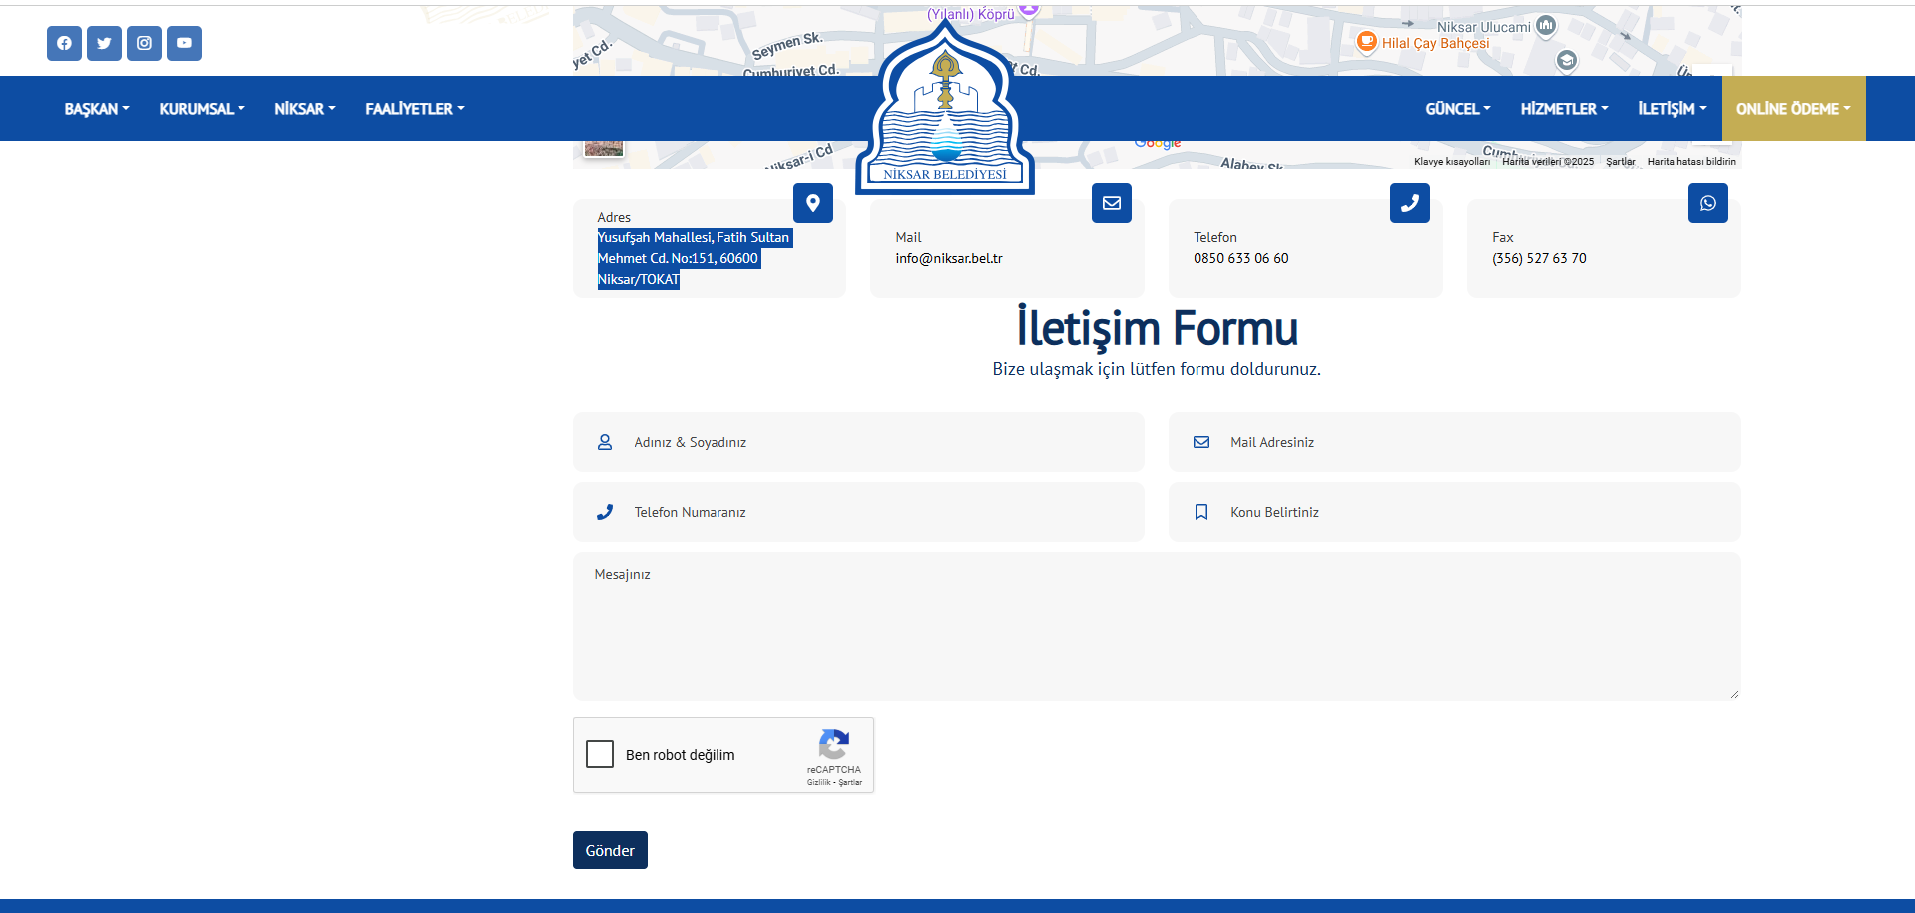
Figure 4. Niksar Municipality Website
The grievances, requests, suggestions and opinions of the public will be recorded (See Annex- C) through the GM contact person (GMCP) to be assigned by Niksar Municipality. Grievances can also be submitted anonymously, and such grievances will be evaluated with the same level of attention. In the case of anonymous grievances, while a direct response to the complainant may not be possible, the grievance will still be recorded and addressed. General feedback on such issues, including actions taken or policy changes made, will be disclosed publicly through appropriate communication channels such as the municipal website or public notice boards, without compromising confidentiality. All grievances are examined to be classified according to whether they are real or not and whether they are related to sub-project activities. If a grievance is deemed unsuitable for investigation because it is not genuine or not related to sub-project activities, the complainant will be provided with an explanation as to why the grievance could not be followed up. Appropriate grievances are responded to according to the sub-projects social and environmental requirements defined in the ESMP and SEP.

Grievance Mechanism for Workers
The GM for employees (applicable to both Niksar Municipality personnel and contractor and subcontractor employees) has been established in accordance with WB ESS2. The implementation of the GM for employees will be ensured throughout the financing life cycle of the sub-project. PIU requests contractors to develop and implement a grievance mechanism for the workforce, including subcontractors, before starting work. Subcontractors will prepare labor management plans that will include a detailed description of the grievance mechanism for employees.
Employees are informed about employee rights, basic occupational health and safety, the grievance mechanism and its operation at the time they start work. An up-to-date list of contact points is available in employee handbooks and/or bulletin boards. All processes related to the grievance mechanism are conveyed in a language that employees can understand. Employees are encouraged to use the grievance mechanism without fear of retaliation.
When employees detect a hazard or risk for which no precautions have been taken regarding occupational health and safety, they inform the employee representative, occupational safety specialist and/or occupational physician selected by the employees about this hazard or risk. The employee representative shall forward the details of the hazard and risk to the occupational health and safety board, if any, or to the employer/employer's representative, and request an evaluation. If the problem is not resolved, all legal rights are reserved by applying to the contractor/subcontractor level GM contact persons through the grievance boxes located at the workplaces. Requests regarding employee rights and occupational health and safety are collected in complaint boxes placed in areas that employees can easily access.
The collected complaints and suggestions are carried out in accordance with the periods determined in the basic process of the grievance mechanism.
After the applications are evaluated, if there is an imminent, urgent and vital danger, a notification can be made directly to the Labor Life Communication Center, ALO 170 line or the Provincial Labor and Employment Institutions Directorates operating in the province. Upon receipt of the requests, the workflow grievance mechanism is carried out in accordance with the workflow chart.
The Niksar Municipality/PIU Team will be ready to handle complaints regarding working conditions. The Niksar Municipality/PIU Team will evaluate complaints and suggest solutions for direct and contracted employees using this internal GM, which all sub-project employees can easily access.

MONITORING AND REPORTING

Summary of how SEP implementation will be monitored and reported
It is the responsibility of Niksar Municipality to ensure that the SEP is fully integrated and implemented in all sub-project activities. All stakeholders will be consulted and will be able to use the GM throughout the sub-project lifecycle. On the other hand, the SEP will form part of all tender documents related to the physical works within the scope of the sub-project.
In line with İLBANK’s ESMS and the World Bank’s ESF requirements, the draft ESMP and draft SEP will be disclosed to the public once they are approved for disclosure by İLBANK. The responsibility for this disclosure lies with the Niksar Municipality. The SEP must be made available both in hard copy and on the official website. Similarly, several copies of all prepared environmental and social documents will be available locally in Niksar Municipality, where affected groups such as the Mukhtar offices operating in the Central District of Niksar Province and local NGOs can easily access.
The SEP is a dynamic document and will be reviewed, updated and approved by ILBANK when necessary (e.g. changes in the design of sub-project components according to Environmental and Social Monitoring Reports (ESMRs), stakeholders' requests/grievances regarding the sub-project. Implementation of the SEP throughout the implementation of the sub-project, elimination of non-conformities, etc.). Niksar Municipality will be responsible for making a statement through communication channels for each updated version of the SEP.
The ESMRs are prepared by the sub-borrower and/or contractor on a regular basis monthly to monitor the environmental and social performance of the sub-project. These reports include information on compliance with environmental and social mitigation measures, stakeholder engagement activities, grievances received and resolved, and health and safety performance indicators.
During the construction phase (approximately 1.5 months), Environmental and Social Monitoring Reports (ESMRs) will be prepared monthly. Internal monitoring will be carried out on a weekly basis, and stakeholders will be informed as needed. Grievance records and resolutions will also be monitored and reported monthly.
During the operation phase (25 years), ESMRs will be prepared annually. Stakeholder engagement activities and disclosure will be conducted at least once per year, and grievance mechanism performance will be summarized annually. Any significant incidents, accidents or major grievances will be reported to the relevant authorities and the World Bank without delay.

ANNEXES

Annex-A
Sample Grievance Submission Form

 |  | NİKSAR MUNICIPALITY  SOLAR POWER PLANT PROJECT
 |  | GRIEVANCE FORM
Person Filling Out the Form: |  |  |  |  | Date and time:
Interview Agenda: |  |  |  |  | Reference No: Niksar Municipality-Project Code-0001-2..
- INFORMATION ABOUT THE COMPLAINANT
Name surname:  If the complainant requests that this complaint be treated anonymously, this complaint will be recorded anonymously and the request will be met. |  |  |  |  | How received the Grievance:
TC Identification number: |  |  |  |  | Telephone / Toll Free Line
Telephone: |  |  |  |  | Face to Face Meeting
Address: |  |  |  |  | Website / Email
Email: |  |  |  |  | Other (Explain)
Stakeholder Type
Public | PAP |  | Private Enterprise | Trade Association |  | NGO
Interest Groups | Industrial  Association |  | Labor Union | Media |  | University
- DETAILED INFORMATION ABOUT THE GRIEVANCE
Description of the grievance:
Solution method requested by the complainant
Registrant Name Surname/Signature |  | Complainant Name Surname/Signature

Annex-B
Sample Grievance Closure Form

NİKSAR MUNICIPALITY

SOLAR POWER PLANT PROJECT
 | GRIEVANCE CLOSURE FORM
Reference form:
- DETERMİNATİON OF CORRECTIVE ACTION
1
2
3
4
5
- CLOSE OUT THE GRIEVANCE
This section will be filled and signed by the Complainant in case the grievance stated in the “Grievance Registration Form” is resolved
Name Surname /  Signature of the Person  Closing the Complaint/Date | Name Surname /  Signature of Complainant/Date

Annex-C
Grievance Database Form
Grievance Date | Complainant Name | Grievance Subject | Corrective Action | Grievance Closing | Status | Closing Date | Notes

Annex-D
Sample Consultation Form (For Stakeholder Consultation Meeting(s))
Niksar MUNICIPALITY

SOLAR POWER PLANT PROJECT
 |  | CONSULTATION FORM
Person Filling Out the Form: |  |  |  | Date time and place:
Meeting Agenda: |  |  |  | Interview Registration Number: Niksar Municipality/Project Code-0001-2..
- INTERVIEW INFORMATION
Interviewed Institution: |  |  |  | Form of Communication
Name and Surname of the Interviewee: |  |  |  | Telephone / Toll Free Line
Telephone: |  |  |  | Face to Face Meeting
Address: |  |  |  | Website / Email
Email: |  |  |  | Other (Explain)
Stakeholder Type
State agency | PAP | Private Enterprise | Job Room |  | NGO
Interest Groups | Industrial Unions | Labor Union | Media |  | University
- INTERVIEW DETAILS (List of Invitees and actual participants, Summary of presentations made by whom, minutes of meeting will be annexes of this form.)
Questions about the project:
Concerns/feedback regarding the project:
Responses to the views expressed above:

Annex-E
Field Interviews
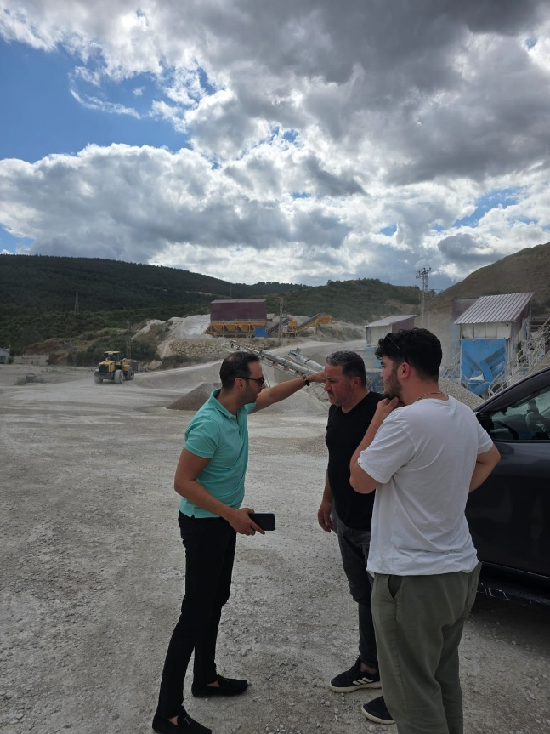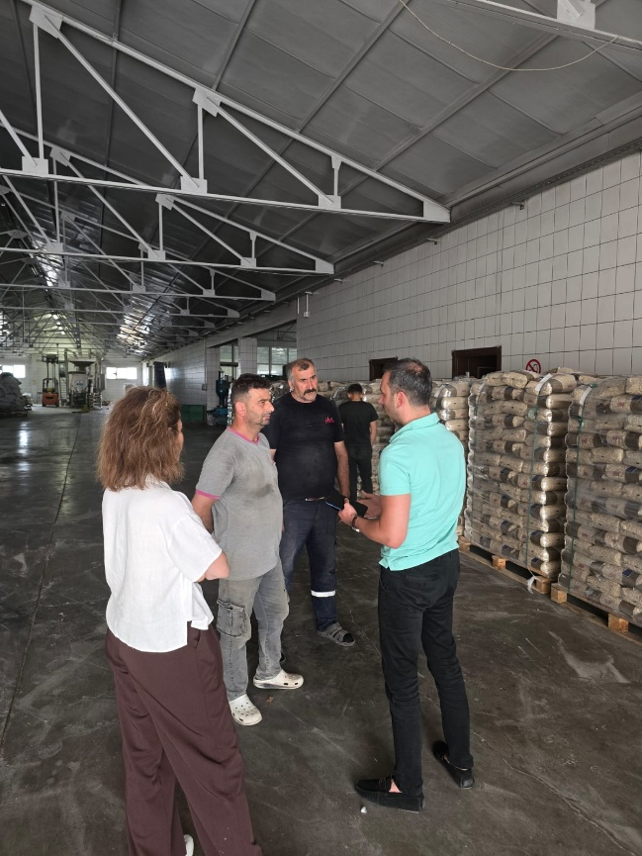
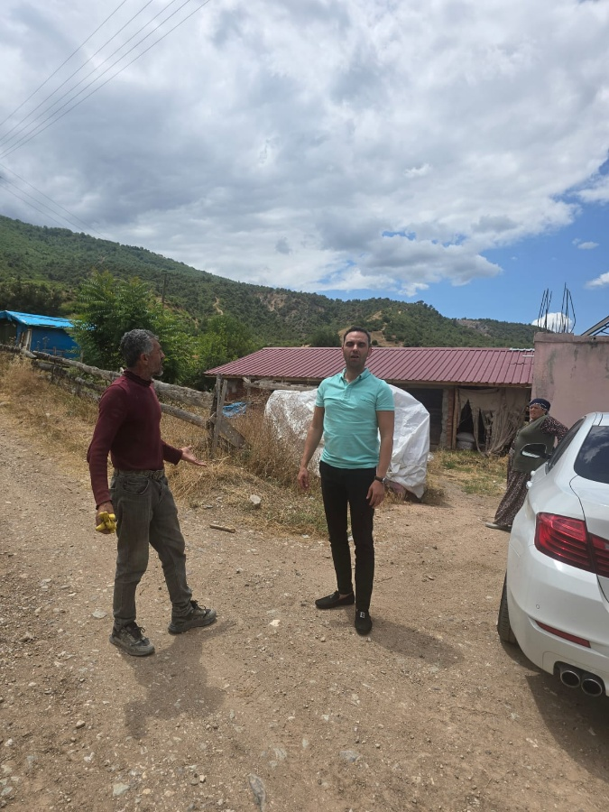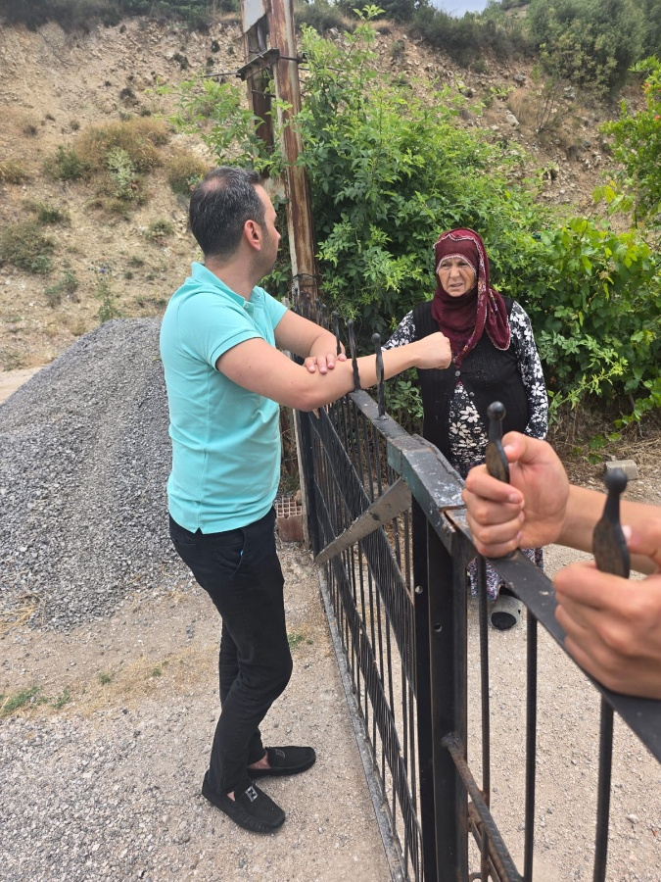
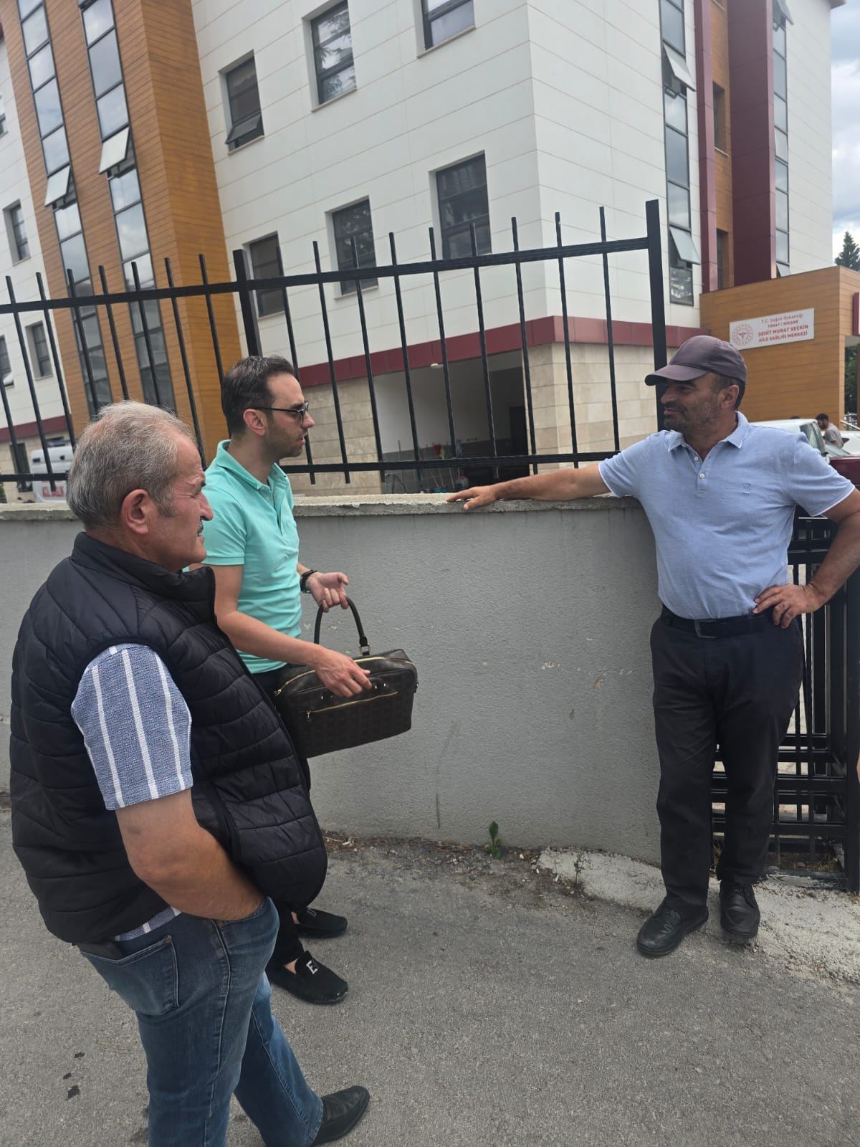

Annex-F
Community Level Survey Form
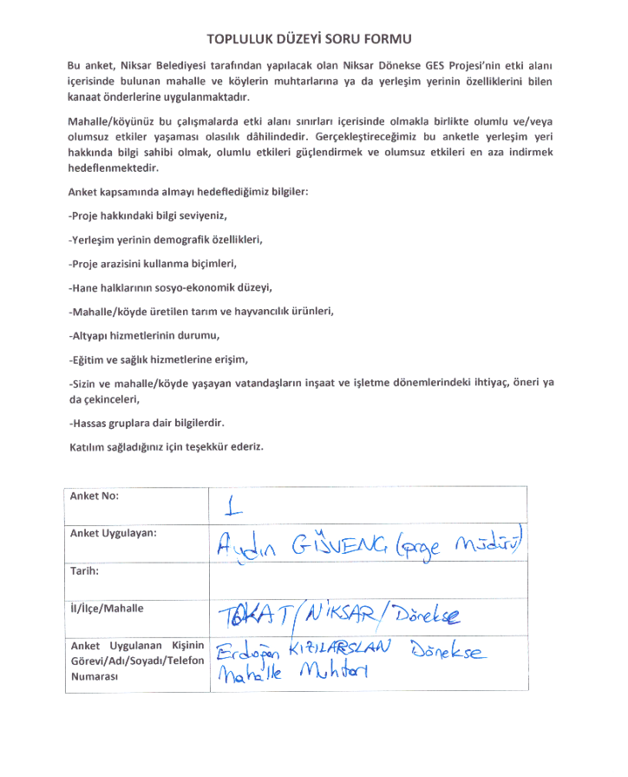
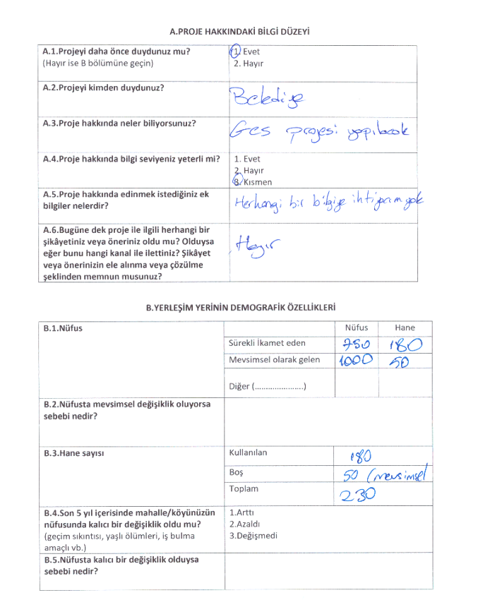
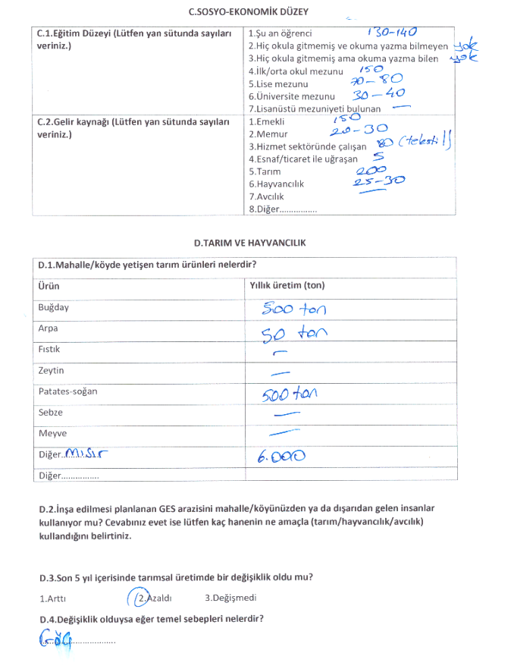

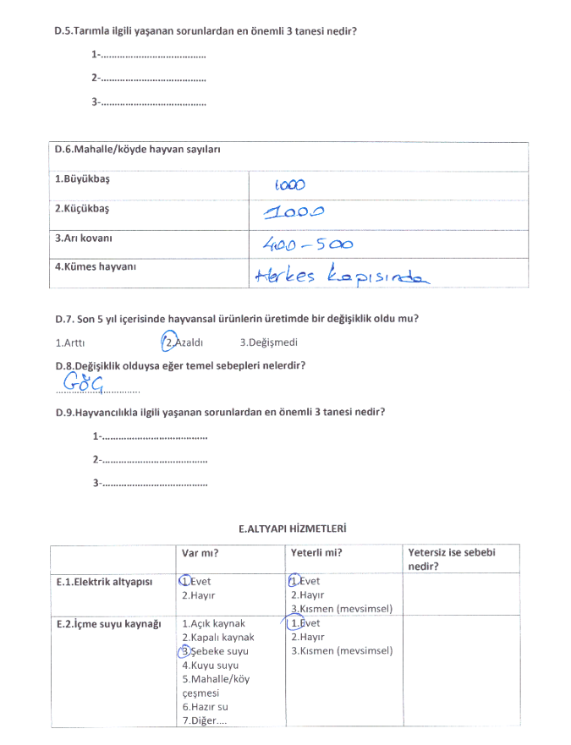

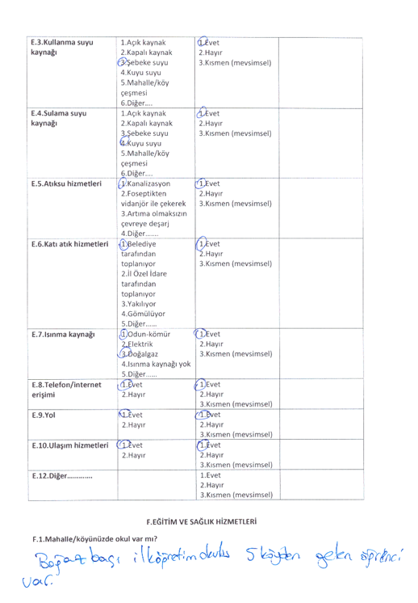

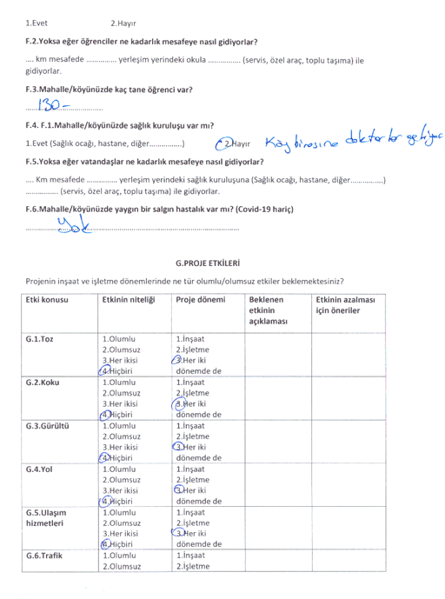

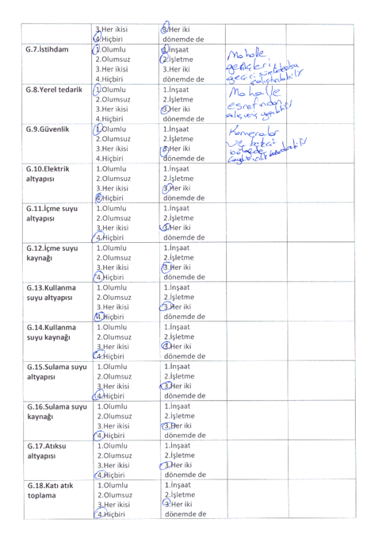

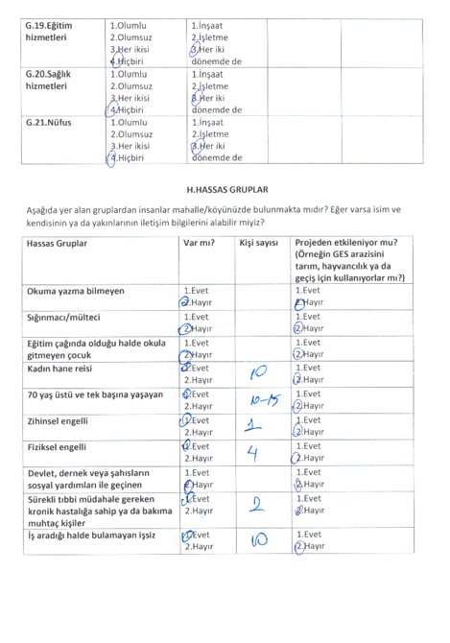

For details please see: https://www.ilbank.gov.tr/userfiles/files/Grievance_Mechanism.pdf

